POST-OPERATIVE CARE
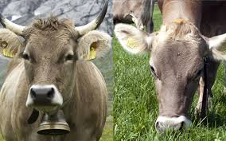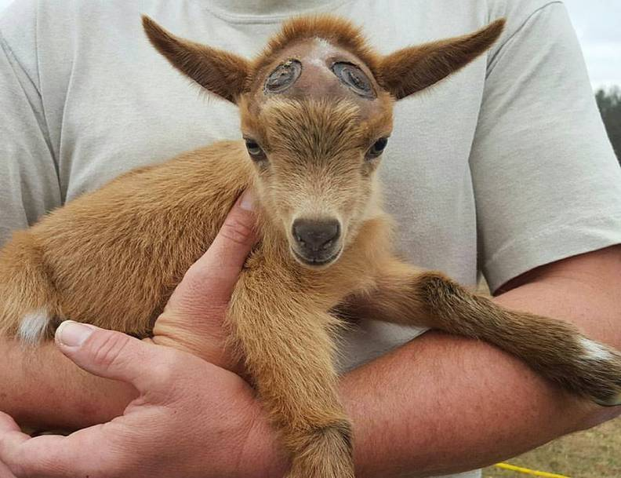
- Observe signs of bleeding post dehorning, if bleeding persists, cauterize using hot iron to stop bleeding.

- Cotton can be used to pad the exposed frontal sinus and oxytetracycline as well as screwworm spray can be sprayed around the area to decrease chances of sinus infection and myiasis.

- Animal should be closely monitored for signs of pain (vocalization, reluctance to get up or move or decreased appetite).

- Animal should be kept in a safe, shady, easily accessible and clean environment with adequate food and water for proper recovery and monitoring.

- Vitals should be evaluated (temperature, pulse and respiratory rate).

- Standard wound cleaning should be routinely done to prevent bacteria or debris build up and by extension an infection.

- A veterinarian should be contacted if any complications occur.

Post dehorning, animal should be given 0.2mg/kg of ivermectin subcutaneously to help decrease chances of myiasis
Tetanus antitoxins is also advised to be given.
Calf’s should be vaccinated for tetanus.
Caprine should be vaccinated immediately after dehorning procedure.
