MONITORING OF DEHORNED ANIMALS
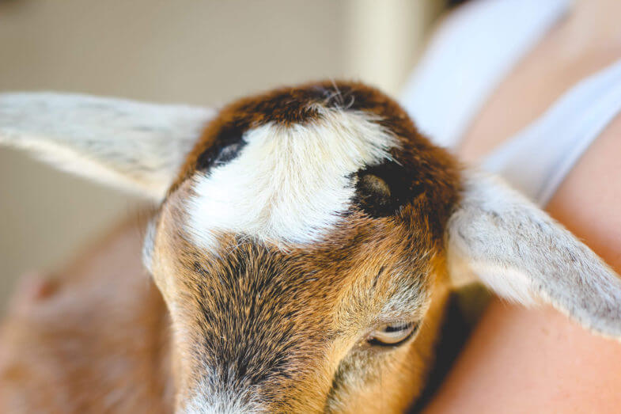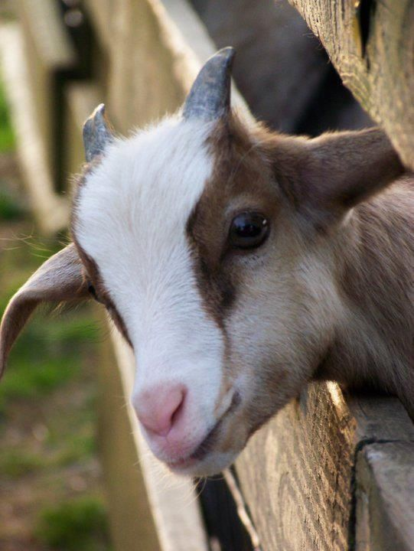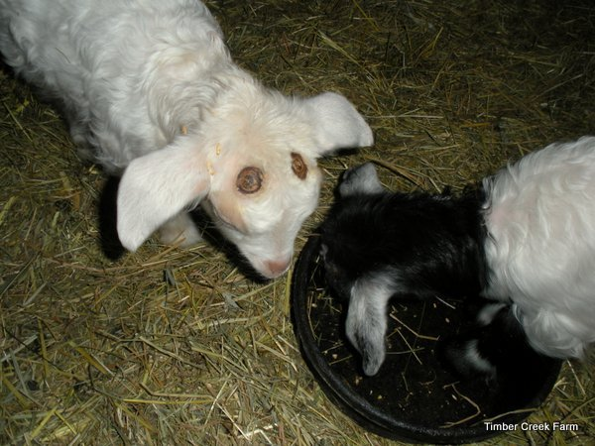
- Assess animal’s behavior from a distance to detect any signs of pain or isolation and ensure the animal is bright, alert and responsive to the environment.
Signs of pain include (reluctance to move, reduced appetite, head shaking, rubbing and tilting)

- Following the distance exam, conduct a physical exam of the animal, assessing the overall body condition with extra attention to the head and neck region.

- Routinely take the animals vital (temperature, pulse and respiratory rate).

- Monitor the animal’s appetite, weight loss, and body condition score.

- Remove cotton from frontal sinus and tilt head to drain excess fluids.

- Clean cotton should be reapplied with nitrofurazone ointment into the frontal sinus to prevent/treat bacterial infection of the site.

- Oxytetracycline can be used along with screwworm spray to spray around the site to prevent any buildup of debris.

- Penicillin/streptomycin can be administered via IM as an antibiotic.

