Dehorning
What is dehorning- where the horn buds from calves and the mature horns from older cattle are removed
Why dehorn- dehorning increases the safety of the farmer and reduces the risk of injury to other cows. It also aid handling of cattle which may be aggressive. Dehorning cattle can improve access to feed and reduces the amount of space needed for each individual animals increasing the capacity for cattle on a farm, namely an intensive farm.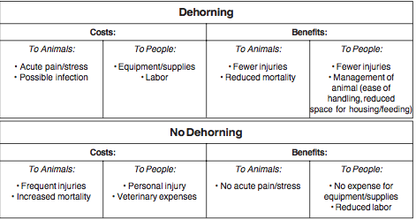
When to dehorn- Calves should be dehorned early in life to reduce the risk of few complications such as infection. Younger calves heal quicker. Calves >2 month may be require more time to return to their pre-dehorning weight. Calves should be dehorned in the spring and fall avoid rainy weather.
Methods of Dehorning
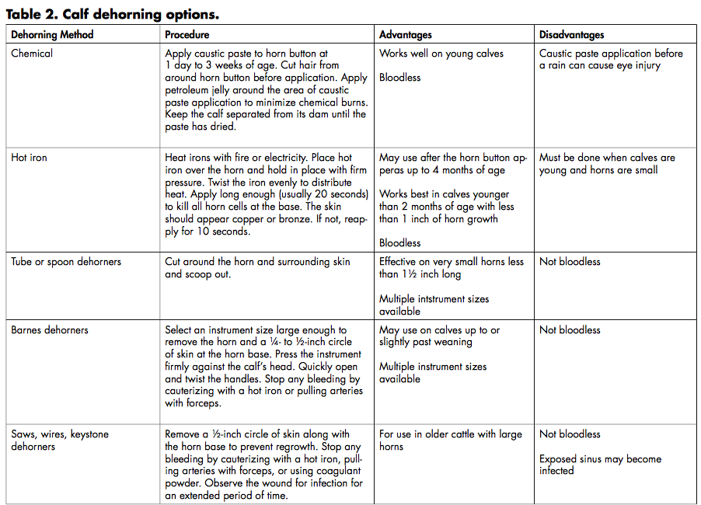
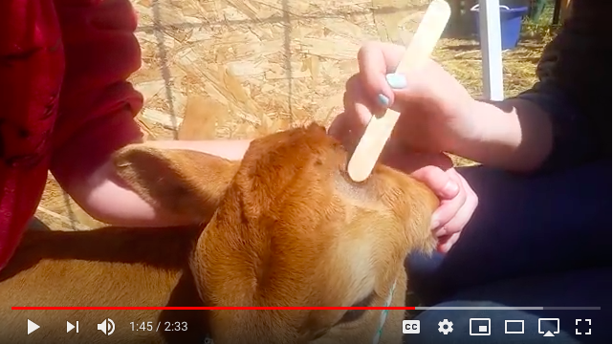
Chemical -prevents the growth of horns by destroy the modified skin cells around the horn bud which that mature into the cells of the horn. It can be applied within 3-7 days of life to ensure that all the horn germinating cells are destroyed
Benefits
- This method can be done on younger animals.
- Does not require hemostasis
- Can be done at any time in the year
- Decrease risk of sinusitis
Precautions-
- Wear gloves when handling these caustic products
- Use petrolatum jelly to reduced irritation to the skin and prevent run off of the caustic agents
- Avoid application near the eyes. Monitor for potential run off after application.
- Calf may also rub the affected area on surfaces encouraging drainage or transfer. As a result the calf should be kept away from the mother until the product is dried to prevent burning and irritation of the skin and udders.
- Avoid application in rainy weather, to prevent run off.
- If preformed incorrectly, regrowth can occur.

Method
- Administer sedation, analgesia and local anaesthetic.
- Clip and clean area. apply a ½ inch band of petroleum jelly, on the clipped area around the base of the horn.
- Using a wood applicator, apply the caustic agent to the horn button.

Considerations- according to the Ministry of Agriculture, Food and Rural Affairs, Ontario Canada, experienced operators believe that not clipping hair keeps the caustic agent in place, reduces the risk of irritation to the cows udder and flanks and reduces irritation to other facial skin of the calf.

Thermal Cautery- heat is used to kill the horn germinating cells at the base of the horn. A heated iron is used to perform this method. The iron must be hot enough to kill the germinal cells. If successful the horns slough off in 4-6 weeks. The heating iron can be electrical or battery operated. Monitor the heat source to ensure it is at the right temperature, between each calf. At times batteries may need to be recharged or the iron may need some time to reheat. Some heating iron, require an external heating source. The cherry red color of the tip signifies that its ready for use.
Benefits
Can be done on younger animals. 7 days – 2 months
Do not require hemostasis
Can be done at any time in the year
Decrease risk of sinusitis

Method
- Administer sedation, analgesia and local anaesthetic.
- Preheat the dehorning.
- Avoiding the ear Place the tip of the burner over the horn and apply slight pressure. slowly rotate the dehorner. A white ring at the base says that the burn successfully cut the blood supply.
- Apply heat for 10-15 seconds. Caution the bones of the calves skull are thin and prolonged contact can cause brain damage.
- A copper-colored ring around the base of the horn denotes a success procedure..

Cutting

- Tube Dehorner- can be use on calves less than two months of age with horns less than 1.5 inches long.
A tube gouge or Roberts dehorner makes a circular cut and is then twisted over the base of a horn bud. Finally it is twisted upward to scoop out the horn. Pressure is applied to stop the bleeding however, hemorrhage is minimal. Dehorners must fit around the base of the horn with an extra margin of 1cm to remove 1cm of the surrounding skin

Method
- Properly restrain the animal.
- Administer sedation, analgesia and local anaesthetic.
- Place the cutting edge directly over the horn.
- with slight pressure twist the dehorning tube until the skin around the horn is cut.
- Use the cutting edge of the tube to cut under the horn button and remove it.
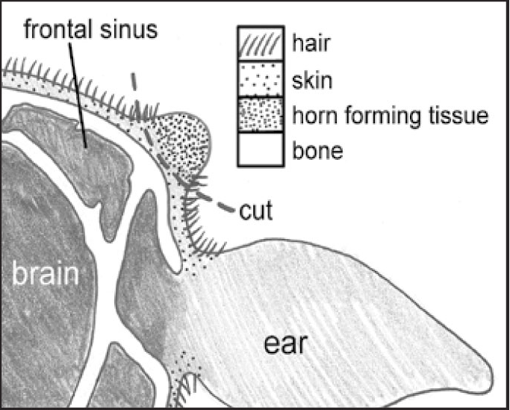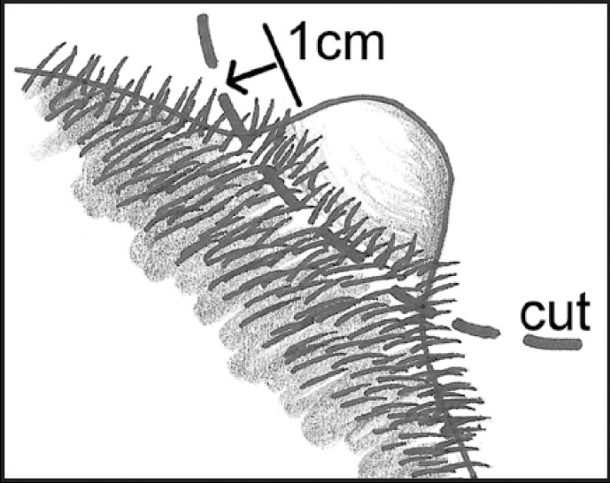
- Scoop/Gouge Barnes-type Dehorner -Scoop Can be used on calves from 3 months to a year or more. The small size for 2- to 8-month old calves and The larger size is for yearlings or older cattle
An elliptical cut is made which removes the horn and exposes the cornual arteries. These arteries can be pulled out until they snap. As a result the remain artery is allowed to clot under the skin. These arteries can also be cauterized. There may be an opening into the sinus which can be left open, or covered with a thin piece of gauze to keep it clean.
Benefits
- Fast
- can be used after the horn bud attaches to the skull
Possible Complications
- hemorrhage
- risk of infection because of open wounds
- opens the frontal sinus in older calves
- fly strike

Method
- Clean and disinfect tool before each calf.
- Administer sedation, analgesia and local anaesthetic.
- Clip and clean the area
- Close the handles together.
- Place the jaws of the dehorner over the horn bud. adjust the opening to remove 1cm of skin
- With pressure and quickly spread the handles apart removing the skin and horn bud
- Pull the arteries or using a hot iron to cauterize them.

- Keystone - A large cutting instrument which has two blades that cut the horn when brought together by two long handles. After the animal’s head is secured, the blades are positioned. The handles are closed cut the horn. When handling large horns, rotation of the blades a secondary snap of the handle can help complete the cut. The arteries can be cauterized or pulled and snapped to arrest hemorrhage.
Method
- Properly restrain the animal. clip and clean the area.
- Administer sedation, analgesia and local anaesthetic.
- Place the opened blade over the horn base given a 1cm allowance for skin to be remved. Quickly close the handles to clip off the horn.
Dehorning saw
Electrically Powered
The electric saw dehorner is similar to a portable electric wood saw. This method is quick, but expensive . The saw is also difficult to disinfect.
Obstetrical Wire and Others
These are used on large heifers, cows, and smaller bulls. They can also be used on horns that are large and difficult to cut with other equipment. Anesthesia is recommend as this method is slower than the others. Hemorrhage can be arrested with cautery , however horn dust may decrease the amount hemorrhage that occurs. Room is needed to accommodate the handles. Horn dust can act as an irritant within the sinus

References
Cosmetic dehorning
https://research.uq.edu.au/files/17501/sop_aht_57_surgical_dehorning_in_cattle.pdf
Dehorning calves https://extension.tennessee.edu/publications/documents/pb1684.pdf
Dehorning of cattle https://www.researchgate.net/publication/294581420_DEHORNING_OF_CATTLE/link/56c2271b08aee5caccf9b1b1/download
Bovine surgery of the Skin https://www.vetfood.theclinics.com/article/S0749-0720(08)00052-2/pdf
Disbudding/dehorning Dairy calves https://outagamie.extension.wisc.edu/files/2010/12/Dehorning-Debudding-Dairy-Calves-Factsheet.pdf
Dehorning of Calve Fact sheet- http://www.omafra.gov.on.ca/english/livestock/dairy/facts/09-003.htm#hot
http://www.dehorning.com/disbudding-and-dehorning
Dehorning Methods- https://animart.com/files/Dehorning%20Tech%20Bulletin_0.pdf
Dehorning of Dairy Animals https://www.google.com/url?sa=t&rct=j&q=&esrc=s&source=web&cd=&ved=2ahUKEwiblO7_uILsAhWCo1kKHTo5B14QFjABegQIAhAB&url=https%3A%2F%2Fnjaes.rutgers.edu%2Fpubs%2Fdownload.php%3FstrPubID%3DFS769&usg=AOvVaw0zww4llMr7XaVFaqQf38qV

Techniques in large animal surgery
Farm Animal Surgery

