Pre-op Equipment
- Drugs- lidocaine (local anesthetic), xylazine (local anesthetic and analgesia), NSAIDs, Antibiotics (Penicillin-Streptomycin), Anti-parasitics (Ivermectin)
- Antiseptic solutions should be used e.g. povidone iodine, chlorhexidine and isopropyl alcohol
- Restraint aids- disbudding box, chemical restraint (drugs for sedation and analgesia), halters and lead ropes

Scenario 1: 2wk old Saanen | Scenario 2: 6mnth old calf | Scenario 3: 2yr old breeding ram
Disbudding box | Restraint aids- chemical, halters and lead ropes etc. | Restraint aids- chemical (sedation and local anesthesia), halters, lead ropes etc.
Syringes and Needles | Syringes and Needles | Syringes and Needles
Shaver/Scissors | Shaver/Scissors | Shaver/Scissors
Sedation drugs | Sedation drugs | Sedation drugs
Antiseptic solutions | Antiseptic solutions | Antiseptic solutions
Hot iron dehorners | Barnes-type Dehorner* | Draping material
Dehorning paste | Knife* | Scalpel blade and handle
Wound dusting powder | Keystone Dehorners* | Forceps
 | Callicrate Bander* | Needle holder
 | Gigli/Obstetrical Wire* | Suture Material
 | Dehorning spoons, cups and tubes* | Hand Saw
 | Hand Saw* | Gigli/Obstetrical Wire
 | Dehorning pads | Cautery
 | Wound dusting powder | Bone chisel and mallet
 | Bandaging material | Wound dusting powder
 | Antibiotic drugs | Bandaging material
 |  | Gloves
 |  | Antibiotic drugs

NOTE: xxx*- The equipment listed with the star will be chosen for use depending on the size of the horn of the animal. They were listed just to show all the different types of equipment.

Equipment | Advantages | Disadvantages
Dehorning paste  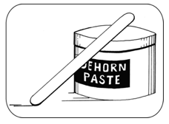 | - Less stressful than other methods  - Can be performed at a young age  - No blood for this procedure  - Less risk of infection | - Should not be used in rainy weather  - Painful without anaesthesia  - Can cause damage to the animal’s eyes if paste contacts the eye
Hot Iron  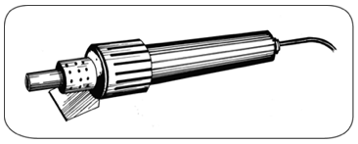 | - Bloodless procedure  - Can be used during anytime of the year  - Performed in young calves up to 12 weeks of age | - If done incorrectly can lead to scurs  - Extremely painful so anaesthesia and analgesia should be used  - Horns should be passed the button stage  - If performed by inexperienced personnel the bones of the skull and calf’s brain can be damaged if iron held on the horn for too long
Dehorning spoon or tube  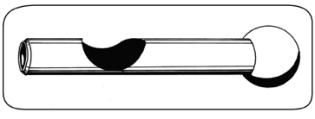 | - Useful for young calves  - Effective on very small horns | - Not a bloodless procedure  - Risk of infection because of open wounds  - Avoid use during fly season to prevent infection  - Leads to scurs if done incorrectly  - Should not be done without anaesthesia or analgesia as well as a way to control bleeding
Scoop, Gouge or Barnes-Type Dehorner  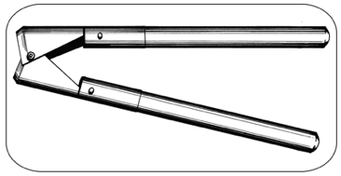 | - Fast procedure- takes a few seconds to perform  - Can be used after the horn bud attaches to the skull  - Barnes-type Dehorner has 2 sizes one for smaller cattle (6-8 months) and one for bigger cattle (yearling or older) | - There is a risk of infection because of open wounds  - Not a bloodless procedure  - Can open the frontal sinus in older calves which can lead to sinusitis  - Avoid use during fly season to prevent infection  - Can lead to scurs if procedure is done incorrectly  - Anaesthesia and analgesia should be used  - Control of bleeding is required for this procedure
Keystone Dehorner  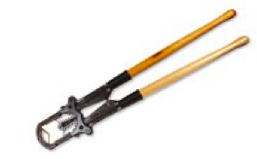 | - Can be used in older cattle with large horns | - There is a greater risk of infection because of exposed sinus  - Not a bloodless procedure  - Can be extremely painful and anaesthesia or analgesia should be used  - Requires follow-up care
Knife  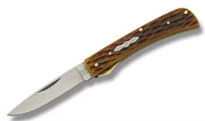 | - This is effective on very small horns | - It is a bloody and painful procedure  - There is a risk of infection
Gigli/ Obstetrical Wire  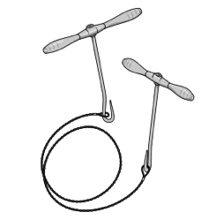 | - Can be used for horn removal in older cattle | - There is a greater risk of infection due to exposed sinus  - It is a bloody and painful procedure so therefore anaesthesia and analgesia should be used  - Required follow-up care
Hand Saw  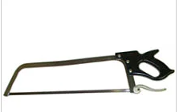 | - Can be used for horn removal in older calves with large horns | - There is an increased risk of infection  - Death from blood loss can occur with this method  - Monitoring afterward is required to prevent infection  - Can be extremely painful so anaesthesia and analgesia should be used
Callicrate Bander  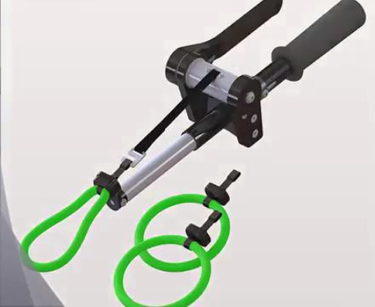 | - Can be used on cattle, goat and sheep with large horns  - Not as painful as other procedures  - Less risk of infection  - Less stressful on the animal  - It is a bloodless procedure | - Takes about 2-3 months for horns to be completely removed  - Anaesthesia or analgesia should be used  - Bands should be covered with duct tape to prevent fly strike or infection

Videos on How to Use Equipment:
- https://youtu.be/Z1KcieP5H-E - Dehorning paste
- https://youtu.be/F_WWq1jssGU- Hot-iron on calf
- https://youtu.be/lnxI5_gi7BI- Hot-iron on kid
- https://youtu.be/GxV35EZ1px4- Gigli wire dehorning
- https://youtu.be/JmmbpOG5NzQ- Keystone dehorner
- https://youtu.be/Fg4qCwq58nQ- Barnes-type dehorner
- https://youtu.be/hLZ-DwRlXgY- Callicrate bander dehorner

References
- http://www.thebeefsite.com/articles/2261/dehorning-of-calves/
- http://www.dehorning.com/dehorning-methods/hand-saw-dehorning
- https://www.dpi.nsw.gov.au/animals-and-livestock/beef-cattle/husbandry/general-management/dehorning-cattle

