Removal of the horn buds before they become attached to the skull at two or three months of age is called disbudding. This results in less injury and pain compared to dehorning. Once the cells are permanently destroyed, horn tissue will not be able to grow later in life.
Dehorning equipment
Physical restraints used: ropes, halter, nose pliers, cattle crush. These equipment are use to restrain the animal for proper handling and to maximize safety.

Rope and halter- 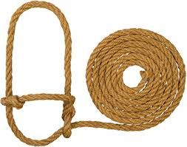

Nose pliers- 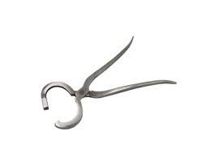

Cattle crush- 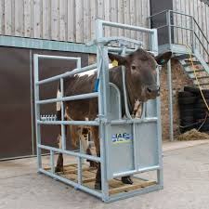
Rope and a halter can be used to restrain the head by tying the rope on the halter onto a bar tightly with a quick release knot to firmly control the head. Nose pliers give further control by acting as a distraction.
Chemical equipment

caustic paste to the calf’s horn buds is another method for dehorning and is most effectively done at 1-3 days of age. Calves must be kept from rubbing paste on other animals, prevent contact with rain or other moisture for at least 24 hours will prevent the paste from running and causing injury to the calf. Cover the horn buds with duct tape or vet wrap after the paste is applied.

Injectable; calcium chloride
Topical
Sodium hydroxide, potassium hydroxide, calcium hydroxide

Pros and Cons of chemical dehorning:
Pros | Cons
Performed at young age | Needs anaesthesia
bloodless | Avoid contact with eyes; blindness
Use in any season | Cant be used in rainy weather
 | Requires pain management

Mechanical equipment

Hot Iron dehorning- calves up to 12 weeks
Pros- used on young calves less than 12 weeks/ bloodless/ can be done anytime of the year
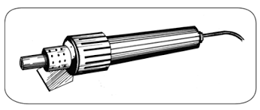 Cons- unreliable if done incorrectly/ requires expertise

Dehorning spoon or tube – calves less than 8 weeks
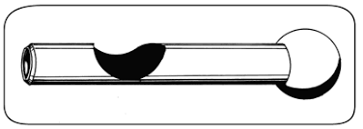Pros- useful on young calves
Cons- not bloodless/ increase risk of infection due to open wound/ should be avoided during fly season/ requires expertise

Barnes type scoop Dehorner- calves ranging from 2-4 months
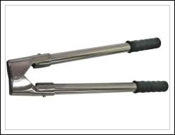
Pros- fast/ used when the horn bud is attached to the skull
Cons- opens the frontal sinus in older calves/ requires expertise/ requires control of bleeding. Bleeding is stopped by cauterizing with a hot iron.

References
- https://animalhandlingavbs1002.weebly.com/cattle-restraint-within-a-cattle-crush.html
- http://www.omafra.gov.on.ca/english/livestock/dairy/facts/09-003.htm

