INTRA OPERATIVE PROCEDURE FOR CASE 2

1. AIM
- To completely remove a ring of skin surrounding the base of the horn.

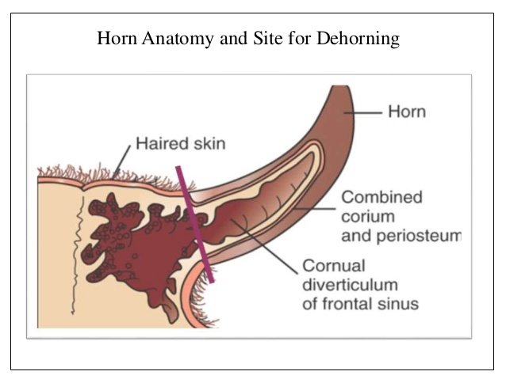

2. RISKS OR CONTRAIDICATIONS
- Pain
- Sinusitis
- Hemorrhage
- Myiasis
- Tetanus
- Bacterial infection

3. TECHNIQUE
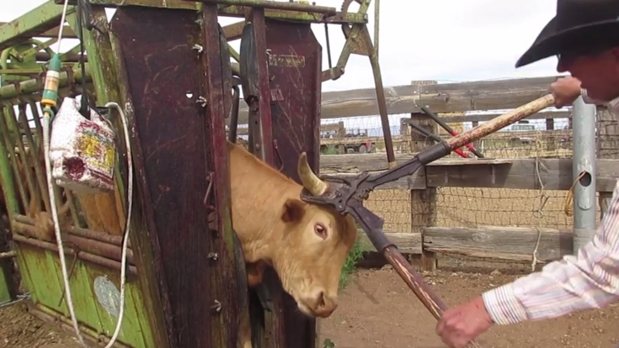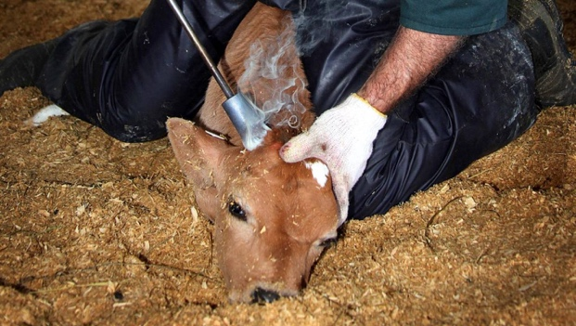

Use of a small Barnes- Type scoop Dehorner (13 inches) Manual dehorner:
- Close handles together
- Place the jaws of the dehorner over the bud of the horn.
- The gouger is pressed gently against the head and pressure is maintained. Quickly spread the handles apart to remove the horn and the skin. Removal of about 0.5 cm (0.25 inches) of skin at the base of the horn to ensure adequate removal of tissue related to horn growth or regrowth.
- The angle of the transaction should produce a uniform contour of the head. It should expose the cornual artery for easy access for traction or torsion and yet should not excessively expose the frontal sinuses.
- Pull the arteries with forceps to control bleeding and ensure adequate hemostasis by using a hot iron cauterization.

