Cosmetic dehorning Procedure using obstetric wire saw, Gigli wire saw, dehorning saw
-Using a scalpel blade, incise the skin 1 cm from the base of the horn.
-Sufficient skin removal is needed from the caudolateral and caudomedial areas, where scarring can occur. This is shown in the diagram below.
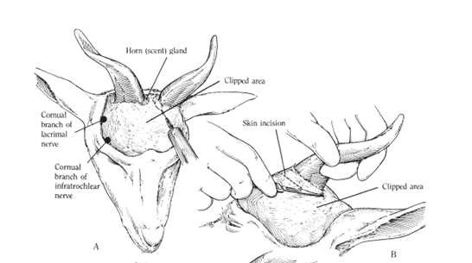
-With the help of an assistant holding the goat’s head, use the obstetric wire saw or Gigli wire saw in a caudomedial aspect of incision and remove the horn by directing the saw in a craniolateral direction as shown below.
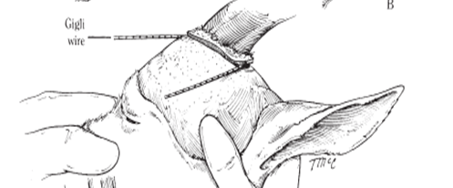
-For this step, a dehorning saw may be better since its less likely to break and less likely to leave a protuberance in the middle of the horn that may grow back.
-For male goats, the scent glands are located at the base of each horn (caudal and medial) and are removed during procedure.
- With the use of a hemostat, twist and pull the superficial temporal artery or ligate it.
- It is important to note that with Cosmetic Dehorning, after the horns are removed and the cornual artery is ligated, any extra bone is removed rostrally along the frontal ridge (so there is no "hump" at the top of head hence it’s a cosmetic procedure).
-The site is then cleaned with sterile saline. To ensure a cosmetically pleasing appearance a cruciate suture pattern is used. Then the bandage is applied.
-When the goat is dehorned correctly, the frontal sinuses are exposed. This is due to the extensive communication between the lumen of the cornual process and the frontal sinus.
- The head may be bandaged postoperatively to prevent both myiasis and the collection of foreign material in the sinus.
-Prior to bandaging, a topical antibacterial powder such as nitrofurazone is dusted onto the dehorning site.
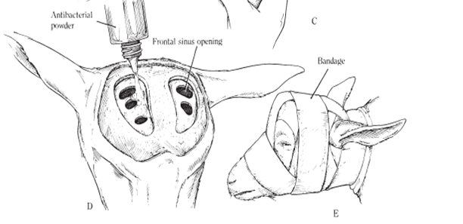
Reference- Hendrickson D. Techniques in Large Animal Surgery 3rd Edition. Chapter 17. Dehorning goats. Pages- 297 to 299

