Disbudding of Kid Goat
Preoperative
History
- Important aspects of history include
  - Diet plan
  - Past or present illnesses
  - Past or present medications used
  - Past surgeries or procedures
  - Deaths or illnesses in the herd
  - Vaccination history

Signalment
- ID#: 144
- Age: 2 week old
- Breed: Saanan
- Sex: Male
- Weight: 20 kg
- BCS: 3.5/5
Presurgical Exam
- Distance Exam
  - Assess the environment the patient is in, including any faecal matter found.
  - Assess cleanliness and airflow of the environment.
  - Assess the patient’s behaviour, gait, and stance.
  - Assess the patient’s respiration rate, and look for lesions, discharges, or abnormalities.
- Physical Exam
  - Perform a 5 station physical exam on the animal, looking for abnormalities.

Anesthesia
A combination of alpha 2 agonist xylazine, ketamine and butorphanol is given intravenously via the jugular or cephalic vein. This combination (KXB kid mixture) is made by using 10ml (100mg/ml) ketamine, 1ml (20mg/ml) xylazine and 1 ml (10mg/ml) butorphanol. This is then given at 0.1ml/5kg IV. Goat kid should be fully anaesthetized before procedure.
Analgesia
Although butorphanol is given, it only reduces pain for 2 hours after disbudding. Meloxicam a non-steroidal anti-inflammatory agent is also given (0.5 mg/kg) which provides analgesic effects for up to 24 hours after disbudding and can minimize stress and pain associated with procedure.
Restrain
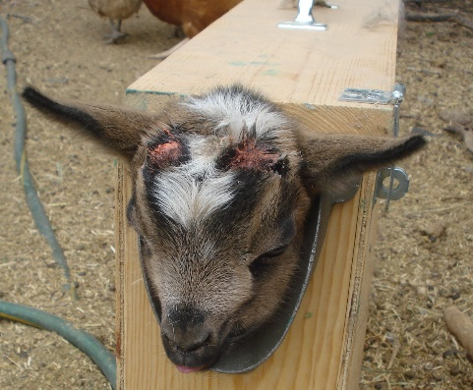
https://www.youtube.com/watch?v=R9gYG5JSpvs&ab_channel=Chick-a-WoofRanch
Goat is placed in a kid disbudding box for safety and to limit movement which may affect procedure.
Equipment testing
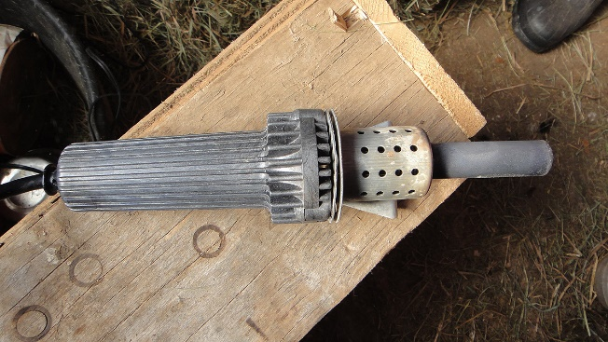
Disbudding iron should reach a cherry red glow and when placed on a piece of wood it should leave a depressed black ring indicating optimum temperature.
Disbudding area prepping
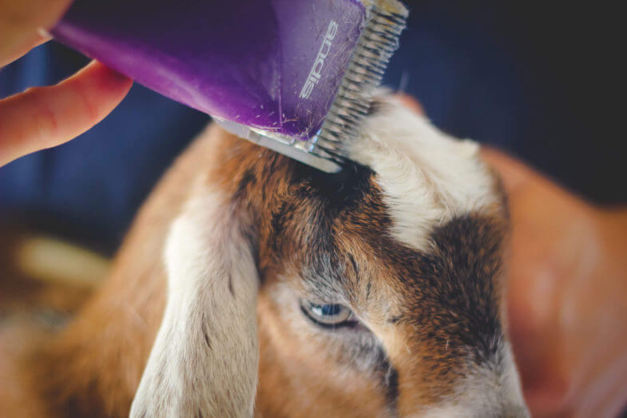
Hair surrounding the horn buds should be clipped to make surgical area clearly visible and to reduce smoke released with disbudding iron from burnt hair.

Links-
https://inpractice.bmj.com/content/41/9/433?int_source=trendmd&int_medium=cpc&int_campaign=usage-042019
http://www.comstockequine.com/storage/app/media/Proper_Disbudding_Technique_in_Goats.pdf
file:///C:/Users/salin/Desktop/yr3sem2/yr4sem1/35523-Article%20Text-126454-1-10-20180130%20(1).pdf
Turner and McIlwraith's Techniques in Large Animal Surgery 4th Edition

