Intraoperative
Aim
- To completely remove the horns of an animal and cover the site with surrounding skin to give the appearance of a polled animal.

Risks or Contraindications
● Pain
● Sinusitis due to bone fragments remaining
● Haemorrhage
● Myiasis
● Tetanus
● Infection

Video link-
https://www.youtube.com/watch?v=oWLAVPpXO4E&t=411s&ab_channel=Homesteady
A 200-watt disbudding iron with ¾ - 1inch tip is used for kid goats.
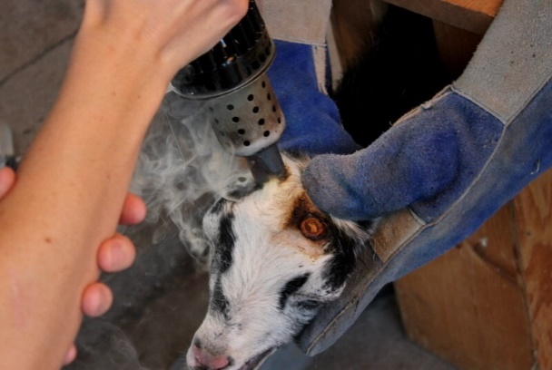
Hold the goat head to control and direct area for disbudding. Press the disbudding iron over horn bud for 3-5 seconds at a time to reduce complications. So, 3-5 seconds on and 3-5 seconds off should be followed.
If entire bud cannot be covered in one circle then burn half circle and alternate on next side to complete circle.
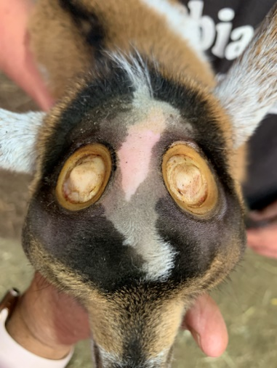
Continue with disbudding iron until a copper colored ring around horn bud is achieved. Two application of the disbudding iron should be adequate to destroy corium. Cap of the horn should also be burnt to destroy central horn tissue and the circle of burnt skin created should not be able to scrape away to ensure death of horn tissue.
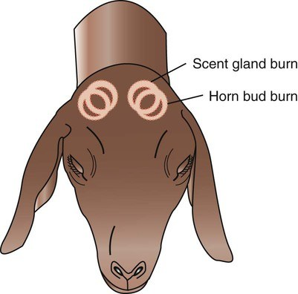
Optionally at this point bucks can be descented by burning the skin caudomedially to each horn bud
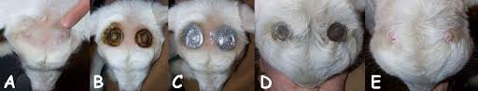
Spray disbudded area with aluminum antiseptic spray to clean and promote wound healing.

Links-
https://inpractice.bmj.com/content/41/9/433?int_source=trendmd&int_medium=cpc&int_campaign=usage-042019
http://www.comstockequine.com/storage/app/media/Proper_Disbudding_Technique_in_Goats.pdf
file:///C:/Users/salin/Desktop/yr3sem2/yr4sem1/35523-Article%20Text-126454-1-10-20180130%20(1).pdf
Turner and McIlwraith's Techniques in Large Animal Surgery 4th Edition

