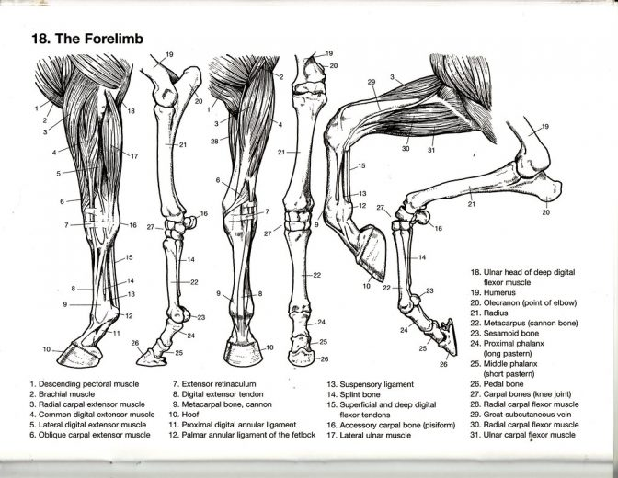

a) Just distal to the carpus the MEDIAL PALMAR ARTERY, VEIN AND
NERVE (2) lie next to each other in this dorsopalmar seque...

5 The passive Stay-Apparatus of the Thoracic Limb
The structures making up the PASSIVE STAY-APPARATUS are shown on
the opp...

11
Arteries, Veins, and Nerves of the Distal Forelimb
(Medial view) (Lateral view)
1 Dorsal branch of ulnar nerve
2 Medial...