INVESTIGATION OF HORSE LAMENESS

Possible differentials for lameness in horses
- Wobbler syndrome
- Navicular syndrome
- Equine protozoal myeloencephalitis
- Lyme neuroborreliosis
- Trauma (muscle, tendon, bone or joint injury)
- Hoof or subsolar abscess
- Ataxia
- Laminitis
- Carpal Arthritis
- Caudal heel pain syndrome
- Degenerative joint disease

DIAGNOSTIC METHODS AND INVESTIGATION OF LAMENESS IN THE HORSE.

Horse lameness must be analyzed and examined by an assortment of conditions to completely evaluate the horse's abilities. This is because a horse may not show matching garages of lameness under various conditions.

The measuring/grading of lameness are dependent on:
- Reason for the lameness
- The of the movement
- Difficulty or ease of the movement

The vet or analyst must fully comprehend and be knowledgeable on; equine anatomy/ structures, typical gait and conformation, local sedation, and imaging procedures as well as have the skill to perceive lameness of the forelimb and hindlimb. The lameness exam is a multi-step methodical veterinary exam wherein a veterinarian tries to determine where the pain in a limb originates and the nature of that pain.

*Horses should be kept off any anti- inflammatory, for example, Bute or Banamine, for 24 to 48 hours before the test because these drugs can conceal any lameness and pain.

Procedures: (*The diagnosis and treatment plan is derived from a synthesis of findings from all of the below areas of the lameness exam)

- Basic recognition of lameness:
This is key to a correct diagnosis. The head nod of the horse is the most consistent sign of a unilateral forelimb lameness where the head and neck rise when the affected forelimb strikes the floor when bearing weight and fall when the normal limb strikes the floor.
As for hindlimb lameness, the pelvic/sacral rise is the easiest observed and mostly seen, where the entire pelvis and sacrum rise when the lame limb strikes the floor and bears weight.
Both the head nod and sacral rise occur to reduce concussion on the limb that is lame.
Recognition of lameness is a key skill to successful diagnosis. The most consistent sign of a unilateral forelimb lameness is the head nod. The head and neck of the horse rise when the lame forelimb strikes the ground and is weight bearing and fall when the sound limb strikes the ground. The sacral (pelvic) rise is the most consistent and easily observed sign of hindlimb lameness. The entire pelvis and sacrum rise when the lame limb strikes the ground and is weight bearing and fall when the sound limb strikes the ground. Both head nod and sacral rise serve to reduce concussion on the lame limb.

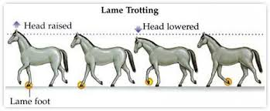

The American Association of Equine Practitioners (AAEP) developed a lameness scale to aid veterinarians and horse owners in communicating about cases and recordkeeping:
0-No lameness
5-most extreme
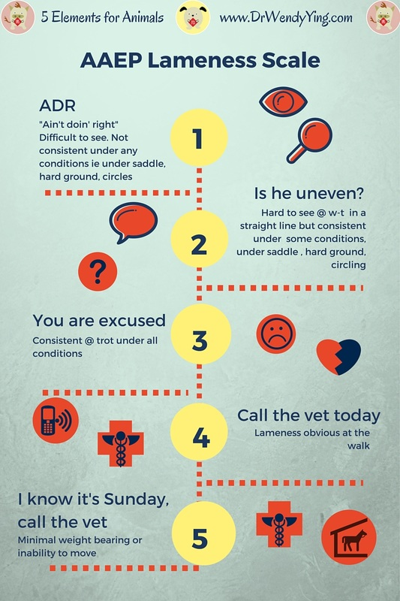

0: Lameness not perceptible under any circumstances.
1: Lameness is difficult to observe and is not consistently apparent, regardless of circumstances (e.g. under saddle, circling, inclines, hard surface, etc.).
2: Lameness is difficult to observe at a walk or when trotting in a straight line but consistently apparent under certain circumstances (e.g. weight-carrying, circling, inclines, hard surface, etc.).
3: Lameness is consistently observable at a trot under all circumstances.
4: Lameness is obvious at a walk.
5: Lameness produces minimal weight bearing in motion and/or at rest or a complete inability to move.

- A careful patient history:
*A detailed and thorough history of both horse and the injury is the first step of a lameness examination
- Age
- Breed
- Discipline and training routine
- Date lameness first noticed
- Effect of exercise on the degree of lameness
- How severe is lameness and how it occurred?
- Any recent changes in management practices
- Any treatment implementation

- Evaluation of the hoof:
- A careful examination of the feet of the horse since nearly 90% of lameness occurs in the foot. The veterinarian will also evaluate the trimming of the hooves, the shoeing, and may remove the horse's shoes to more carefully observe all areas of the foot. The bottom of the hoof should also be examined. The shape of the sole, size of the frog, and shape of the bars can indicate overall health of the hoof. The digital pulse evaluation is important when addressing the hoof. An increased digital pulse often indicates that the lesion is in the foot, and are usually most significantly increased in horses with laminitis. The coronary band may also be palpated. Cool swelling can indicate coffin joint effusion, swelling with an increase in temperature can indicate laminitis.

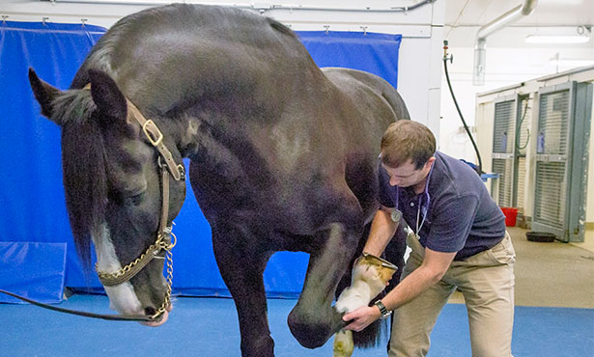

- The standing exam
- A standing exam is done at a distance to evaluate and observe the horse’s conformation, weight bearing balance, symmetry and overall general appearance. Afterwards, a more careful visual exam and palpation of the specific anatomic structures for any present injuries, muscle atrophy/ abnormalities, sensitivity to pressure indicating pain, swelling, heat or joint effusion.

- 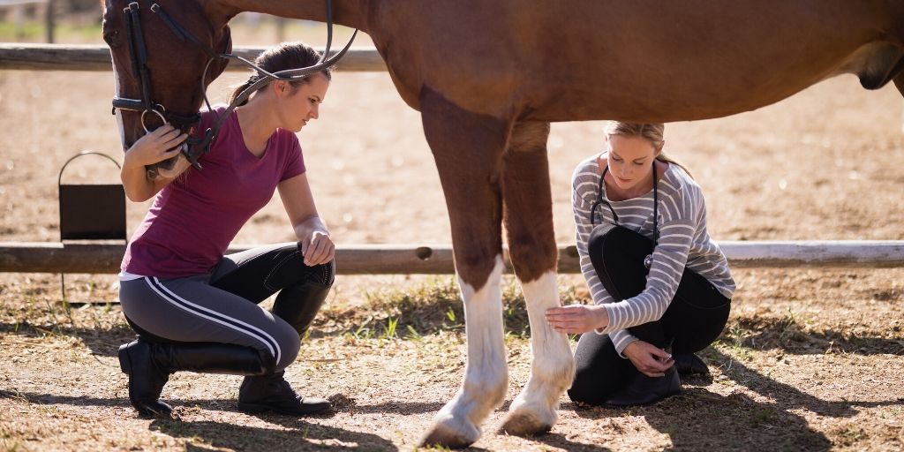

- An exam in movement/motion
- The walk is often the best gait to evaluate foot placement or any deviation from the normal. Lameness is mostly evaluated at the trot. The trot is generally the best gait to localize the lameness to a particular leg, because it is a symmetrical gait where the front half of the horse and the back half move in unison. Most thorough lameness exams are performed on firm to hard, consistent footing. Examination often includes trotting in hand in straight lines, and circles to both directions. It may also include moving a horse up or down inclines or through specific patterns. For the diagnosis of some types of lameness problems, having a rider up can be advantageous. Gait is evaluated for symmetry. This includes the overall fluidity of the horse's motion, length of stride, loading of a leg, how the hoof lands on the ground (flat, toe, or heel-first), range of motion of the joints, deviations in body position, and position of the head and neck.

- 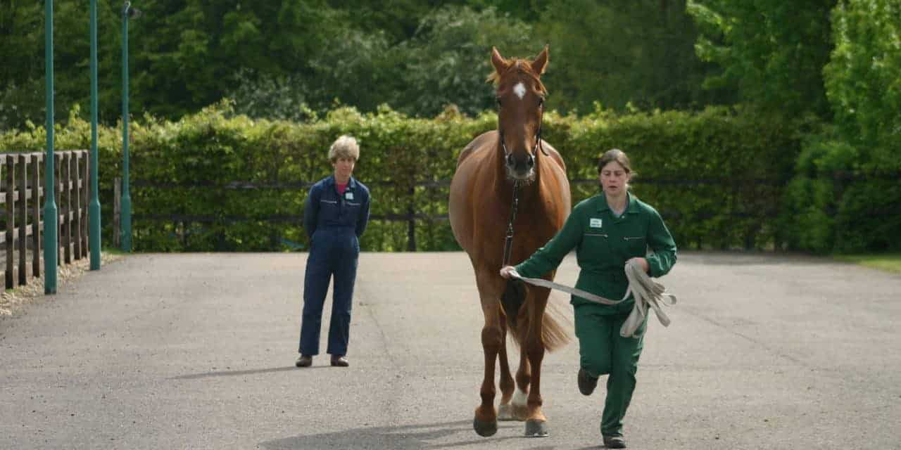

- Flexion of joints exam
- Flexion exams involve putting specific joints or regions of the limb under stress/pressure for a specified and consistent period of time where the horse’s degree of lameness is assessed before and after the flexion. The limb is forcibly flexed for between 30 seconds and 3 minutes. The result; which is the change in severity of lameness following flexion, provides additional information regarding the origin of the pain. As with many parts of the exam, flexion tests are subjective, and the vet must interpret them in light of what is considered normal for that specific horse.

- 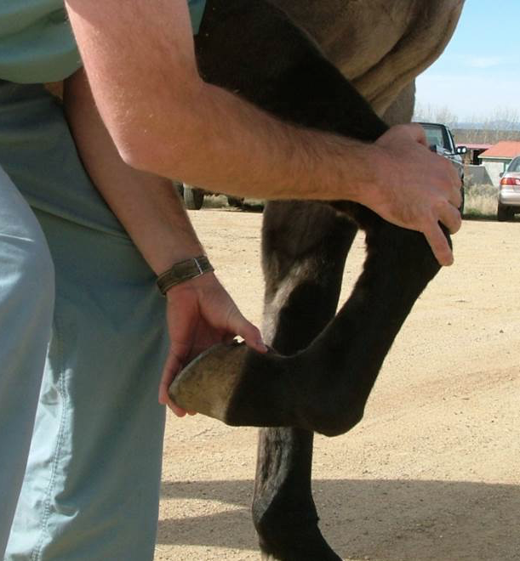

- Hoof tester exams
- This involves the use of a pincer-like tool to put pressure on specific regions of the foot in search of a pain response. As with flexion exams, the key to accurate interpretation of hoof tester examination is knowledge of what constitutes a normal response. This can only be gained through a methodical approach, and lots of experience with different types of horses and hooves.

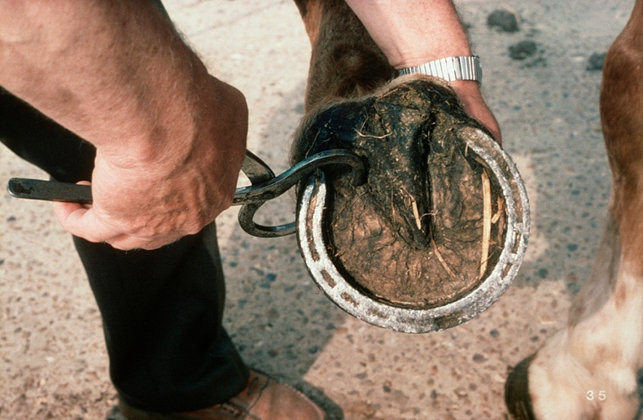
- Diagnostic anesthesia – nerve and joint blocks
- Nerve blocks involve injecting a small amount of local anesthetic around a nerve or into a synovial structure (such as a joint or tendon sheath) in order to block the perception of pain in a specific area. Nerve blocks are used to numb portions of the limb as a means of finding the site of pain, using the process of elimination. Nerve blocks are performed in a step-wise fashion, beginning at the most distal (lower) part of the limb and moving upward. The block is then tested by pushing a blunt object, such as a ballpoint pen, into the area that is supposed to be desensitized. If the horse does not react to this pressure, the area is desensitized, and the horse is trotted to see if the lameness has improved.
- The horse is examined at the trot before the block, and the degree of lameness determined. Then the area in question is numbed, and the horse is asked again to trot off. Either there is improvement in the lameness or not. If there is not, the process is continued on specific nerves progressing up the limb until the lameness is visibly lessened. Specific joints and tendon sheaths can also be blocked for a more specific localization of lameness. Blocks into a joint or tendon sheath require surgical cleanliness and technique to prevent infection of these structures. Limitations of blocking include spread of local anesthetics to adjacent regions, clouding the interpretation of the results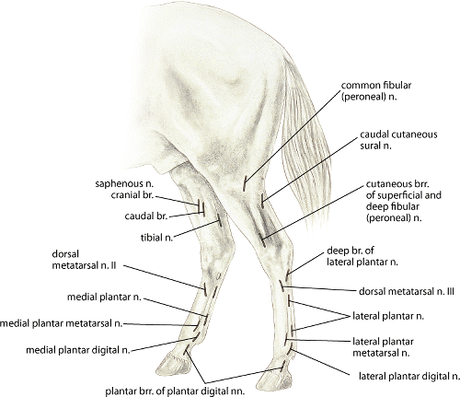
- 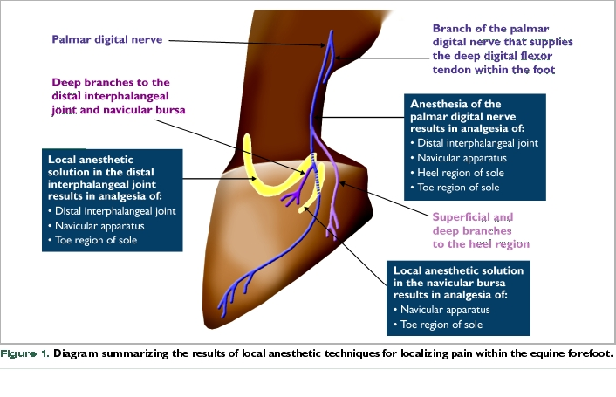
- Imaging the site of injury and pain-
Once the site of pain is located, diagnostic imaging is used to view the structures in the area and provides additional information about the nature of the injury

The purpose of diagnostic imaging when investigating lameness?
In most of the lameness investigations, diagnostic imaging is done to help determine the exact cause of the lameness. These include:
- Digital radiography: Radiographs capture ionizing energy (radiation) produced by a small machine on a plate of silver embedded in emulsion. The rays pass through soft tissue, but are stopped by bone, creating an image in which bony structures show up as white, while muscle, fatty tissue, ligaments, hooves, and tendons are invisible or show up as mere shadows.
- 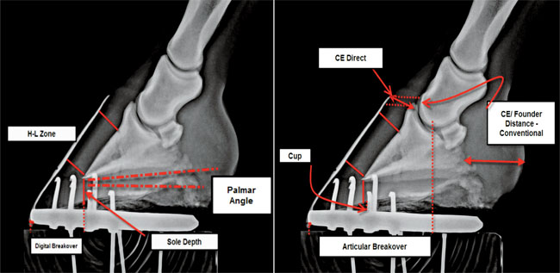

- Digital ultrasound: Ultrasound uses harmless, high-frequency sound waves that bounce back at different intensities depending on the density of the tissues they encounter. It is also an instant gratification technique, displaying results on a computer screen in real time. Ultrasound allows us to look into the soft tissues of the horse, making it the modality of choice for suspected tendon and ligament problems as well as muscle abnormalities. To get a quality image, the veterinarian must clip and properly prepare the target area and have access to a dimly lit, quiet area for this examination. Ultrasound helps vets to diagnose moderate to severe injuries in the distal limbs and stifles but is less effective in very mild or subtle type lesions.
- 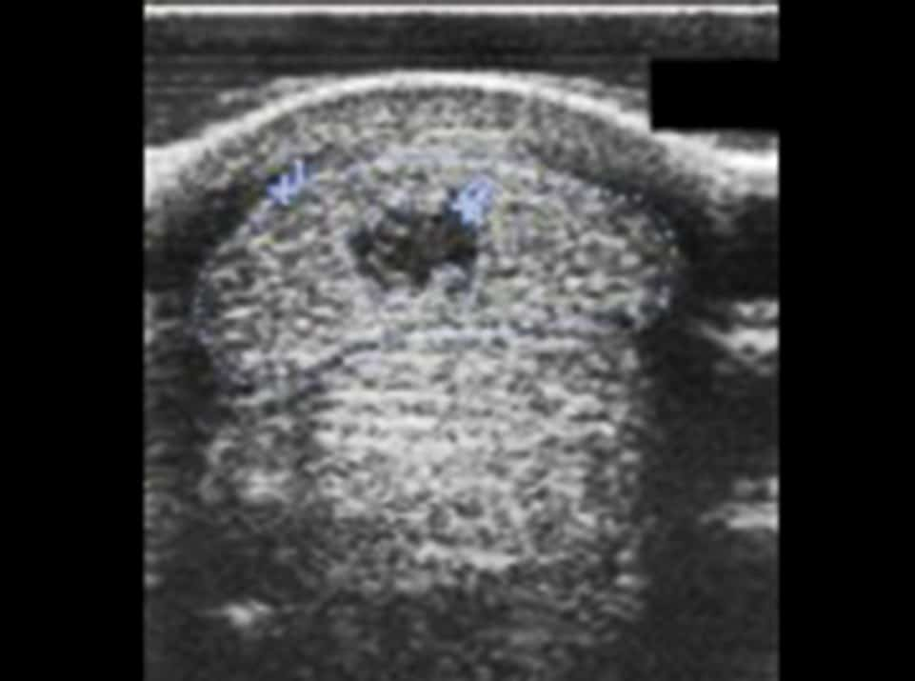

- Fluoroscopy: Fluoroscopy generally lacks the sharp detail that is achieved by high-end X ray units, but it makes up for that by providing instantaneous images that aren’t affected by slight movements by the horse.

- 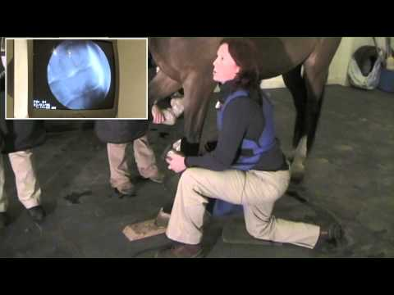

- Nuclear scintigraphy: Nuclear scintigraphy uses very small, tracer amounts of radioactive molecules to diagnose diseases involving bone, soft tissues and vessels. These molecules attach to agents that bind to bone lesions, soft tissue tumors and sites of infection. Nuclear scintigraphy is most commonly used for bone scans in horses. A radiopharmaceutical is given IV that binds to areas of exposed hydroxyapatite in the bone. Bone scans are useful for horses with multiple limb lameness, subtle lameness or lameness of the proximal limb, back or pelvis. The radioactive isotope travels to bone and abnormal uptake is detected as “hot” or “cold” spots. Uptake of the isotope helps pinpoint sites of injury or problems. This very sensitive technique can often diagnose diseases not visible with other imaging methods.
- 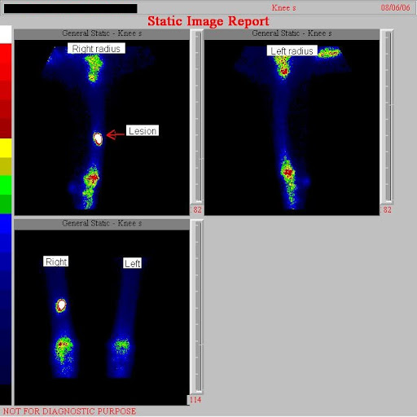

- Computed tomography: In a CT scan, a rotating, focused X ray beam takes “sliced” images of the anesthetized patient as he is advanced through a gantry which is the frame housing the unit. It allows exquisite separation of the tissues, like a loaf of bread sliced up. So, unlike a conventional X ray where everything is superimposed, a CT can reveal cross-sections one to 10 millimeters thick. One of the major advantages of CT over other types of diagnostic imaging is the superior resolution. With both magnification and three-dimensional capabilities, lesions too small or well-buried to detect with conventional radiography often jump out on the CT screen. It is an excellent way to look inside the hoof capsule, especially with the addition of some injected contrast dye. The dye ‘lights up’ the interior structures and shows up as a bright spot on the computer screen, which can generate a new image every second. CT is also most useful for fractures. In cross-section, you can see all the fracture lines and plan where you’ll need to insert screws or plates to make the repair.

- Magnetic resonance imaging: MRI uses a powerful magnetic field instead of radiation to create images, so no lead aprons are required. The black-and-white images that appear in sequence on the computer screen take only a couple of minutes each to generate, but it might take many “slices” in a 1 1/2-hour session to get a full diagnostic picture. MRI provides an infinite number of possibilities with regard to manipulating the images–they can be viewed dorsally (from the top of the horse), transversely (horizontal cross-section), sagittal (vertical cross-section), or in any other plane you desire. All of the tissues can be revealed at once–tendons, ligaments, bone. So instead of seeing just part of the anatomy, you’re getting the whole picture. Because of this, there is no question that MRI is the best imaging technique we have for foot problems. And it can also highlight bone chips or fractures that other techniques might miss.

What can be seen on a nuclear scintigraphy image specifically for horse lameness:

The technique offers the major advantage of increased sensitivity over standard radiographic imaging. Most of the pathologic changes to the horse's musculoskeletal system that might cause lameness are detected on bone scans. Many acute bone diseases can be diagnosed by scintigraphy that cannot be discerned by radiographs until the condition has become chronic. Because of their body size, these conditions may not be diagnosed at all in horses
Scintigraphy in horses offers the other major advantage of affording accurate imaging of the upper limbs, pelvis, and vertebral column without general anesthesia. Therefore, it has a final advantage of increased safety over conventional radiography. A second major benefit of scintigraphic imaging is to differentiate mixed lameness conditions in which the component of bone disease must be separated from that of soft tissues to arrive at a rational course of treatment or prognosis. Finally, for athletic horses suspected of having lameness due to localized myositis, scintigraphy not only allows confirmation of muscle inflammation but also identifies the muscle bellies injured reasonably accurately so that specific local treatment may be given. The technique is safe and comparatively inexpensive also.

- A neurologic examination
- This should be part of the workup since conditions such as Wobblers Syndrome and Equine Protozoal Myeloencephalitis (EPM), as well as trauma and other diseases can masquerade as lameness. The examination should include evaluation of cranial nerve and upper and lower motor neuron function. The back and neck should be thoroughly examined with the horse restrained and standing square on a level surface. Flexibility and extensibility of the back can be checked by alternately pinching the midline in the midthoracic and sacrococcygeal regions, whereas lateral flexion can be checked by turning the horse short around its own axis.

- Blood or synovial fluid testing-
- Samples of blood, synovial (joint) fluid, and tissue taken for examination to determine if infection from pathogens or inflammation are present. Both cytology and a bacterial culture can be done to help identify the cause.

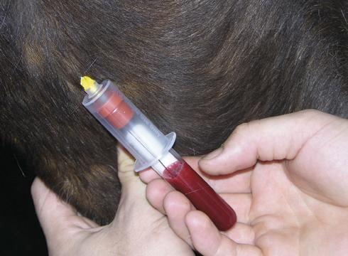

REFERENCES:

https://www.msdvetmanual.com/musculoskeletal-system/lameness-in-horses/the-lameness-examination-in-horses

https://equimed.com/health-centers/lameness/articles/diagnosing-horse-lameness-the-veterinary-process

https://aaep.org/horsehealth/understanding-lameness

https://en.wikipedia.org/wiki/Lameness_(equine)#History

https://www.msdvetmanual.com/musculoskeletal-system/lameness-in-horses/imaging-techniques-in-equine-lameness

