JOINTS
Forelimb- Shoulder Joint (Glenohumeral/Humeral Articulation)
- Between Glenoid Cavity of Scapula and Head of Humerus
- Ball and Socket- Extension, Flexion, Adduction, Abduction and Cirumduction
- Ligaments- Glenohumeral Ligamets (Supraglenoid tubercle to the tuberosity of the Humerus), Transverse Humeral Retinaculum Ligament (collagenous thickening across the bicipital tendon at the intertubercular groove)
- Bicipital Bursa between bicipital tendon and bicipital groove
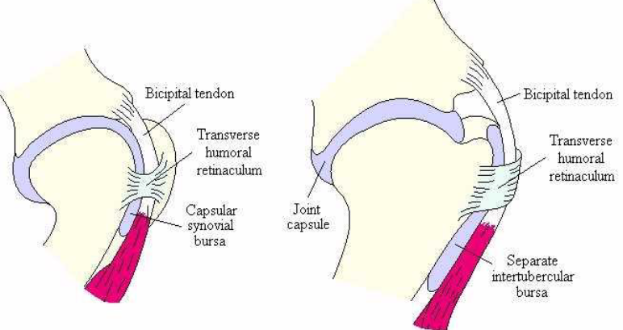
Elbow Joint (Cubital/Brachioantebrachial Articulation)
- Between the distal end of the humerus and the proximal ends of radius & ulna
- Hinge- Extension and Flexion
- Ligaments- Collateral Ligaments (Medial/Radial [Medial Humeral Condyle and Medial Radial Tuberosity] and Lateral/Ulnar Collateral Ligament [Lateral Humeral Condyle and Lateral Radial Tuberosity]
- No Bursa
- The proximal and distal radioulnar joints ossify in case of horse and ruminants

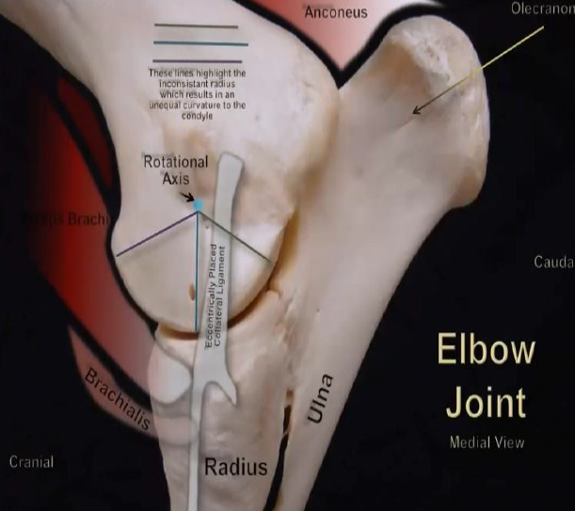
Knee Joints (Carpal Joints)
- Composite Joint (3 joints)- Radiocarpal (carpal articular surface of the radius and first row of carpal bone)
-Middle Carpal (between the proximal and distal rows)
- Carpometacarpal (between the distal row of the carpal bone and proximal surface of the metacarpal bones)
- All 3 joints act together as a Hinge Joint permitting Extension, Flexion and limited gliding
- The synovial joint capsule forms 3 sacs (Antebrachicarpal, Midcarpal and Carpometacarpal)
- Ligaments- Medial Collateral Ligament (From medial Styloid Process of the Radius to the 2nd and 3rd Metacarpal bones)
Lateral Collateral Ligament- Superficial Part (Lateral Styloid Process of the Radius to the 4th Metacarpal)
- Deep Part (Lateral Styloid Process to the Ulnar Carpal bone 4th carpal 4th metacarpal
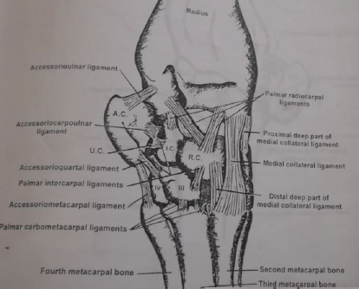
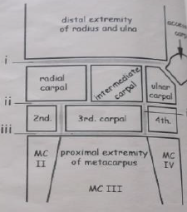
Manus Region (Similar in both limbs)
Fetlock Joint (Metacarpohalangeal Articulation)
- Distal articular surface of 3rd metacarpus/metatarsus and Proximal articular surface of the First phalanx and Proximal Sesamoid bones
- Hinge Joint- Extension and Flexion
- Ligaments- Collateral ligaments
  - Superficial- distal end of 3rd Metacarpal/Metatarsal Bone and First Phalanx
  - Deep- Between the 3rd Metacarpal/Metatarsal Bone and Abaxial Surface of Sesamoid Bones and the First Phalanx
-Sesamoid Ligaments
  - Proximal- Arises from the proximal part of the 3rd Metacarpal/Metatarsal Bone and inserts into the Abaxial Surface of the proximal Sesamoid Bones
  - Middle – Intersesamoidean Ligament (A mass of fibrocartilage in which the Sesamoid Bones are partially embedded), LATERAL and MEDIAL Collateral Sesamoidean (Arises from the abaxial surface of the corresponding sesamoid bone and insert into the 3rd Metacarpal/Metatarsal Bone and First Phalanx)
  - Distal- Superficial (Arises from sesamoid bone and inserts on fibrocartilage of 2nd Phalanx), Middle (Arises from sesamoid bones to triangular region of 1st Phalanx) , Deep (Arises from sesamoid bones, crossing each other and inserting on the proximal part of the 1st Phalanx) and Short (From sesamoid bones to the proximal end of the 1st Phalanx)
Pastern Joint (Proximal Interphalangeal Articulation)
- The articular surface of the distal end of the 1st phalanx, the articular surface of the 2nd phalanx and plate of fibrocartilage forms the joint.
- Hinge Joint- Extension and Flexion
- Ligaments – Collateral Ligaments (Lateral and Medial) from the distal end of the 1st Phalanx and proximal end of 2nd Phalanx
- Palmar Ligaments (Central, Lateral and Medial Bands) arising from the 1st Phalanx and insert on the Palmar/Plantar surface of the 2nd Phalanx

Coffin Joint (Distal Interphalangeal Articulation)
- The articular surface of the distal end of the 2nd Phalanx, proximal surface of the 3rd Phalanx and Navicular bone form the joint
- Hinge Joint- Extension and Flexion
- Ligaments-
  - Collateral Ligaments (Lateral and Medial)- short bands attach between the distal end of the 2ndphalanx and extensor process of the end of the 3rdphalanx
  - Suspensory Navicular Ligaments- attach between the distal end of the 1stphalanx and distal sesamoid bone and angle of the 3rdphalanx
  - Navicular Impar Ligament- from distal sesamoid bone to flexor surface of 3rdphalanx

