Hindlimb- Hip Joint (Coxal/Coxo-femoral Articulation)
1. Head of the femur with its fovea capitis and Acetabulum of the os coxae forms the joint.
2. Ball and Socket Joint- Flexion, Extension, Abduction, Adduction and Circumduction
3. Ligaments:
• Transverse Acetabular Ligament (A ring of fibrocartilage completing the acetabular cavity)
• Round Ligament (From the acetabular cavity to the notch on the head of the femur (fovea capitis)
• Acessory Ligament of the head of the femur (Round Ligament)- Extends from the prepubic tendon to the fovea capitis
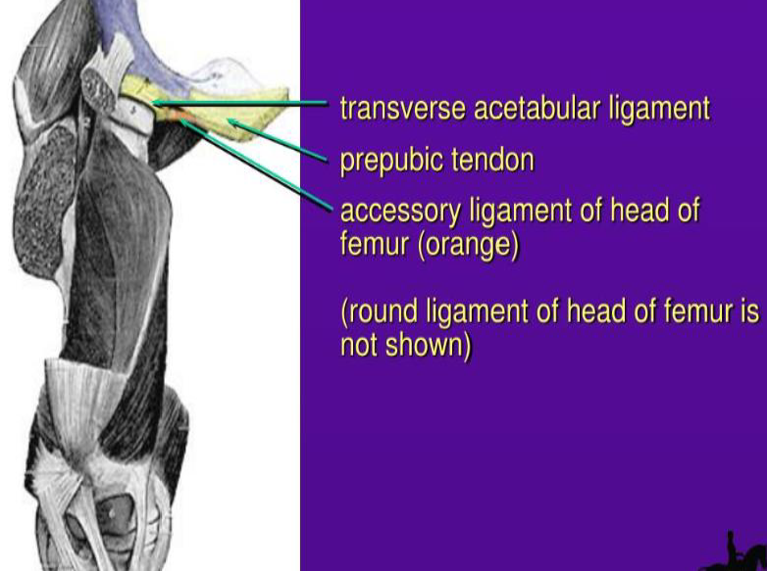
Stifle Joint (Genual Articulation)
1. Consists of two articulations which are Femoro-patellar and Femoro-tibial joints
2. Composite joint capable of Flexion and limited rotation

FEMORO-PATELLAR ARTICULATION
I. Formed between the articular surfaces of the patella and trochlea of the femur
II. Ligaments:
• Femoro-Patellar Ligaments- Lateral (From the lateral epicondyle of the femur to the lateral border of the patella)
- Medial (From medial epicondyle of the femur to para patellar fibrocartilage)
• Patellar Ligaments – Lateral Patella Ligament
- Middle Patellar Ligament
- Medial Patellar Ligament

FEMORO-TIBIAL ARTICULATION
I. Points of articulation are condyles of the distal extremity of the femur, condyles of the proximal extremity of the Tibia and Crescentic Mensci (Medial and Lateral)
II. Ligaments:
• Medial Collateral Ligament (from the medial epicondyle of the femur to a level distal to the medial condyle of the tibia)
• Lateral Collateral Ligament (from the lateral epicondyle of the femur to the head of the fibula)
• Cranial Cruciate Ligament (from the central fossa on the tibial spine tothe inter-condyloidfossa of the femur)
• Caudal Cruciate Ligament (from the popliteal notch of the tibia to the inter-condyloid fossa of the femur)
• Each Meniscus has a cranial and caudal ligament from each meniscus to the corresponding condyle of the tibia. The lateral meniscus has a third attachment (Menisco-femoral ligament).
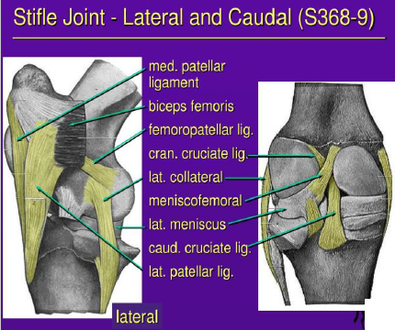

Hock Joint (Tarsal Joint)
1. It is a composite, uniaxial joint capable of flexion and extension
2. The Tarsal joint comprises of 3 joints; Tibiotarsal, Intertarsal (Proximal and Distal) and Tarsometatarsal Articulation.
• Tibiotarsal joint- Hinge joint formed by articulation of the proximal row of tarsal bones (talus and calcaneus)
• Proximal Intertarsal joint- Articulation between the proximal row and the central and fourth tarsal bones
• Distal Intertarsal joint- Articulation between the central tarsal and the 1st,2nd and 3rd tarsal bones
• Tarsometatarsal joint- Articulation between the distal row of tarsal bones and the 2nd,3rd and 4th Metatarsal bones
3. Tarsal Joint Capsule is Fibrous and Synovial with the Fibrous part on the dorsal and plantar surfaces and the Synovial part enclosing the individual tarsal joints called Synovial Sacs:
• Tibiotarsal Sac
• Proximal Intertarsal Sac
• Distal Intertarsal Sac
• Tarsometatarsal sac
The intercommunication between the different joints of the tarsus is important clinically in horses for intra-articular injections in lameness diagnosis.

Ligaments of the Hock
- Lateral Collateral Ligament- Long (From the lateral malleolus to 3rdand 4thmetatarsal bone)
-Short (From the lateral malleolus to thetalus and calcaneus)
- Medial Collateral Ligament- Long (From the medial malleolus to the 2nd and 3rd metatarsal bones.)
- Short (From the medial malleolus and divides into 2 branches on the medial surface of the talus)
- Long Plantar Ligament- Connecting the calcaneus to the 4th metatarsus.
- Dorsal tarsal ligament- From medial face of talus, to the central and 3rd tarsal bones
- Intertarsal Ligament- Numerous connective tissue bands holding the tarsal bones together
- Proximal extensor retinaculum- the transverse ligament across the distal end of the tibia holding down the tendons of the long digital extensor and cranial tibial muscles.
- Distal extensor retinaculum- the transverse loop that holds the tendon of the long digital extensor muscle.
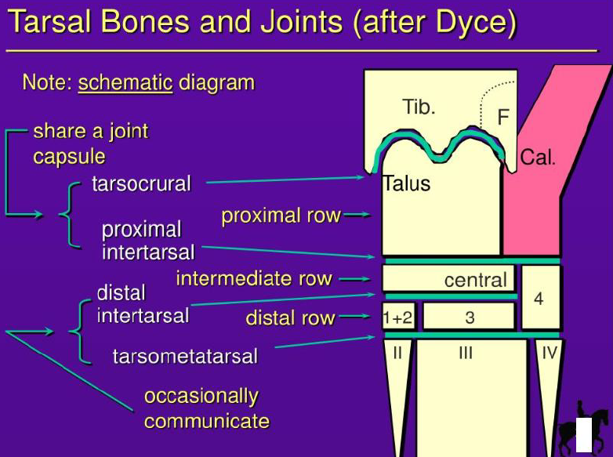

MANUS REGION IS SAME A FORELIMB
