RESTRAINT IN THE 4-MONTH-OLD KID

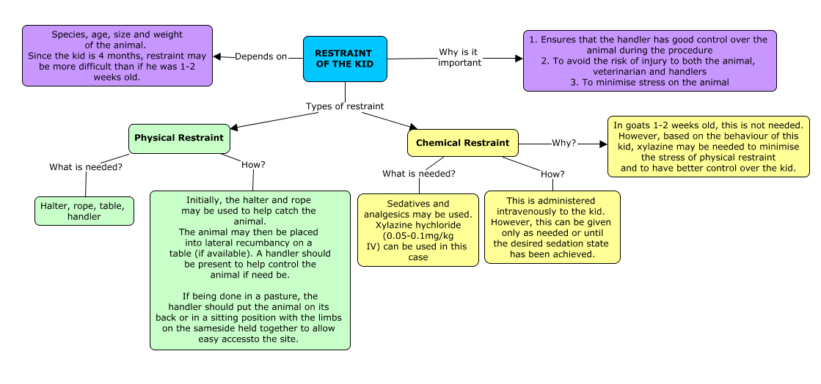

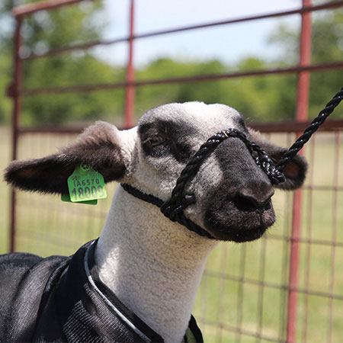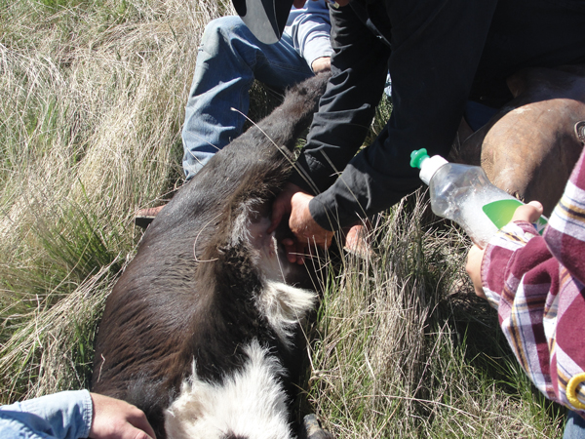
Figure 1: Halter on a goat Figure 2: Goat in lateral recumbency

