EQUIPMENT REQUIRED FOR CASTRATION

Surgical Castration
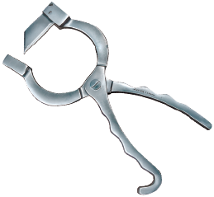 Newberry Knife

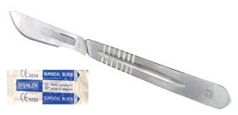 Scalpel Blade

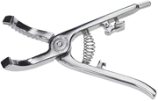 Henderson Castration Tool

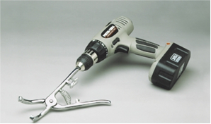 Henderson Castrating Tool with Drill

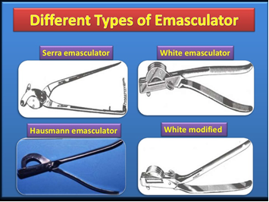

Non-Surgical Castration
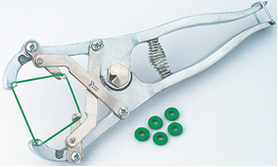 Elastrator Banding Tool
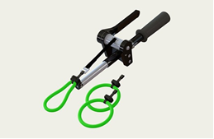 Callicrate Bander
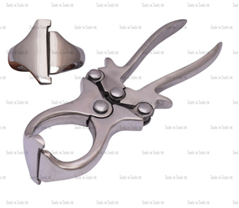 Burdizzo Emasculatome
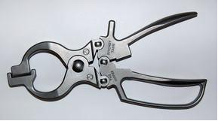 Ritchey Nipper
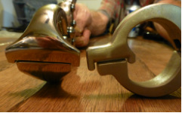 Burdizzo (Left) and Ritchey Nipper (Right)

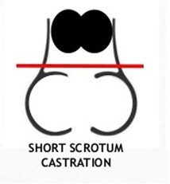
Band is placed where the Red Line is present on the scrotum, forcing the testicle to adhere to the abdominal wall. The band can be placed using an Elastrator Banding Tool.

Things common to both methods of castration
- Wash and clean your hands and surgical equipment using an antiseptic solution (eg Hibitane® or Savlon®).
- Change Antiseptic Solution regularly to ensure that equipment is always clean (for hands and instrument storage) every 15–20 castrations to stop them becoming contaminated.
- Make sure the scrotum is clean, especially for Surgical Castration. Use a mild surface disinfectant (such as iodine) to prepare the incision sites.

