INTRAOPERATION
Locate the spermatid cords in the scrotum
The scrotum should be examined for any hernias and presence of 2 testes.
The scrotum should be cleaned if there is excessive dirt to prevent contamination.
Local anaesthetic is then injected into scrotum, close to the spermatic cords on either side
2 % lidocaine is used.

Calculations:
Toxic dosage of lidocaine – 10mg/kg
Therefore, the volume of lidocaine that can be administered in a 350 kg buffalo is:
V= weight * dosage/ concentration
Volume= 350*5/20
Volume = 87.5 ml

Lidocaine is injected into the spermatic arch. The spermatic cords are then located, one testis is pushed upwards for proper placement of the burdizzo on the other.

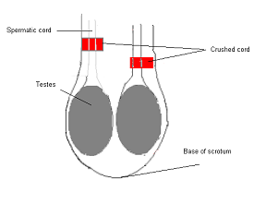The burdizzo is placed on the right spermatic cord which is pushed laterally away from the left. This is done so that only the spermatic cord is cut during this procedure. The emasculator is held so that the C- shaped side of the jaw is facing up, therefore proximally crushing, distally cutting. It should be placed about 1cm above the testis and to crush as little of the scrotum as possible. The jaws of the burdizzo is closed and squeezed for at least 5-15 seconds. It is then repeated another time on the spermatid cord (twice on one side), total of 4 squeezes. The left spermatic cord is then crushed in a similar manner. For each time, the burdizzo is used, the cuts should not be coinciding, having a staggered cut. Both spermatic cords are not cut straight across to prevent loss of blood supply and to prevent necrosis of the scrotum.

