Intra-operative Case 5
https://www.youtube.com/watch?v=vCn3V-IU61A&has_verified=1&ab_channel=KeeboVet
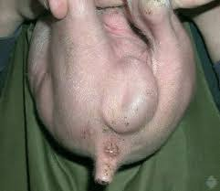
Inguinal or scrotal hernia is less difficult to fix prior to castration of the boar.
- Oblique incision is made over the inguinal ring which is affected
- Bluntly dissect subcutaneous tissue after making incision
- With external pressure on the scrotum, isolate the tunica vaginalis and pull free from scrotal attachments. The hernial sac with testicle and other contents are exposed through incision.
- This tunic and testis are twisted to force the intestines into the peritoneal cavity
- With transfixation suture, the tunics and spermatic chord are transfixed as close to the inguinal ring as possible.
- Cut the tunic and spermatic chord after which the inguinal ring in closed with interrupted or horizontal mattress suture
- Check the site for success by applying pressure on the abdomen
- Check opposite inguinal ring for bilateral herniation before castration. If there was serum accumulation from larger hernia, the incision is made more ventral to scrotum to allow drainage.
- Close skin using absorbable suture and remove other testicle through normal castration
- To remove other testicle, a 4-6cm incision is made over remaining testicle
- Inguinal fat and tissue are removed from spermatic chord after which it is twisted until level of inguinal ring
- 2 circumferential ligatures are tied around the vaginal tunic and spermatic chord
- Use an emasculator to complete castration and remove testicle
- Incision may remain open if asepsis was not maintained

