* **Third degree laceration**

Tearing through the rectovaginal septum, musculature of the rectum and vagina and the perineal body.

There can either be a rectovestibular tear where the laceration is complete and

involves the perineum and anal sphincter or a rectovestibular fistula where the perineum and anal sphincter are not involved.

**Clinical signs**

Third-degree lacerations are apparent because of the loss of normal anatomy and fecal contamination of the vestibule/vagina.

Mares make a “windsucking” sound from air movement in and out of the abnormal orifice.

**Treatment plan**

This technique is performed in two stages: in the first operation, a shelf is constructed between the rectum and vagina while the second operation involves reconstruction of the perineal body. The aim of two-stage repair is reduction of the incidence of straining and subsequent tearing of sutures. Delaying reconstruction of the perineal body avoids reduction in the size of the rectal lumen, minimizes the accumulation of feces, and reduces the number of muscular contractions necessary to void feces. Surgical treatment is started 4-6 weeks after foaling which allows for formation of granulation tissue. Immediate care tetanus prophylaxis and broad spectrum antibiotics, mineral oil via NGT for several days to soften faeces and debride devitalised wound.

Pre-op

1. Sedate the mare using a mix of xylazine HCL and ketamine and place in stocks.
2. Administer 2% lidocaine HCL epidurally.
3. Administer Phenylbutazone as an analgesic to the mare and administer tetanus toxoid and antitoxin.
4. Wrap the tail and tie in a cranial direction to avoid interference during the surgical process.
5. Remove feces manually from the rectum and vagina and scrub the perineal region with mild soap and water.
6. Cleanse the rectum and vagina with povidone-iodine solution (Betadine), and absorb excess fluid with a moistened cotton.
7. Use a pair of malleable retractors to enhance visualization of the surgical site.

Intra-op stage 1

1. Make an incision along the scar tissue at the junction of the rectal and vaginal mucosa, commencing at the cranial end of the shelf and moving caudal towards the operator.
2. Reflect the vaginal mucous membrane and submucosa central from the incision line to form a tissue flap(~2.5cm wide).
3. At the shelf, the rectum and vaginal mucosa are separated cranial(2-3cm)
4. Close the shelf by apposing the vaginal roof using no. 0 polyglyconate and the on the midline of the vaginal roof cranial to the defect.

* The knot should become the cranial and of a continuous horizontal mattress suture pattern, inverting the vaginal mucosa and forming the first layer of the repaired roof of the vagina.
* The suture pattern should penetrate the edges of the vaginal mucous membrane and should be continued caudal for one-third to one-half of the laceration. The suture is tied and is tucked into the vagina until it is needed later in the repair.

1. Commence a second row of no. 0 or no. 1 polyglyconate suture between the rectum and the vaginal wall in a purse-string pattern (interrupted sutures) passing through the rectal submucosa, perivaginal tissue, and vaginal submucosa on both sides of the common vault.
2. After the interrupted sutures are placed as far caudally as the new sutured vaginal roof, resume the continuous horizontal mattress pattern of polyglyconate and suture the vaginal mucosa in a caudal direction to the dorsal commissure of the vulva.
3. Continue the interrupted sutures to the dorsal commissure of the vulva ( keep direction horizontal to avoid narrowing of the rectal lumen)
4. Administer Procaine Penicillin for 5 days and allow 2 weeks of healing before moving to the 2nd stage of the procedure.

Stage 2

1. Surgical prep and anesthesia same as stage 1.
2. Examine the retrovestibular shelf for healing. If there is a small granulating fistula remaining, surgery is delayed until the fistula is healed. If there is a large fistula, the first stage procedure is repeated.
3. Remove newly formed epithelialized tissue. Make an incision from the cranial margin of the perineal body to extend peripherally along the scar tissue margin until the dorsal commissure of the vulva to form two sides of a triangle.
4. Make an incision on the opposite side and remove a superficial layer of epithelium to form two raw triangular surfaces.
5. Undermine the skin of the perineum and reflect it laterally to permit subsequent skin closure without tension.
6. Close deep layers of the perineal body using no. 0 or no. 1 polyglyconate simple interrupted sutures.
7. Complete closure with 2-0 polyglyconate simple interrupted sutures at the epithelial edges of the rectum.
8. Remove the dorsal portion of the vulva using Caslick’s operation for pneumovagina and close the skin of the perineum and lips of the vulva with interrupted sutures of 2-0 nylon or polyglyconate.

 Note: this procedure can also be done in one continuous process where right after stage 1, stage 2 can be done without waiting the 2 weeks.

**Post-op management**

Place the mare on a low bulk feed immediately after surgery. Use stool softners like mineral oil for at least a week. Administer Procaine Penicillin antibiotic, Flunixin meglumine analgesic for 5 days and remove non-absorbable sutures from the perineum and vulva lips 14 days after surgery. Following healing, examine and treat for endometritis if present. Avoid natural service for at least 6 months.

**Complications**

Complications include; dehiscence, abscessation and cellulitis, constipation, and fistula formation. Excessive straining results in cystitis of fecal impaction of the rectum. Excessive closure of the vulva cleft or poor perineal conformation can lead to urine pooling. Prognosis is good as mares have a 75% fertility rate. Recurrence of 3rd degree laceration at subsequent parturitions range from no injury to occurrence of another 3rd degree laceration.

**Instruments**

General surgery pack

Malleable retractors

Long-handled needle holders, thumb forceps, and scalpel handles

Polyglyconate suture

**Drugs**

Third degree perineal laceration Pre-op:

|  |  |  |  |
| --- | --- | --- | --- |
| **Drug class** | **Drug name** | **Recommended dosage and route** | **Volume of drug to be used** |
| Prophylactic drug | Tetanus toxoid and  antitoxin | 1mL IM | --------- |
| Analgesia | Phenylbutazone | 2.2mg/kg body weight IV- no more than 5 successive days of IV therapy  Conc: 200mg/ml | 4.95ml |
| Sedative | Xylazine HCl | 0.5 mg/kg IV this depends on induction protocol and what outcome is wanted  Conc: 20mg/ml | 11.25ml |
| Local anesthesia | 2% Lidocaine HCl | 1.3-2 mg/kg IV loading dose and 3 mg/kg/hr  Conc: 20mg/ml | 29.25-45ml (can be less than this) |
| Antibiotic | Procaine Penicillin | 22,000-44,000 units/kg IM every 12 hours (25,000 units used)  Conc: 1,000,000units | 11.25mls |
| Emergency drug | Yohimbine | 0.05-0.2 mg/kg Administered IM or slowly IV  Conc: 10mg/ml | 2.25ml-9ml |

Third degree perineal laceration Post-op:

|  |  |  |  |
| --- | --- | --- | --- |
| **Drug class** | **Drug name** | **Recommended dosage and route** | **Volume of drug to be used** |
| Analgesia | Flunixin meglumine | 1.1mg/kg IV or IM once daily up to 5 days  Conc: 50mg/ml | 9.9ml |
| Antibiotics | Procaine penicillin | 22,000-44,000 units/kg IM every 12 hours  (25,000 units used)  Conc: 1,000,000 units | 11.25ml |

VIDEO:

<https://youtu.be/T4DsKcHs0v4>

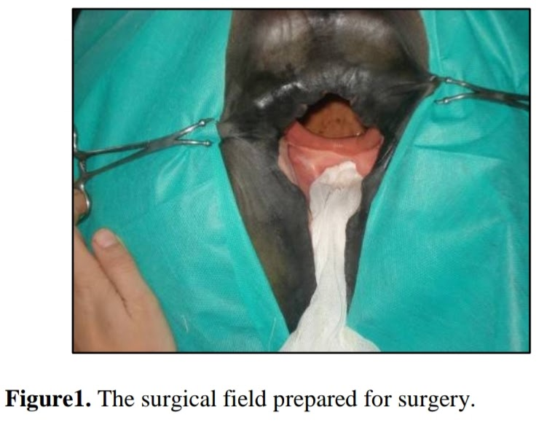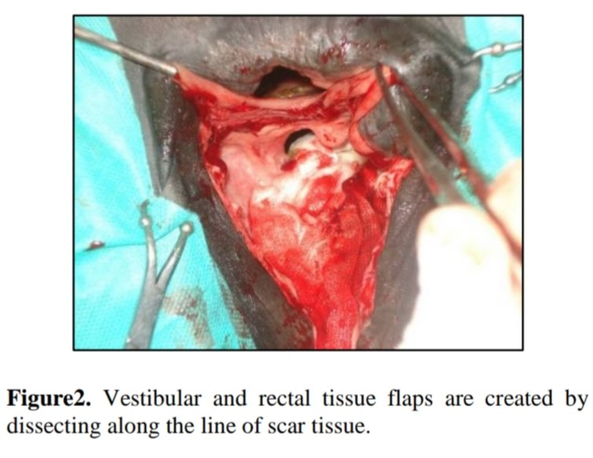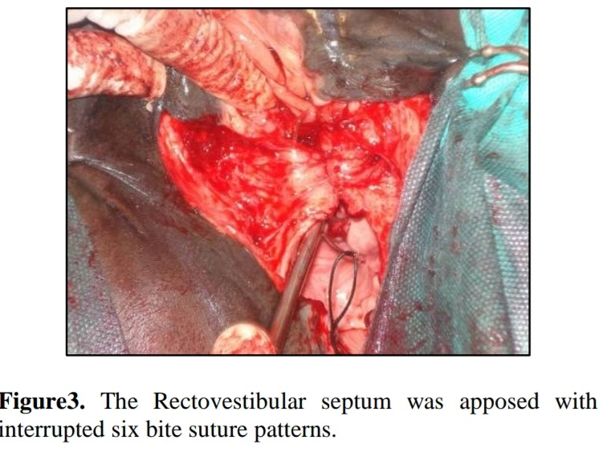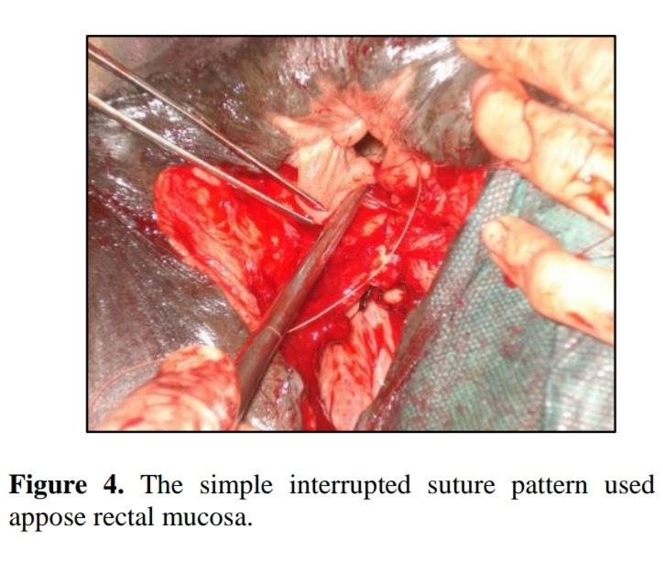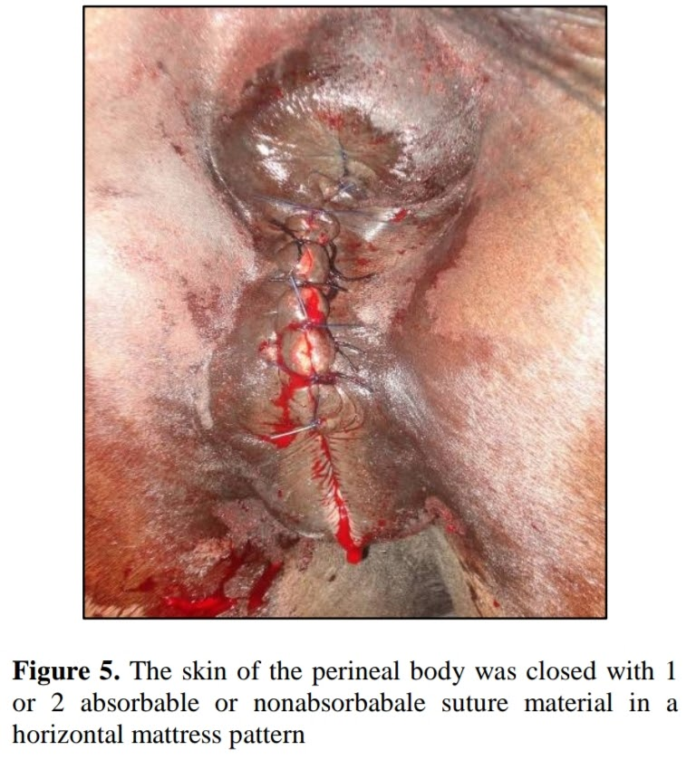

References;

1. Iranian Journal of Veterinary Surgery
2. Turner and McIlwraith's Techniques in large Animal Surgery