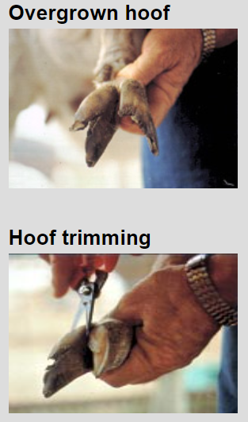

OVERGROWN VS.
NORMAL HOOF

