Female Equine Reproductive Anatomy

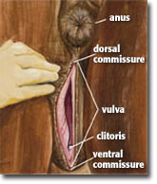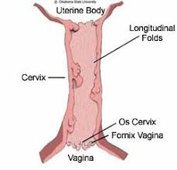
- The vestibule is the common opening of the urethra and the vagina, and it opens up to the vulva.
- The vulva is directly below the anus, and due to the conformation of some horses, faecal matter can accumulate on the vulva.
- In older mares, the vulva can be opened to the point where the cervix is visible.
- The vestibule and vulva are innervated by the pudendal and caudal rectal nerves, which are derived from the third and fourth sacral nerves.
- Meanwhile the ovaries, oviduct, uterus and vagina are innervated by the renal, aortic, uterine and pelvic plexuses.

