Equipment used in Equine Castration

Equipment | Indication for Use | Procedure
Emasculator- Reimer and Serra  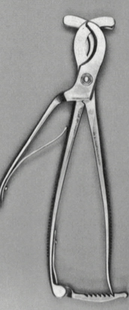 Reimer  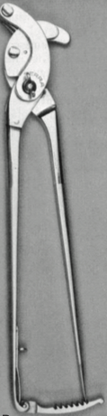 Serra | Reimer- severs the cord with a blade on a separate handle so that the cord is not accidentally cut before it is satisfactorily crushed.  Serra- It draws the cord concentrically into the jaws, thus preventing slipping of the cord, as the jaws are closed on the spermatic cord it is gripped by the clamping part. Ratchets holds emasculator locked. | Crushes the spermatic cord to control hemorrhage.  The crushing side should be as close to the body wall (nut-to-nut)as possible for successful use.
Sands emasculator  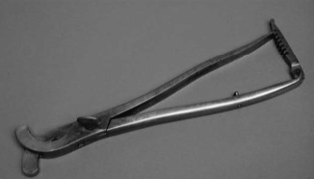 | It is similar to the Reimer emasculator but has no cutting blade. The spermatic cord must be severed distal to the emasculator with a scissors or a scalpel blade.
Henderson castration device  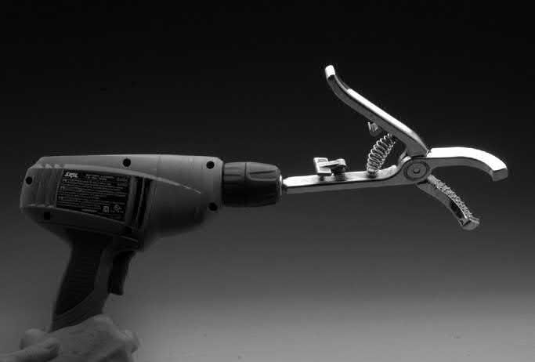 | Use of a drill to twist the spermatic cord which allows the blood vessels to be occluded leading to good hemostasis. | One handle of this pliers- like instrument is attached to a 12-W or greater variable-speed drill (slippage is likely to occur with a less powerful drill) with a 38 -in or larger chuck. With one hand holding the testis, the instrument is clamped across the entire cord, just proximal to the testis. With slight tension on the drill and with the instrument held parallel to the cord, the testis is rotated slowly for about five turns. The speed of the rotations is gradually increased while keeping slight tension on the cord. After 20 to 25 rotations, the cord separates about 8 to 10 cm proximal to the instrument. The twisting of the cord effectively seals the severed vessels.
Scalpel (#20)  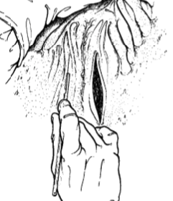 | Done through surgical scrotal incision- should be sufficiently long to provide adequate postoperative drainage | Used for surgical castration and allows for the most certain procedure because of complete removal of the testicles.
General surgery pack
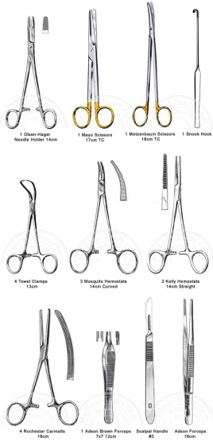

#1 or #2 Polyglyconate suture and long handled needle holder
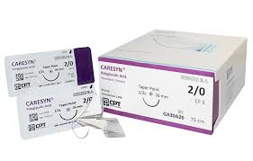
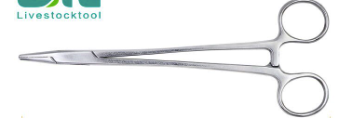

Other Equipment used:
- Halter
- Rope
- Betadine- antiseptic solution
- Alcohol swabs
- Syringes
- Needles- 20g, 1 inch
- Sterile gloves
- Sterile gauze

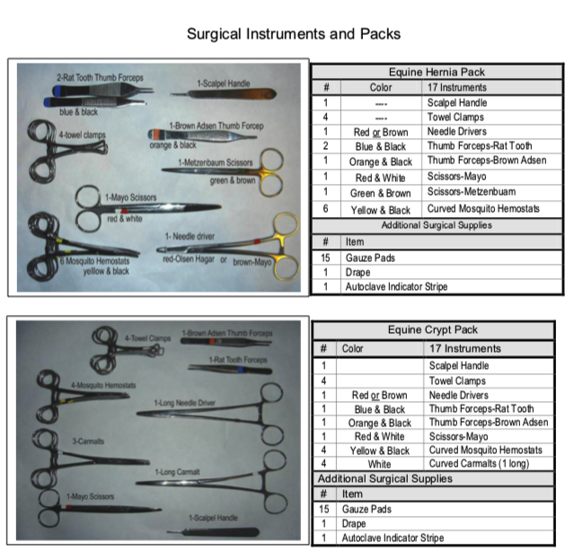

REFERENCES:
Sisson S, Grossman JD. The Anatomy of the Domestic Animals. 4th ed. Philadelphia: Saunders; 1953:581–605.
2. SchummerA,NickelR,SackWO.TheVisceraoftheDomesticMammals. 2nd ed. Berlin: Paul Parey; 1979:304–350.
3. de Lahunta A, Habel RE. Applied Veterinary Anatomy. Philadelphia: Saunders; 1986:287–297.
4. Habel RE. Applied Veterinary Anatomy. 2nd ed. Ithaca, NY: Self- published; 1981:278–289.

