Pre-Operation Considerations For Septic Arthritis

Restraint
Standing animals:
- Standard restraint in a crush and till limb is lifted using ropes or a pulley system and restrained using ropes by tying it to the side of the crush.
Recumbent animal:
- The animal is given a general anesthetic or the procedure is carried out in an animal that is under heavy sedation and has been cast.

For septic arthritis of the coffin joint, the most common surgical procedure done is distal digit amputation. This process can be done with the animal standing in a trimming chute but is easier to do when the animal is in lateral recumbency. To prepare the animal for surgery, the following steps can be followed;
- Sedate the cow using xylazine 0.03-0.1 mg/kg IV
- Surgically prepare the distal limb by shaving the hair around the surgical site.
- Aseptically wash the surgical site using chlorhexidine.
- Administer the local anesthetic 2% HCL lidocaine at 0.2 to 0.4 mg/kg under tourniquet at the 4-point digital block.

Instruments
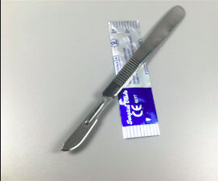

- Gigli Wire
- Scalpel
- Gauze
- Adhesive bandage
- Syringes
- Needles
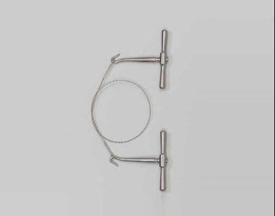

Drugs
500 kg cow
Drug class | Drug name | Recommended Dosage and route | Volume of drug to be used
Sedative | Xylazine | 0.03 to 0.1 mg/kg IV/ 0.02 to 0.5 mg/kg IM. Conc. 100mg/ml. | 0.75ml to 2.5ml IV or 0.5ml to 12.5 ml IM.
Local anesthetic | 2% HCL Lidocaine | 0.2 to 0.4 mg/kg | 5ml to 10ml
Analgesic | Flunixin meglumine | 1.1-2.2 mg/kg IV, IM once daily up to 5 days. Conc. 50mg/ml | 11ml to 22ml
Prophylactic drug | Tetanus toxoid and antitoxin | 1ml IM | 1ml
Emergency drug | Yohimbine | 0.1 to 0.2 mg/kg IV. Conc. 10mg/ml | 5ml to 10ml IV

Sample calculation of xylazine
Max dose: recommended dose x weight = 0.1mg/kg x 500kg= 50mg
Xylazine concentration= 20mg/ml
Total volume = max dose/concentration= 50mg ÷ 20mg/ml = 2.5ml

Sample calculation of 2% HCL lidocaine
Max dose: recommended dose x weight = 0.2mg/kg x 500kg = 100mg
Lidocaine concentration: % = g/100mL. 2% solution = 2g/ 100mL.
2g~2000mg 》2000mg/100ml = 20mg/ml.
Total volume = max dose/conc. = 100mg ÷ 20mg/ml = 5ml

