RESTRAINT

Physical restraint

Halter-
A halter is placed on the animal. A lead is attached and wrapped around a bar twice to prevent damage to the person handling the animals and a quick release knot is place so that in case there is a problem and the animal is needed to be released from the restraint quickly it can become unlossen fast.
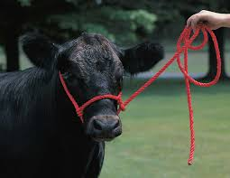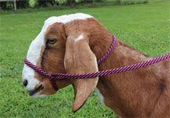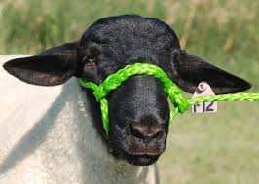

BOVINE

Nose Tong, Bull dogs- These are used to distract the cow from what the vet is doing.
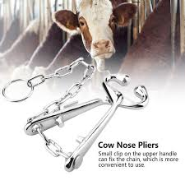

Tail jack- This is where the tail is lifted this makes it difficult for the cow to kick or move.
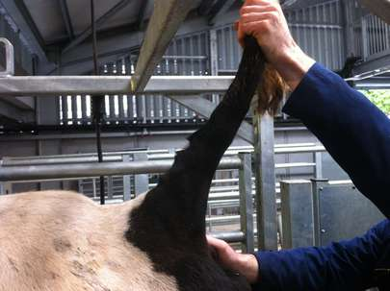

The leg can be manually lifted without the use of ropes by pinching the dewclaw, the cow will automatically raise its leg.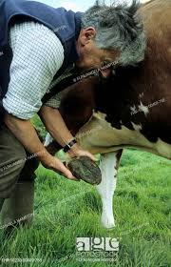

Crush- It prevents the animal from moving, thereby decreasing the risk of injury to the animal and the personnel. There are special crushes that allow for the assessment of hooves.
>SA0026 (M+E) KLAUWBEKAPBOX
The SA0026 hoof trimming crush the cow is able to walk into the crush and the hoof is elevated manually In addition, a patented back bar system rests on the back of the hindlimb this ensures that increased back leg fixation is done and maintained. This system also allows for two legs to be worked on at the same time as there is a strap placed in the thoracic area.
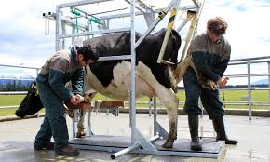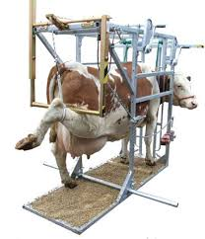

Rope and pulley system

Ropes are held by assistant instead of tying because incase the cow starts to go down the rope can be easily released to prevent injury to the animal and the vet.

HINDLIMB-
The pulley system is attached above and behind the cow or bull, loop above the hook around the leg , pull the foot up with the second rope attached above the dew claw and pass the rope above the bar couple of time and make sure and no not tie the free end. Let the assistant hold that in place. Another way this method can be done is to loop around the leg, over the hock tie it to a bar over head, use the free end and tie the dew claw to the bar of the crush behind the cow.

https://www.youtube.com/watch?v=MgxGSBEVYWY

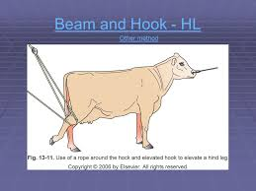

FORELIMB-
A pulley is attached onto the side bar close to the shoulder of the animal, the loop is attached to the leg, which is then pulled up. Another rope is attacked to the leg and pulled firmly to adjust the position of the leg. The assistant will hold this rope. Other method can be done without the use of a pulley. A rope is lopped around the leg above the fetlock with the use of a quick release slip knot. The free end of the rope is then passed under the bar round the leg and over the bar. Tie the rope to the bar.

In the picture Below shows the rope is tied around the pastern. The free end is pass over the withers at the other end and the assistant holds the rope in place.

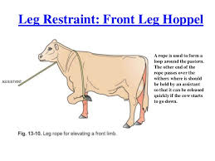

https://www.youtube.com/watch?v=CHYYiuBJo-o

CAPRINE

RUMPING- the animal forelimbs are held up so that they are on their hindlimbs, the restrainter uses one of their legs and with a sweeping motion putting the animal off balance causing them to go onto their rump. The restrainter supports the the back of the animal on their legs while the other technicians are able to assess the hooves.
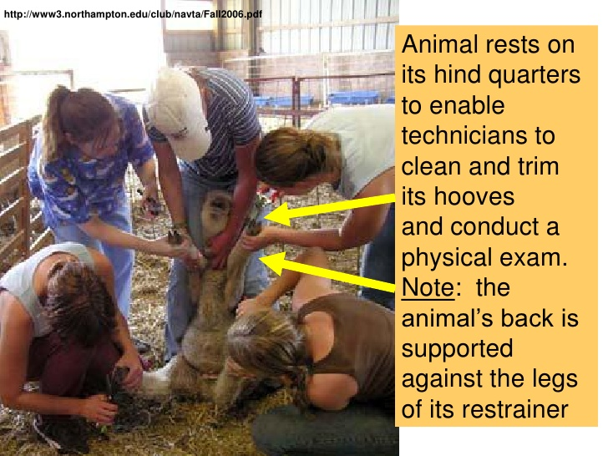

LATERAL RECUMBENCY- Hooves are assessed in lateral recumbency. It is recommended that 2 individuals are required to do this, one holding the head so that when the goat is going down they dont hit their head and the second to perform the method. This method involves the person standing on the side that the animal will be recumbent like if its right lateral recumbency then the person will stand to the right of the animal same as if it was left lateral recumbency and the opposite side of the side that will facing up, meaning if the person is on the right when the animal is in right lateral recumbency the left side is what will be visible. The person stands on the right of the animal bends over to the left side slides their hand between the legs on the left side and grasp the legs on the right (closest to him) and pull away from them so that the animal falls with its body on the restrainter and slides down to the ground while the other personeel holds its head. The restrainter then puts their feet on the goat restraining the goat so that the technicians can do their work.

