Rumenotomy
- After the cow is prepped, blocked and draped, a large window is cut in the drape. This window should be as large as possible so that it is not in your way.
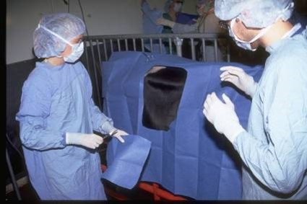
- A vertical incision is made, typically in the center of the paralumbar fossa, starting at least 10 cm below the transverse processes and extending about 20 cm.

Note:
- If the space is too little then make the incision longer since the incision heals side to side, not end to end.
- If it is too high the kidneys can be seen.
- Making the incision lower makes access to the abomasum much easier especially for persons with shorter arms.
- Remember to keep your blade on the skin, using your non-dominant hand to spread the incision edges to see how deep you are.
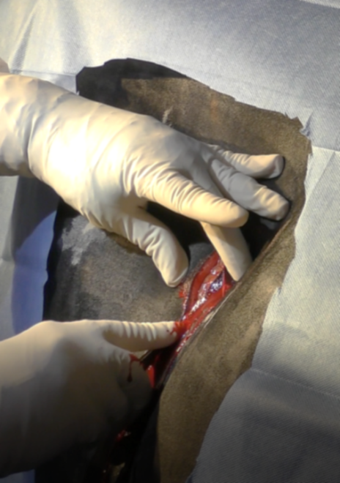

- Incise through the external abdominal oblique muscle.

Note: To safely and quickly cut through each muscle layer:
- First determine how thick a muscle is by starting with a 3 cm incision at the top, shaving (cutting in thin layers in the same area) until you reach the white fascia layer.
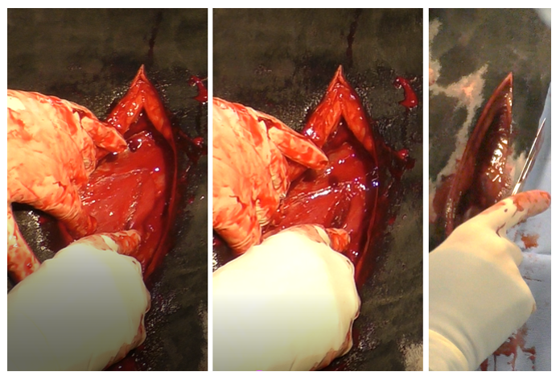
- Once the fascia is seen (slide a finger between the muscles), slide a set of long thumb forceps under the external abdominal oblique and above the fascia (it should go easily). Slide them down as far as possible and turn these so the tongs are flat, creating a “groove director” between them.
- Use the center of the forceps as a “groove director” and as a guide for your incision. If the cow moves, the thumb forceps will help protect the deeper layers from accidental incision and enable you to incise without worry as long as you keep your blade flat.
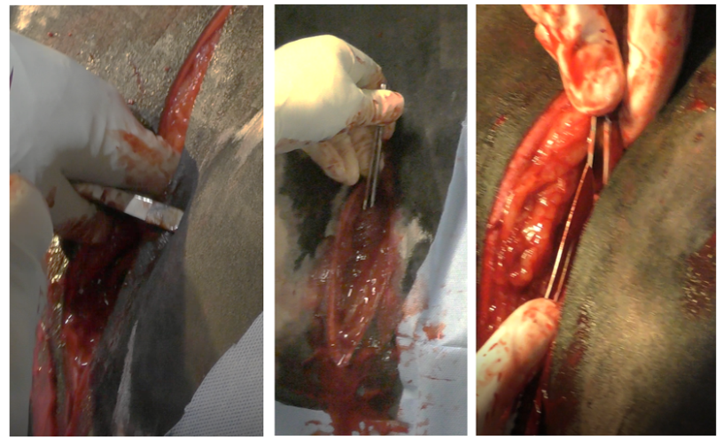
- Incise the internal abdominal oblique (thinner muscle) using the same technique.

- Tent the transversus abdominus muscle and cut with scissors or with the blade turned so the cutting edge is facing the surgeon. This is to ensure it is not cut too deeply.

- Incise the peritoneum, listening to see if air rushes in. Extend the peritoneal opening to allow easy palpation with one arm.

- Perform thorough exploration. Place a sterile sleeve on arm.

Note: If it is large for your hand, add a sterile glove over the top to improve your palpation skills.

- Exploration should be done from clean to potentially (or known) contaminated regions. In cattle, the riskiest areas are by the reticulum (hardware disease), liver (abscesses) and abomasum (perforated ulcers).

Note:
- All of these are cranioventral; start caudodorsal and to the left, followed by caudoventral, craniodorsal and finally, cranioventral.
- Adhesions should NOT be broken down. They are usually attempting to wall something off.

- The rumen is tacked to the body wall to hold it in position. This will minimize the work needed to hold it up and decrease the risk of peritoneal contamination.
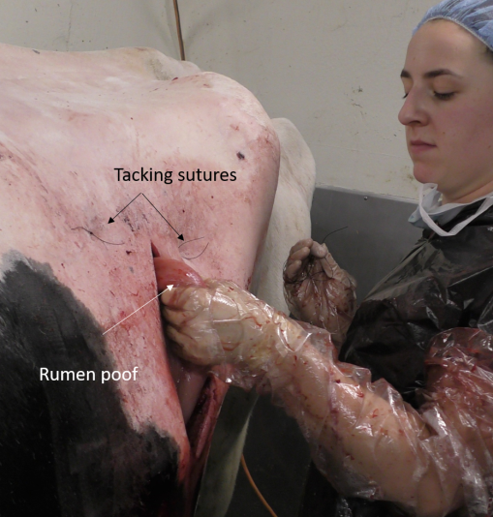

- Insert the needle (attached to #2 suture) through the skin away from the incision into the abdominal cavity.

- Grab a large bite of rumen away from the proposed rumen incision.

- Drive the needle back through the skin near the original insertion and tie.

- Repeat until the rumen is held in position by the tacking sutures.

- Create a water tight seal through inverting suture pattern since it is most effective. (Other methods are discussed in second document).

- Secure the rumen to the skin using a continuous Cushing pattern of 2 suture on a cutting needle. When completed accurately, no suture should be visible.

- Gaps should be closed with a mattress suture, especially at the ventral aspect.

Note: The rumen would be ballooning out a little but not too much since this would lead to poor matching with the skin and lead to more gaps.
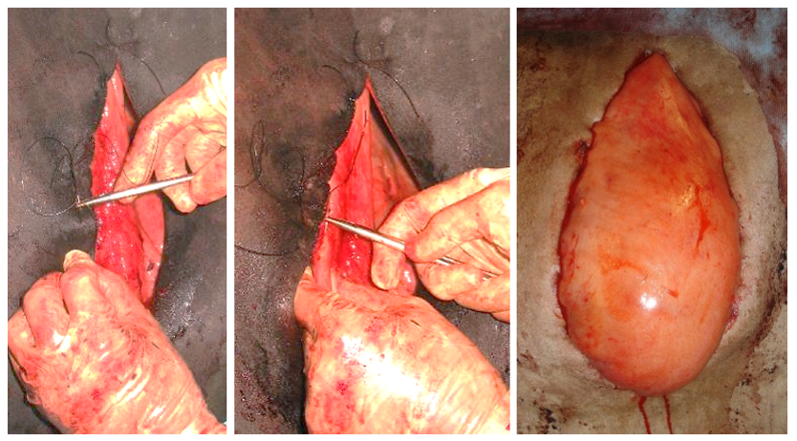

- To minimize contamination, separate rumenotomy instruments (scalpel, saline, gauzes, needle holders, suture and scissors) from closure instruments. Cover closure instruments to keep sterile and move them away from the area.

- Incise the rumen.

- A wound protector as shown in the image below can be used to minimize trauma to the rumen surface or the rumen can be tacked open or even temporarily sutured open to minimize exposure to the serosal surface.

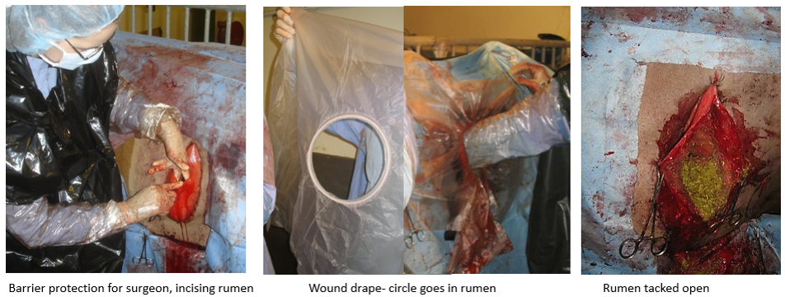

- The rumen can now be evacuated at this point.

Note:
- Remove all ingesta present.
- A tube can be used to siphon out liquid contents.

- The reticulum, oesophageal opening and omasal opening can be explored at this point.

Note: Can check for:
- Foreign bodies
- Abscesses

- Rumen transfaunation (transfer of rumen fluid and associated microorganisms, including protozoa, bacteria and fungi, from a healthy donor cow) should be done at this point.

- At this point the rumen can be closed.

- The rumen drapes or shields can be removed and the rumen surface is cleaned.

- The rumenotomy incision is closed in two layers.

- The first layer is closed with #2 chromic catgut suture materials in a Lembert pattern.

- After the first layer is closed, the rumen surface is cleaned. Surgeon’s gown and gloves are changed and clean instruments are used.

- The first layer is now over sewn with a Cushing pattern using #2 chromic catgut suture materials.

- The rumen is now lavaged and fixation sutures are slowly removed releasing rumen into the abdomen.

- The peritoneum and muscle layers can be closed using absorbable suture material using a continuous pattern.

- Two layer muscle closure can be done using #3 chromatic gut suture materials.

Note:
- Peritoneum and transverse abdominus
- Internal and external abdominal oblique muscles

- High levels of air in the abdomen can lead to pain so the cows are often “burped” during closure. Start the closure at the ventral aspect of the muscle layers. As you reach the top, preplace the final sutures and the first throw but do not tighten. Push in on the cow’s flank to push the gas out. With the flank still shoved in, tighten the last throw and then tie.

- The skin is closed with a Ford Interlocking pattern using non-absorbable suture in size 3 or 5. It can be finish with an Aberdeen knot.

Tip: Suture with needle perpendicular to the skin so it would go in easier.

- A cruciate or simple interrupted suture is often placed at the ventral aspect. This can be removed to allow drainage if needed.

