PHYSICAL EXAMINATION IN RUMINANTS

Why is a physical examination important?

This is crucial to assess the overall health status of the animal and detect any abnormalities or underlying conditions. Its clinical findings contribute significantly to the diagnosis and treatment regimes for the animal.

What must be done before the physical examination?

Before conducting a physical examination, it is crucial to obtain the signalment and history of the animal.

- Signalment - This includes a complete description of the animal; species, breed, sex, age. Other distinguishing factors such as weight and colour may also be included.
- History - This is an important step. This part involves obtaining a very detailed description of the animal’s diet, environment and living conditions, medical and reproductive history and vaccination status. This will assess if external factors are influencing the animal’s condition as well as to detect abnormal behaviour.

Steps included in the Physical Examination
Before attempting the “hands-on” physical examination, a distance examination should be executed. This is where the general appearance and initial observations are noted. The following assessments are made during the distance examination:
- Assess the demeanor; bright, alert and responsive
- Evaluate the hair coat
- Assess the symmetry of the animal; evaluate body conformation and abdominal contours
- Observe any abnormal discharges (from vulval, nose, eyes, mouth etc)
- Evaluate the body condition score which will later be confirmed in the physical examination
- Observe for ectoparasites or if the animal is itching
- Take the resting respiratory rate

The physical examination of a ruminant is conducted by a 5 station approach. This is explained in the table below.

STATION 1: Back or Rear  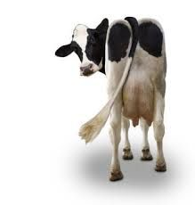 | - Take the coccygeal pulse from coccygeal artery and assess anal tone  - Take a urine sample for further investigation  - Check the vulva and mucous membranes (should be pink)  - Assess the skin and hair around the perineal area; no evidence of hair loss, vulval discharge, diarrhea or ectoparasites  - Assess the final body score condition at this station  - Take the rectal temperature
STATION 2: Left side  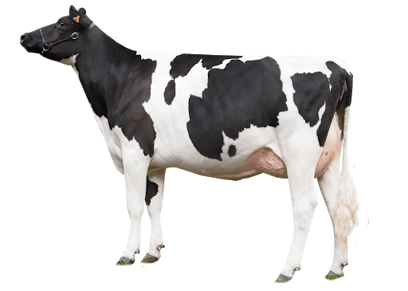 | - This encompasses most of the systems.  - Palpate (deep and superficial) the hind limb  - Assess the rumen using 5 modalities; palpation, auscultation, percussion and auscultation, succussion and ballotment- This gives you an idea of the nature of ruminal contents and ruminal contractions  - Palpate the thorax and assess for rib fractures  - Assess the lung field- elbow to caudal point of scapula to 11th rib- Listen throughout this region to assess sounds  - Assess the forelimb and ensure there are no abnormalities  - Assess the scapula to ensure no pain and swelling  - Withers test to assess for pain  - Listen to the heart and measure rate, strength and character
STATION 3: Head and neck  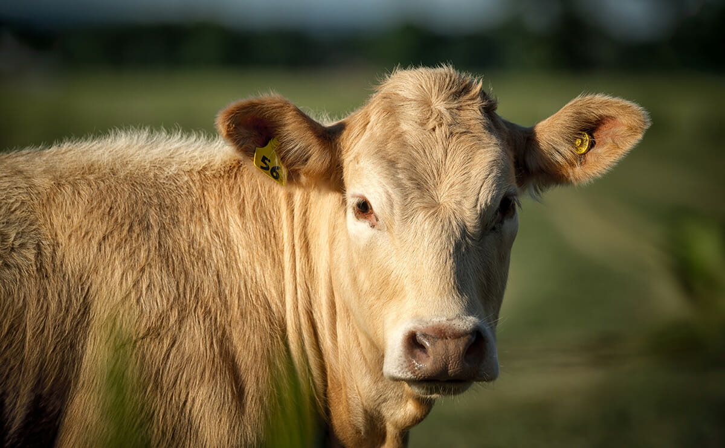 | - The symmetry and shape of the head is evaluated; ensure no masses, lumps or bumps are present. Is she naturally polled or dehorned?  - Ears; ensure there is no unusual discharges, scents or parasites  - Eyes; ensure the eyes are moist with no excessive discharges, ulcers. Assess the third eyelid.  - Nose; percuss the paranasal sinuses  - Muzzle; ensure it is moist with no excessive discharges  - Mouth; palpate the tongue and assess the teeth. Ensure there are no ulcers or abscesses.  - Lymph nodes; carotid, submandibular and retropharyngeal lymph nodes. These are normally non-palpable.  - Palpate the trachea and ensure the animal does not cough  - Palpate the neck and ensure there are no masses.  - Check neck for hydration status  - Take the jugular pulse  - Assess the dewlap and brisket and ensure there is no swellings
STATION 4: Right side  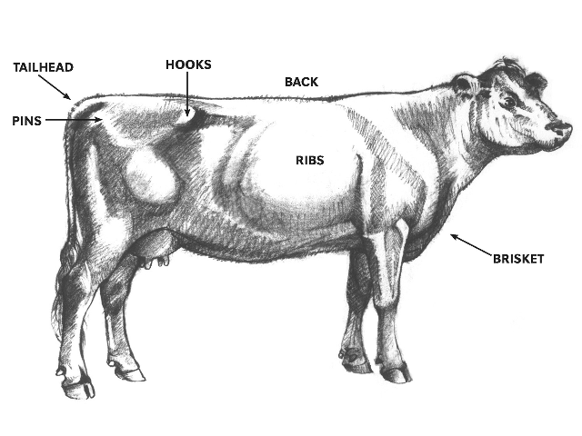 | - This is similar to the left side  - Assess the prescapular lymph node and forelimb  - Assess the right lung field which is bigger than the left because the rumen is not present on this side  - Palpate the right paralumbar fossa  - Listen to intestinal sounds  - Deep palpation, ballottement, auscultation and percussion  - Assess the liver (if enlarged)  - Assess the prefemoral lymph node  - Assess the hindlimb
STATION 5: The ventrum  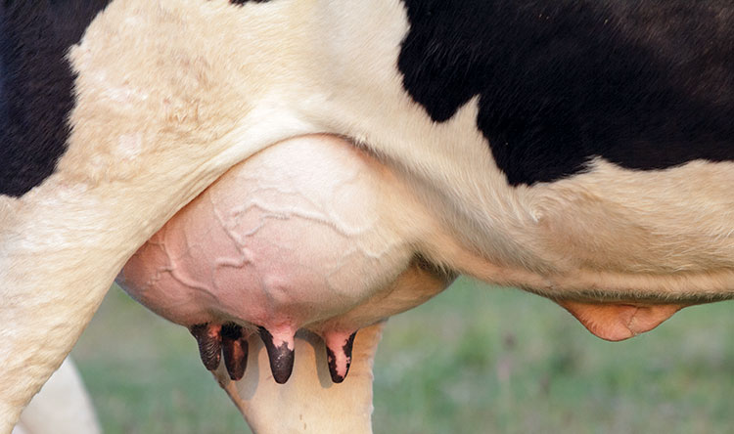 | - Ensure there is no swellings, wounds or lacerations  - Inspect each quarter of the udder- palpate, check the orifices and teats  - Inspect the skin of the udder and the thigh  - Assess for mastitis by taking a milk sample  - After inspecting the udder, inspect the supramammary lymph nodes. Ensure there are no swellings.  - Rectal examination

