Reasons for surgical options for teat and udder surgery

The teats and udder are vulnerable to external trauma or injury due to their anatomical location, increase in size of udder and teats during lactation, faulty methods of milking, repeated trauma to the teat mucosa, injury by teeth of calf, unintentionally stepped on teat, paralysis resulting from metabolic disturbances at parturition.
Condition of udder and teats not only causes painful milking but also makes udder and teats prone to mastitis. The diseases of udder can be classified as:
- Congenital anomalies, they are known at the time of first calving
- Acquired anomalies, they can affect at any stage of lactation.
Congenital and acquired surgical conditions of udder and teats can be subdivided into three main categories:
- Conditions of epithelial surface of udder and teats.

- Supernumerary or extra teats
These teats are often seen on the posterior surface of udder and in-between the teat. They may be functional or non-functional, functional activity can be determined only after parturition of the animal. They frequently interfere with free milking process and are objectionable on show animals. It has been reported that presence of supernumerary teats has no significant effect on milk yield, lactation length, age at calving, conception rate and service period. Surgical removals of these teats are best in young animals and in case of older cow in dry condition.
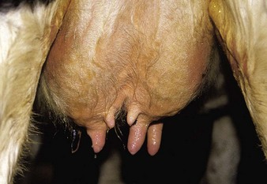

- Bovine ulcerative mammitis (sore teats)
Due to the presence of crakes, traumatic injuries, lesions due to disease conditions such as pox, FMD etc. If these lesions are not treated well in time, the animal will not allow touching of the affected teat for milking. The milk can be classed as unfit for human consumption due to the oozing of blood from injured teat causes contamination of milk while milking. In such cases, sterilized teat siphon should be used to drain the milk out. For treatment of such painful lesions, the wound should be washed with light potassium permanganate solution and then soothing preparation such as iodized glycerin, bismuth iodoform paraffin paste, zinc oxide ointment or antiseptic dressing with soothing emollient may be continued till the complete healing of the lesion occurs.
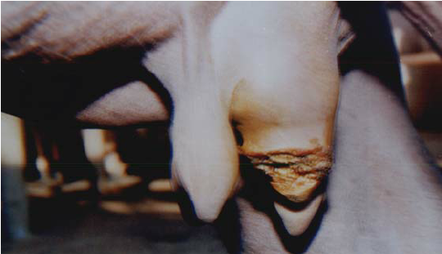

- Udder and teat abscess
Abscess formation occurs more often on the udder than the teat. Many cases with chronic mastitis especially due to resistant microbes suddenly develop abscessation on side of affected udder. This can easily be diagnosed by puncturing the swollen part. The abscess cavity is opened for complete drainage of pus. After drainage of the pus, the cavity can be dressed in a tincture iodine followed by application of soothing agents until obliteration of abscess cavity. In case of necrosis of teat or udder, amputation of teat or affected quarter is recommended followed by daily dressing till complete healing of wound occurs.

Gangrenous Mastitis – is an acute/ per acute condition that involves one or more quarters of the cow’s udder. Ligation of the mammary vessels results in systemic absorption of the toxins produced in the gangrenous tissue mass and can lead to sloughing of the affected tissues.

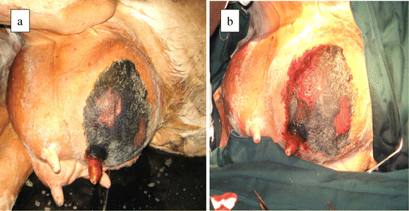

- Teat laceration and fistulae
The condition is mostly observed in those animals that have long teats and pendulous udder. When animal tries to hurdle over pointed or sharp thorny areas their teat gets teared due to laceration of skin and muscles. This condition is called as teat fistula. This condition is considered an emergency due to the delay in the repair of such teat will cause development of mastitis or necrosis of the teat. For repair of such teat, all aseptic precautions should be taken into considerations. A full coverage of systematic antibiotic is required and for proper drainage Larson’s teat plug is used.

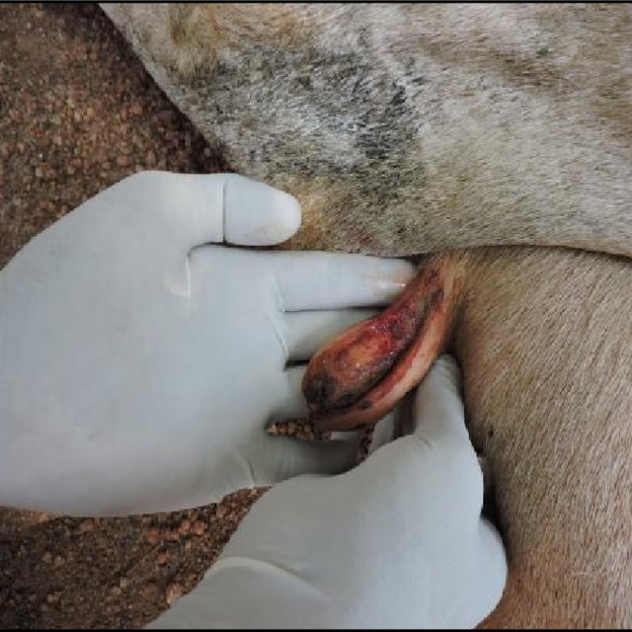

- Conditions of glands and tea cistern or canal.

- Lactolith (milk stone)
Milk stone are formed into the teat canal when the milk is rich in minerals and salty in taste due to super saturation of salts. The stone moves freely in teat canal and hinder the milk flow, when large in size. They usually get washed out along with milk but if large in size then it can be crushed with the use of a small forceps or cutting the sphincter with Litchy teat knife or teat bistouries and milked out.

- Teat canal polyp
These are small pea sized growths attached to the wall of teat canal. The polyps hinder the milking process and sometimes even block the passage of teat canal. Teat polyps can be easily taken out by Hug’s teat tumour extractor. If its location is above the teat canal a the lotomy is the best method for resection of excessive tissue.
- Teat spider
This condition is usually due to congenital absence of teat cistern or canal. It can be acquired in cases of injury, tumour or inflammation of mammary tissue resulting in formation of thin or thick membrane, situated either at the base or middle of the teat. This membranous obstruction can be removed by teat scissor, Hug’s teat tumour extractor, teat bistouries or Hudson spiral teat instrument.
- Fibrosis of teat canal
A condition commonly observed in most of the lactating animals where a hard-fibrous cord like structure is observed in the teat. The cause of this condition is not clear. However, repeated trauma due to mechanical injuries, thumb milking and calf suckling are the main contributory factors. Sometimes mastitis can also result into fibrosis of quarter followed by teat canal. This fibrotic cord will obstruct the teat canal and will create hindrance during milking. The use of hot water followed by counter irritant massage such as iodine ointment and turpentine liniment massage. It is advisable to place polythene catheter after removal of fibroid mass by Hugs teat tumour extractor.

- Tumour of mammary gland
Not commonly seen in lactating animals however, fibro adenoma reported in heifer. The growth can be surgically removed under caudal block or local infiltration analgesia.
- Membranous shelf between teat and gland
A teat cannula can be passed the length of the teat. The goal of this surgery is to open the membrane and allow milk to enter the teat canal. This can be done through the teat orifice or via the lotomy. A teat bistoury is used to make 4-5 slices in the membrane or Kelly hemostatic forceps are repeatedly pushed through the membrane and then opened to widen the new opening. Other options include using a Hudson spiral teat instrument (instrument twisted in and then yanked out) or Alligator forceps used to grab and tear the membrane. Care It is also important to avoid cutting into the venous plexus surrounding the base of the teat. In many instances, a silicone teat prosthesis is inserted to keep the membrane open. It is important to maintain milk flow and prevent blood clots from sitting in the new opening, as they will rapidly turn into scar tissue. The cow should be milked as frequently as possible the first day to remove blood clots. In some cases, this is every 20 minutes for the first two hours, and then hourly for the rest of the day. If the silicone prosthesis is used, the cow is returned to normal machine milking.
- Absent teat lumen
Rarely, a cow presents with no teat lumen (e.g. no mucosal lining). If the lesion extends to the distal or proximal ends of the teat, treatment is difficult and usually unrewarding.
Note: No milk flow is seen in heifers entering their first lactation. This related to some obstruction at the level of the test and gland.

- Conditions of teat sphincter.

- Teat stenosis (Hard milker)
This occurs when teat sphincter gets contracted due to repeated trauma resulting in hard milking of teat. Stenosis of streak canal without acute inflammation can be treated successfully by incising the sphincter in three directions with teat knife, Bard parker blade No.11, Udall’s teat knife McLean teat knife.
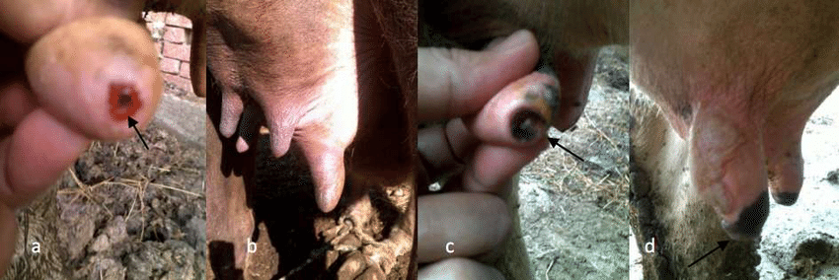
2. Teat leaker (Free milker)
This is a reverse of teat stenosis. It can be due to injury or relaxation of teat sphincter. Milk tend go on leaking and sometimes infection may gain entry leading to mastitis.

- Blind teats
This condition may be congenital or acquired due to any trauma near the teat sphincter. Normally occur just after parturition, on palpation milk thrill found in teat cistern on pressing, milk passed backward toward milk udder cistern. Imperforated teat treated by 15-gauge needle, after creating an opening, it is further dilated using hugs teat tumour extractor, milk canula fixed for 24 hours, after that frequent milking is advised at 4 to 6 hours intervals to prevent adhesion.

- Non-existent teat orifice
If the teat sphincter is intact (as determined by palpation and ultrasound), the skin may be lanced to open the sphincter. The cow must then be milked regularly and/or dilators used to keep the skin from scarring shut. However, if the tear sphincter is abnormal or non-existent, there is no means of reconstructing.

