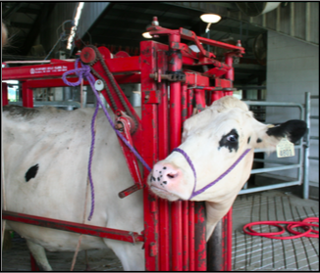
Restraints for Ocular Surgery in Cattle.

Standard Restraint
- These procedures are usually carried out in an standing animal with the use of a crush and halter.
- The head is tied securely but not tightly to one side, allowing access to the offended eye.
- Ensure that the lead is adjusted away from the surgical site.
- Mild to moderate sedation may be required with the use of xylazine.
- Anaesthesia also aids in the reduction of pain and aids restraint. (Please see nerve blocks for anaesthesia.)
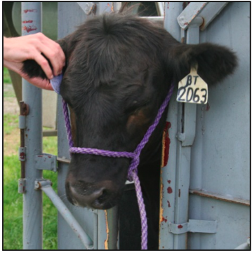

References

Surgical Diseases of the Eye in Farm Animals
https://veteriankey.com/surgical-diseases-of-the-eye-in-farm-animals/

https://www-vetstream-com.ezproxy.sastudents.uwi.tt/treat/bovis/technique/surgery-enucleation-(adapt-equis-article)

