EXENTERATION INTRAOPERATIVE PROCEDURE
- About 2-3 mm from the margin around the eyelids, an incision should be made and the eyelids should be removed with enough skin left to close the incision. Ensure the third eyelid and gland are removed as well.
- The incision is then extended through the orbicularis oculi muscle, and continues along the bony portion of the orbit until the stalk is the only remaining attachment to the globe.
- Clamp the eye stalk, ligate, then incise it.
- The empty socket is packed with sterile gauze with antibiotics laced in them.
- The subcutaneous tissue is sutured closed with a simple continous suture
- The remaining skin of the eyelids are sutured closed with an interrupted horizontal mattress suture.

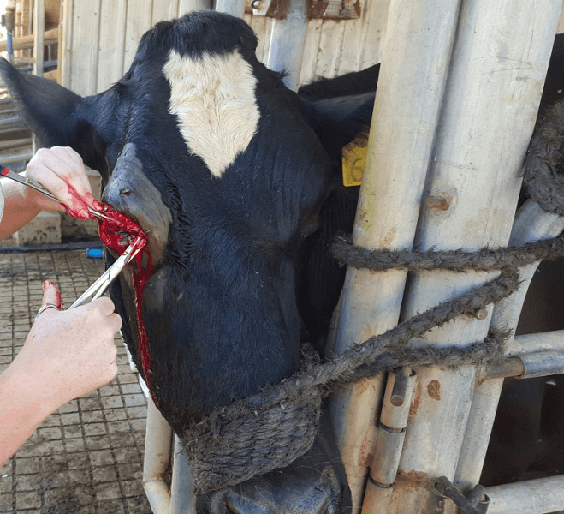
Removal of the eye.

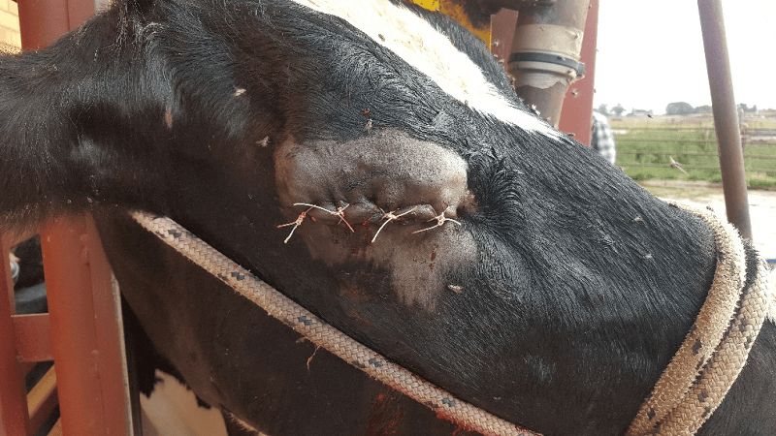
Immediately post operative

