INTRAOPERATIVE CONSIDERATIONS:

Aim:
- To successfully remove the eyeball.

Local anesthesia:
Nerve block using the Retrobulbar ‘4 point block’

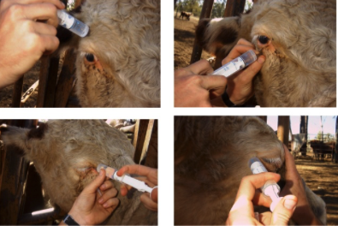
- Local anesthetic is deposited circumferentially around the eye, approximately 4 to 5 cm from the eyelid margins.
- The retrobulbar ‘4 point block’ technique is used;
  - Provides excellent peri-operative analgesia
  - Use of lidocaine 2%
  - 4x 10-20 ml syringes.
  - (4) x 18G 3.5-inch spinal needle – curve by hand to approximate curvature of the bony orbit.

Technique:
- Introduce a 18G 3.5 inch curved spinal needle through the skin laterally, medially, dorsally and ventrally (if the eye was a clock face at 12, 3, 6 and 9 o’clock) either through the eyelids (tarsorrhaphy can be performed first), or via the conjunctival fornices, to a depth of 7-9 cm.
- The orbital septum must be penetrated to ensure the local anesthetic agent is not deposited sub-conjunctively.
- The needle is directed away from the eyeball until the point is beyond the globe and then turned inward to penetrate the muscle cone with the needle running along the bony orbit.
- When no blood is obtained after aspiration, 5-10ml of local anesthetic is deposited behind the eye at each site.
- The use of four sites makes a successful blockade more likely than using only one site.
- Proptosis is suggestive of successful blockade.

Surgical Technique:

- Freeing the globe | - An elliptical Incision is made 10mm from the edge of the upper and lower eyelids, initially using a scalpel blade, followed by blunt and sharp dissection using curved Mayo scissors.  - Mayo scissors are used to dissect the orbicularis oculi muscle, subcutaneous tissue and fascia surrounding the eye.  - Sharp transection of the medial and lateral canthus ligaments is required.  - Using mayo scissors, aggressive blunt and sharp dissection of the retrobulbar musculature is required  - This process is continued caudally behind the eye, with gentle tension applied to the eyelids  - The globe will then become free.
- Transect the optic nerve | - Hemostat is then applied to the optic nerve.  - Incise the nerve with curved scissors 5 mm behind globe between the globe and clamp.  - The clamp is then removed.
- Globe removal | - Sever any remaining attachments surrounding the globe
- Subcutaneous tissue is closed | - An absorbable suture material (no.3) is used to close the subcutaneous tissue in a continuous pattern.
- Skin is closed | - A non-absorbable suture material (no.3) is used to close the skin. The options for the suture pattern used to close the skin include: cruciate, forward interlocking and horizontal mattress.
- Bandaging | - A pressure bandage may be applied over the eye socket to assist in hemostasis.  - The pressure bandage is to be removed after 24 hours.

