Using a small tube such as a syringe, place it inside the prolapse proximal to the anal sphincter without causing further trauma as this will support the lumen for the procedure.
Next using 2 18-gauge needles place it at 90 degrees angle to each other penetrating through the prolapse and supporting tube within and exiting at the opposite side. This will prevent the protruding mucosa from slipping back through the anus when the prolapse is removed.
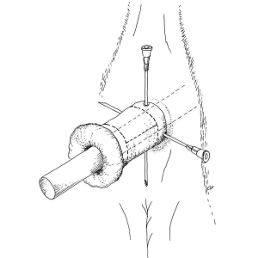
Begin incising the necrotic area of prolapse 1cm proximal to its border. The entire prolapse can be removed at one but hemorrhage may become difficult to control. Small incision area can be made working your way around the circumference of the prolapse all the while suturing as you go. The incision cuts both layers of the prolapse through the outer and inner lumens. A simple continuous suture is used with 2-0 or 3-0 absorbable suture material.
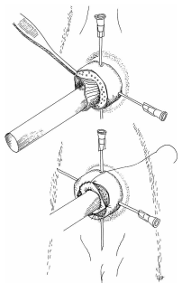

Additionally, tack sutures at the 4 quadrants can be made with an interrupted suture to ensure proper apposition of the tissue for adequate blood supply and healing.
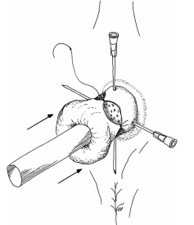

Once resection is complete, inspection of the suture and tissue is done to ensure there will be no leakage and proper apposition is achieved. The tube and needles are removed and the new healthy tissue is released into the anus. If the mucosa is still protruding, a purse string suture can placed to reduce the diameter of the opening thus holding the tissue within and promoting healing.

Resources:
Turner and McIlwraith’s Techniques in Large Animal Surgery
Noordsy’s Food Animal Surgery
Farm Animal Surgery
Video links:
Some other treatment on a calf but the same method can be done on a pig: https://www.youtube.com/watch?v=jOJDjXV_R9g&has_verified=1&ab_channel=KeeboVet

