**Amputation**

* Animal is restrained, anaesthetized and prepared for surgery. The site is prepared for surgery.
* Insert a piece of tubing suitable to suit the diameter of the rectum into the lumen of the prolapse.
* Insert two 18 gauge needles 3 to 4 inches in length through the prolapse tissue and tubing and then back out the opposite side of the prolapsed tissue at 90o angles to one another as close as possible to the anal opening.

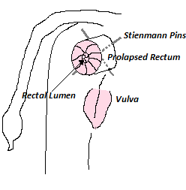

* Make a circumferential incision at least 1cm cranial to the necrotic tissue. All tissue with the exception of the inner mucosa and inner submucosa are incised.
* Blunt dissection is carried out caudally, to create a plane, with the inner submucosa between the inner and outer aspects.
* The outer segment is pulled forward and the inner segment is amputated approximately 2-3 cm distal to the outer segment. This allows salvage of extra mucosa and facilitates amputation of the mucosal layers over the fatty tissue.
* The mucosa is aligned using 4 simple interrupted sutures which are placed equidistant around the circumferential prolapse.
* The 4 separate quadrants are then sutured to appose the edges using a continuous pattern for each segment making a knot when the suture reaches at each of the initial 4 sutures.

Note:

* Use absorbable suture material.
* Use monofilament (3-o to 4-o) suture material to cause minimal trauma and reduce the capillary effect preventing spread of bacteria.
* The needles/pins and tubing are then removed from the rectum.
* The rectum then allowed to retract back into the body.