**Pre-op considerations for Enterotomy- foreign body removal**

ASA Grade

An animal that has a foreign body in its intestines can have an ASA grade of ASA 3- ASA 4 depending on the length of time the foreign body remains and how long it takes to detect the foreign body.

Aseptic technique

Enterotomy can be done while the animal is in lateral recumbency or while the animal is standing. Physically restrain the goat and administer the ketamine xylazine stunt. Then, the skin surface on the left paralumbar fossa is prepared aseptically by washing with water, soap, and salvon (Cetrimide 3% and Chlorhexidine gluconate 0.5% solution). Then the hair is first clipped with sharp scissors and shaved with a razor blade and cleaned thoroughly with a standard solution of salvon. Finally, the area is scrubbed three times with a povidone-iodine 1% solution to decrease the microbial load in the area and left dried till ready for surgery.Additionally, regional or field block are performed by infiltrating the 5 ml lidocaine per each paravertebral space (Lidocaine hydrochloride 2%) to block L1, L2, L4 nerves using an 18-gauge syringe having a 10-cm needle, to desensitize the flank area, abdominal muscles and alleviate pain during the surgical procedure. The needle was inserted halfway between the intervertebral transverse process and the needle is slightly angled to reach and deposit the lidocaine in the subarachnoid space. If draping is feasible do so to maintain asepsis.

Drugs

Goat- case 2- 35kg

|  |  |  |  |
| --- | --- | --- | --- |
| Drug class | Drug name | Recommended Dosage and route | Volume of drug to be used |
| Sedative | Xylazine | 0.03 to 0.1 mg/kg IV or 0.1 to 0.3 mg/kg IM. Conc. 20mg/ml | 0.0875ml |
| General anaesthetic | Ketamine | 0.5 mg/kg conc. 100mg/ml | 0.175ml |
| Local anesthetic | 2% HCL Lidocaine | 5 mg/kg | 8.75 ml |
| Analgesic | Flunixin meglumine | 1.1mg/kg IV, IM once daily up to 5 days. Conc. 50mg/ml | 0.77 ml IV/IM |
| Prophylactic drug | Tetanus toxoid and antitoxin | 1 ml IM | 1 ml IM |
| Emergency drug | Yohimbine | 0.1 to 0.2 mg/kg IV. Conc. 10mg/ml | 0.35ml to 0.7ml IV |

Sample calculation of xylazine

Max dose: recommended dose x weight = 0.05mg/kg x 35kg= 1.75mg

Xylazine concentration= 20mg/ml

Total volume = max dose/concentration= 1.75mg ÷ 20mg/ml = 0.0875ml

Sample calculation of 2% HCL lidocaine

Max dose: recommended dose x weight = 5mg/kg x 35kg = 175mg

Lidocaine concentration: % = g/100mL. 2% solution = 2g/ 100mL.

2g~2000mg 》2000mg/100ml = 20mg/ml.

Total volume = max dose/conc. = 175mg ÷ 20mg/ml = 8.75ml

Toxic dosage: DO NOT EXCEED THE RECOMMENDED DOSE!!!!

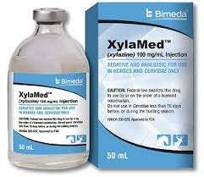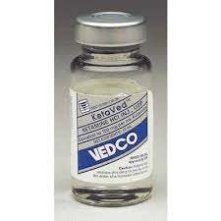

Instruments

* 3-0 polyglactin suture
* No. 4 scalpel handle
* Scalpel blades
* Heamostats
* Mayo-scissors
* Drapes
* Basic suture kit
* 0.9% saline solution
* no 3 Ethilon suture

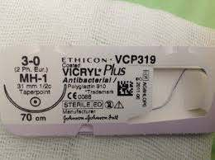 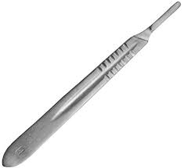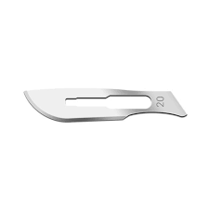

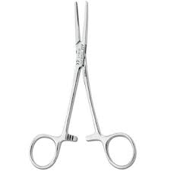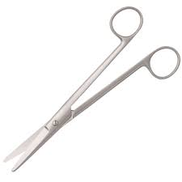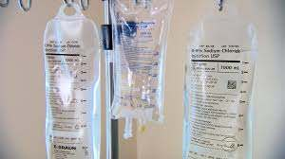

References

http://web.jhu.edu/animalcare/procedures/survival-large.html#presurg