Restraint

- Being restrained onto rump. Sheep are normally cooperative enough to do this.

- Halter and lead rope - Use a halter and lead rope to retrain the head and then bend the leg at the knee to gain access to the hooves.
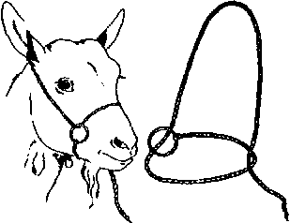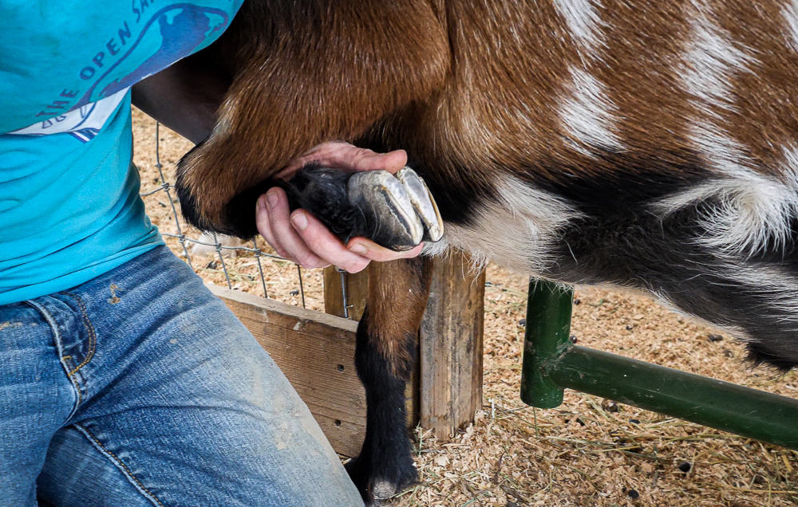

- Goat stanchion which restrains the head while having the body free. So, the legs can be freely moved to trim the hooves.
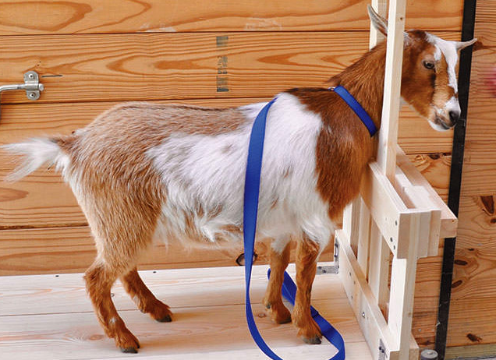

- Sheep deck chair - Sheep can be placed back first into the sheep deck chair which leaves all hooves exposed for clipping while safely restraining sheep. Goats are normally cooperative enough to do this.
