**Rhinehart Dehorner**

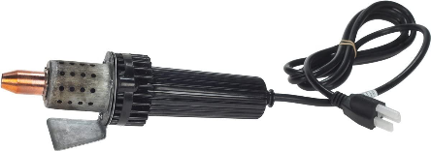

Rhinehart dehorner is an electric dehorner used in ruminants.

* Efficient once the base of the horn is not larger than the inside of the dehorner ring
* Very little blood loss as it also cauterizes the area

How it’s used.

* Properly restrain animal, as the dehorner is extremely hot and can cause serious damage to the handler and persons restraining the animal

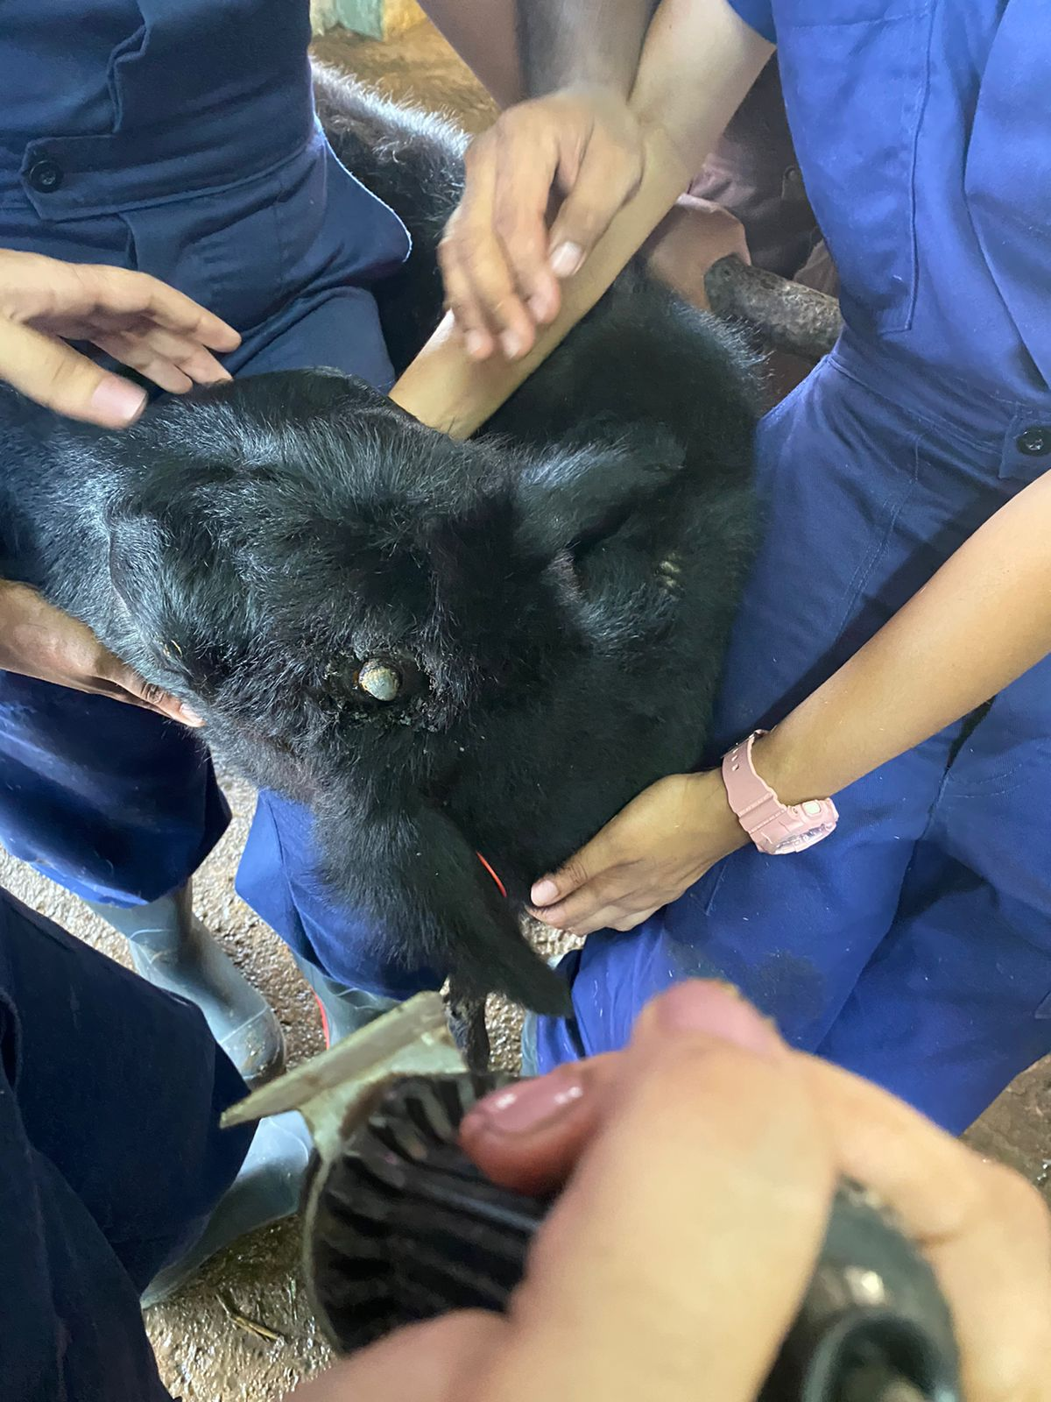

Fig.1 – Animal is restrained during disbudding process

* Place dehorner over horn bud.

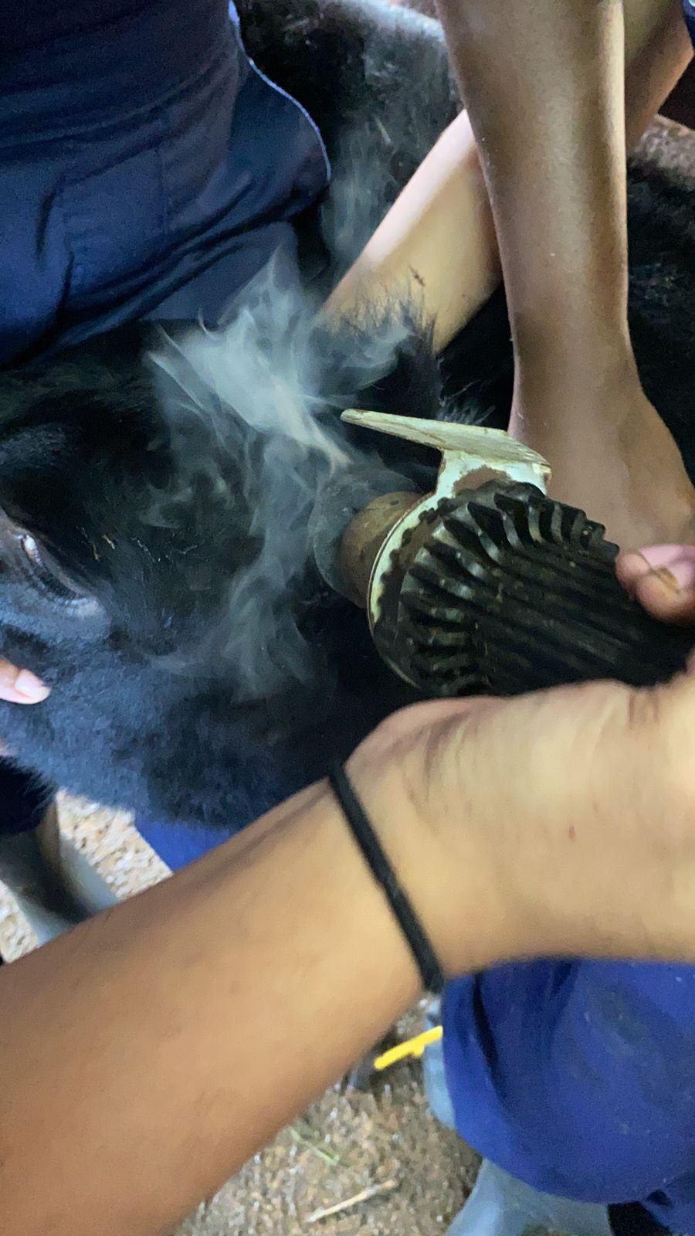

Fig. 2 – Dehorner is placed firmly over the horn bud. Care the ear is also held out of the way to prevent burning

* Rotate the dehorner slowly while pressing on the bud for 10 seconds
* Remove and observe for a copper colour on the bud. If the copper colour is not seen, repeat as needed.

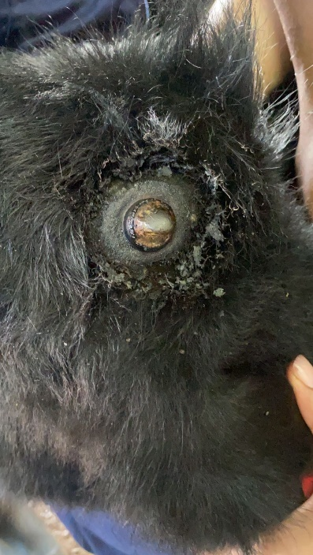 Fig. 3 – Copper colour seen on bud

Do not leave dehorner on the skull longer than 10 seconds as this can cause damage to the skull.