COMPLICATION | REASON
Thermal Meningitis  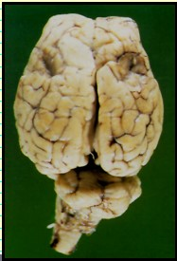 | Occurs when excessive heat is applied to horn bud during disbudding.  Kids/Calves prone this kind of brain damage due to their thin skulls.
Scurs | Develops when the germinal epithelial tissues were not adequately destroyed, and horn begins regrowth.  Arise from improper disbudding technique.
Tetanus  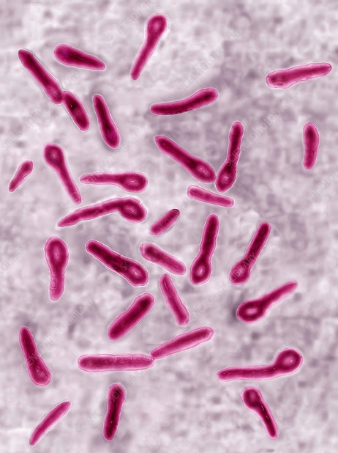 | More associated with goats than cattle. Goats are susceptible to infection with Clostridium tetani and thus tetanus.  Prevent by administering tetanus antitoxin preoperatively.
Myiasis | Occurs due to fly strike on burn wound.

