Equipment Used for Paravertebral Nerve Block

Equipment/Material+Drug | Use
Halter  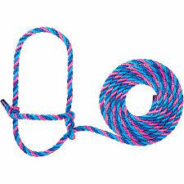 | Applied to the head of the animal for easy restraint and control.
20 ml Syringe  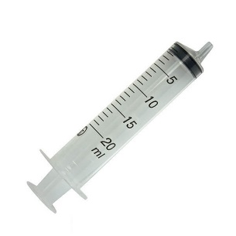 | Accurate measurement of the drug.
20-gauge 1 ½ inch hypodermic needle | Used perform the proximal technique. Penetrate the skin to deposit the drug at the desired destination.
20-gauge 1-inch hypodermic needle | Used to perform the distal technique. Penetrate the skin to deposit the drug at the desired destination.
Lidocaine 2%  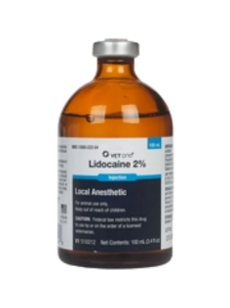 | Local anesthetic used to perform the nerve block
Saline  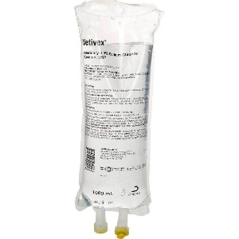 | Used to dilute the Lidocaine.
Clippers  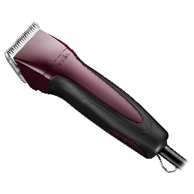 | To clip the hair at the blocking site
Alcohol cotton swabs | To clean area before needle penetrates the skin
TetraVet  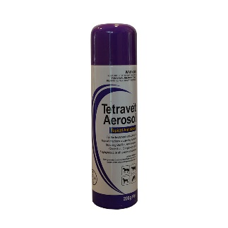 | An antimyiasis spray that is applied to the injection site.

