Equipment for hoof trimming

Rasp – removes extra layers of hoof by filling it away. | Boots – To protect feet
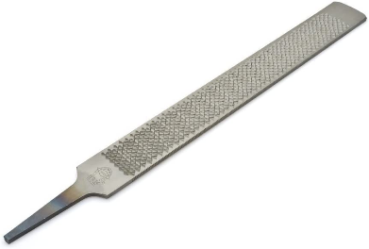 | 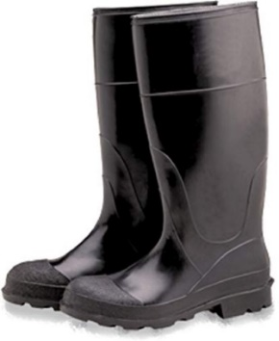
Hoof Nipper -used to clip the hoof into desired shape | Goggles – to protect eyes from flying debris
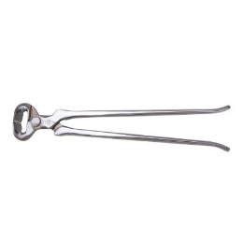 | 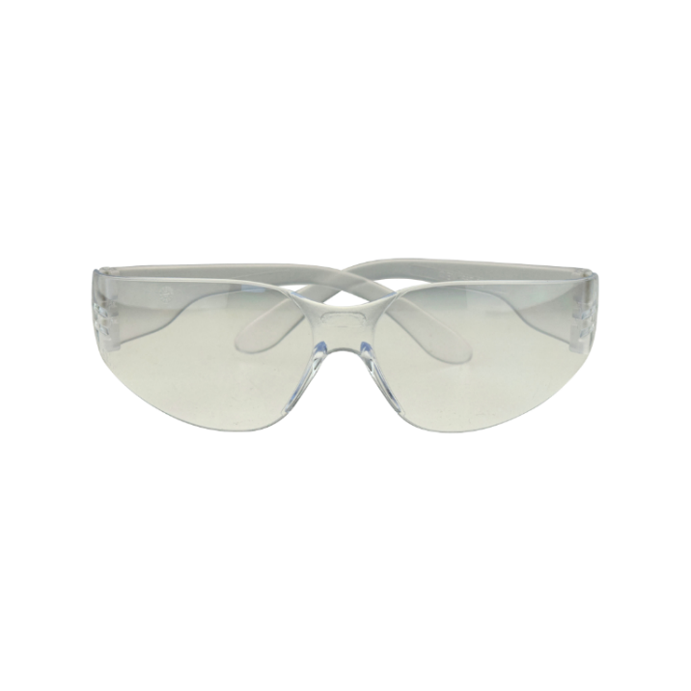
Hoof knife manual and electric - clean up exfoliating sole, to trim shedding frog, and to cut the bars | Heavy duty industrial gloves – To protect hand when using sharp tools as well as any power tools
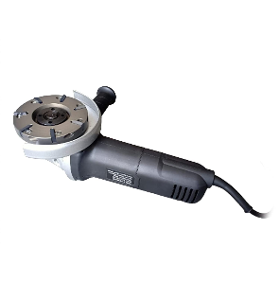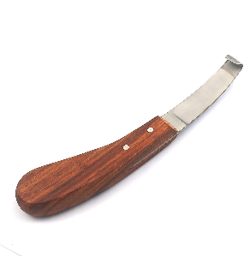 | 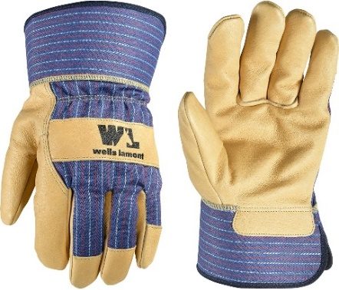
Brush – used to remove foreign object from the hoof | Hoof Grinder—Is a more modern way of trimming he hoof as well as more time saving
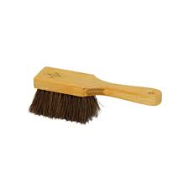 | 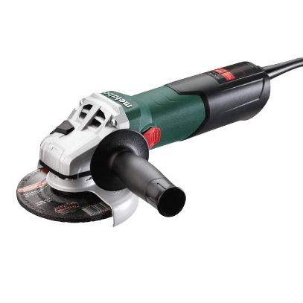
Coveralls – worn when working with the cattle and are normally removed when exiting the farm to prevent any cross contamination between farms.
