CASTRATION
What is Castration?
Definition: The surgical removal or inactivation of the testicles of a male animal
Other Terminology: Cutting, Altering, Neutering, Fixing, Gelding, Sterilization, Orchiectomy, Emasculation

Why is castration done?
Reasons To Perform Castration:
- To make male animal docile and less aggressive
- To prevent unwanted breeding of animals
- For easier management of male animals in the presence of females
- For the promotion of weight gain in meat animals
- In cases where animal has irreparable injury to testes or malignant diseases
- To correct scrotal hernia
- For the removal of testosterone since it can taint the meat

When is castration done?
These are just guidelines but castration can be done at any age. It is important to note that complication and cost increases as the animal is older.

Best ages for specific species:
Horse- 1- 1.5 years
Cattle- 1-2 months
Pig- 1st week
Goat/ Sheep- 2 weeks

Best Season for Castration
- Dry Season
- Early Spring
- Late Fall
- Avoid extremes of climates
- Avoid Fly season
How is castration done? https://www.avma.org/sites/default/files/resources/castration-cattle-bgnd.pdf
There are 3 methods:-
- Physical Methods
Physical castration methods are commonly used.
- It involves the surgical removal of the testicles (Open Method (Open-open and Open closed) which involves knife/scapel/emasculator.
Advantages:-
- cannot miss a testicle with Open Castration procedure.
- Permanent method done on both young/ adult animals
- Decreased aggression.
Disadvantages :-
- more painful
- can cause hemorrhages
- Increases risk of infection/ maggot infestation during fly season
- Requires more skill
- Irreversible procedure

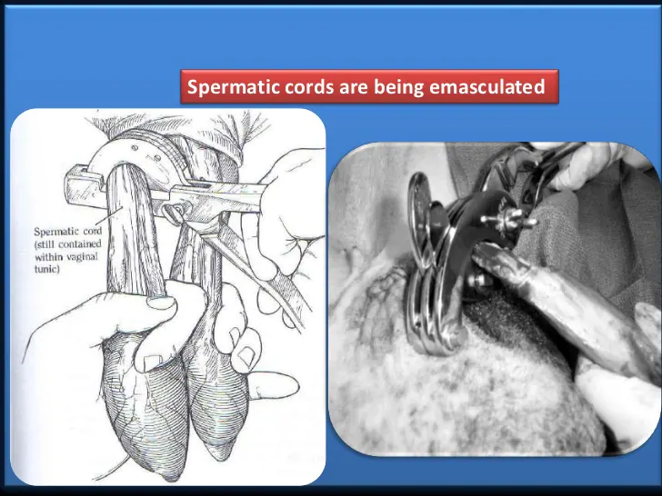
- It can also involve a Bloodless technique in which the use of a Burdizzo castrator which is externally clamped to crush the spermatic cord of the testes.
Advantages:-
- No incision required.
- More painless than cutting( open procedure).
- Quick and easy.
- Reduced risk of infection.
Disadvantages:-
-Mistakes can occur when clamping :-
- Spermatic cord slipped from crush.
- Spermatic cord incompletely crushed.
- Lack of blood supply to scrotum -> Gangrene -> Infection
-Chance of injury to animal/ operator
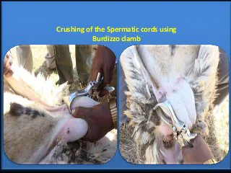

- Additionally, the application of a constricting elastic band (rubber ring) at the base of the scrotum ie Elastrator, EZE Bander, Calicrate Bander. Is another Bloodless Physical Method of castration.
Advantages:-
- -No incision required.
- -More painless than cutting( open procedure).
- -Quick and easy.
- -Reduced risk of infection.
Disadvantages:-
- missed testicles
- Pain and discomfort may result in decreased growth rate
- There are age limitations
- Tetanus shot required

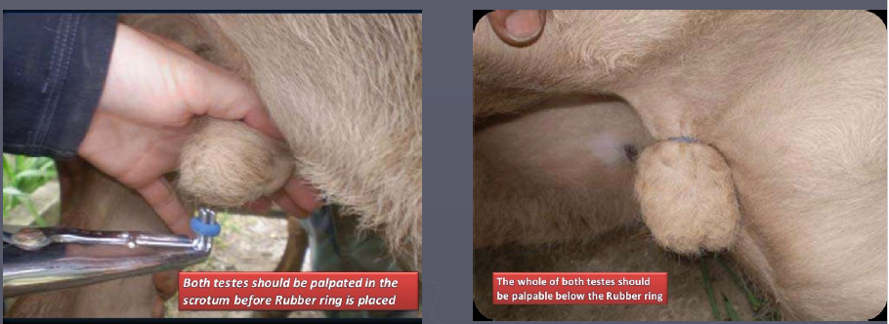

- Chemical Methods
- Chemical castration includes injection of sclerosing or toxic agents (e.g. 88% lactic acid) into the testicular parenchyma to cause irreparable damage and loss of function of the testes.
Advantages:-
- Reduced pain and stress
- Reduced risk of hernia, hemorrhage, myiasis, infections or other surgical sequalae.
Disadvantages:- Chemical castration requires additional procedural time and technical skill, and almost twice the healing time compared with surgical castration.

- Hormonal Methods
- Hormonal castration is also known as immunocastration.
- This involves the injection of immuncontraceptives to induce antibody production against gonadotropin releasing hormone (GnRH), resulting in decreased production of endogenous hormones.

Advantages:-
- increase live weight, hot carcass weight, average daily gain, and dressing percentage following castration when compared with surgical methods.
- Testosterone production is lowered for approximately 6 months after immunocastration.
Disadvantages:-
- persistent mounting behavior
- consumer concerns
- Not a permanent method - the need for repeat injections makes technique less effective and desirable than traditional, physical methods.
- Risk of vaccine failure
- Limited duration of effect
- Need to vaccinate at regular intervals
