The calf was tied with a halter and lead rope to a sturdy area of the pen and a quick release slip knot was tied.

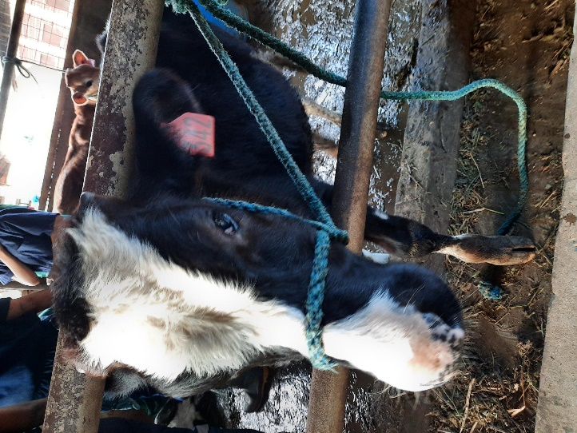

The calf was then injected with Xylazine IM (note dosage in drug table) as a sedative to calm them down.

His hind limbs were restrained using a Tom fools knot to restrain the legs and prevent the calf from kicking during the procedure.

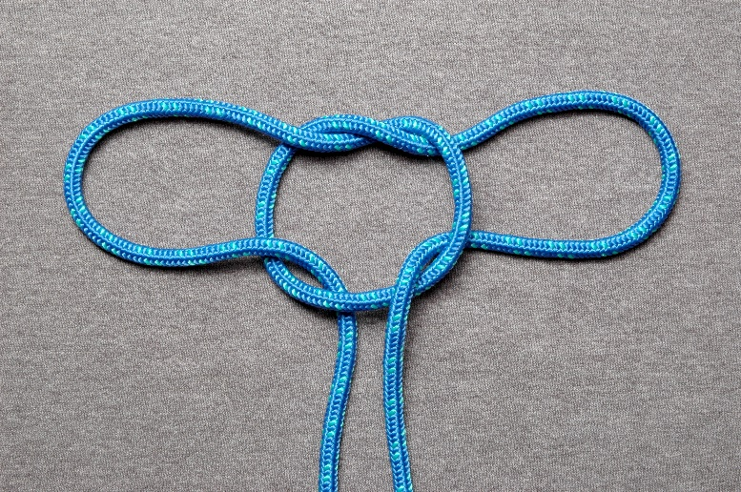

Lastly a nose pinch was done while at least one person stabilized the body to prevent too much movement during the procedure.

