Castration of Boars
Need to Know: ANATOMY OF TESTES
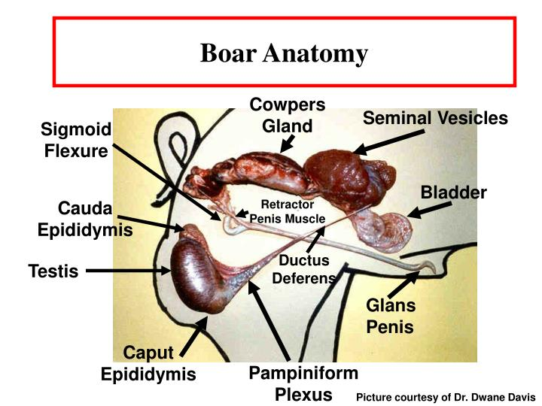
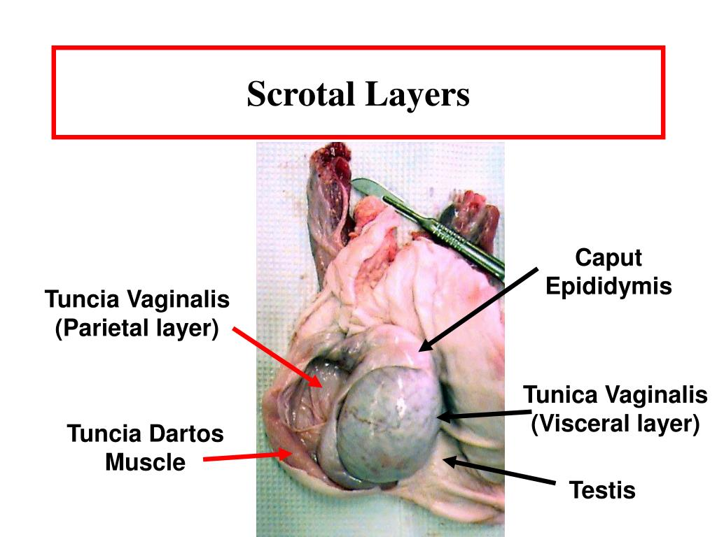
The testes of the boar is elliptical in shape and positioned in the perineal area in a direction oblique cranio ventrally with the tail caudodorsally.

HOW IS CASTRATION IN BOARS DONE?
Physical Castration in piglets https://open.lib.umn.edu/largeanimalsurgery/chapter/piglet-castration/
Piglets are generally castrated 4-14 days of age.
Piglets should be castrated at least 5 days before weaning to decrease the risk of combined stressors.
- A distance and physical exam is conducted. Scrotum and testes are palpated
- Piglets are placed in a hanger and held by the hind limbs so that the animal would remain calm.
- Flunixin Meglumine is administered intramuscularly (neck muscles). This drug acts as an anti-inflammatory drug and analgesic for 12 hours. The dosage for swine is 2.2mg/kg.
- A pre-op scrub of testes and surrounding area is done using chlorhexidine/ alcohol solution and gauze.
- A local block using lidocaine is done intratesticular.
- An incision is made at the base of the testes in the direction of the tail. and the testicle are pulled out. Ensure incisions are low to allow for proper drainage.
- Application of Thumb pressure on the pelvis is important to ensure that the testicular cords break off at the point of your thumb rather than deep inside the body, which may promote development of a hernia.
- If necessary the testicle may be cut free of the cord using a scraping motion.
- Cut away any cord or connective tissue protruding from the incision and spray the wound with antiseptic.
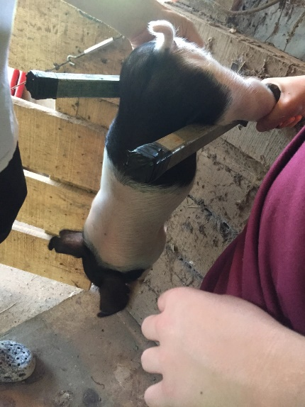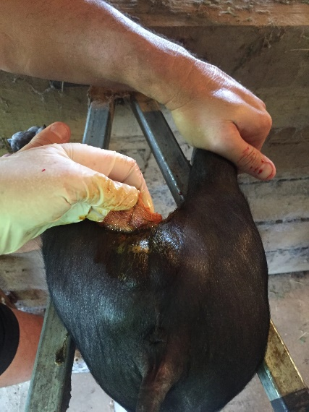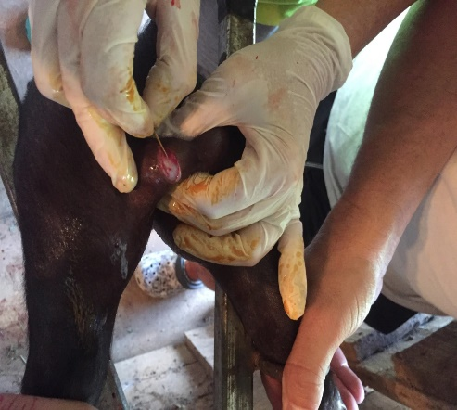
https://drvetsonya.com/2017/09/09/boar-pig-castration/ - source for images ^

CHEMICAL OR IMMUNO-CASTRATION
https://www.ncbi.nlm.nih.gov/pmc/articles/PMC7912067/
https://www.ars.usda.gov/ARSUserFiles/50201500/Castration%20Fact%20Sheet.pdf
This castration method is performed on large boars. It improves performance and animal welfare and prevent boar taint.
- The active ingredient of the immunocastration is a protein that delays the onset of puberty by stimulating the pig’s natural immune system to produce antibodies that inhibit testes function. Immunocastration carries out the immunization against sex hormones such as FSH, LH, LHRH, hCG

- The process is based on an antigen–antibody reaction that is achieved via two injections of the gonadotropin-releasing hormone (GnRH)-analogon Improvac ®
- Immunocastration requires two doses of the vaccine at least 4 weeks apart, with the second immunization typically administered 4-5 weeks prior to slaughter, which means that immunocastration is done in the fattening phase of pigs.

- Advantages- painless, no tissue damage, reversible and decreased aggression in boars.
- Disadvantages- immuno-castrated males act similarly to intact males until the second vaccination. Not permanent. Must vaccinate at regular intervals.
