INTACT/UNCASTRATED ADULT | CASTRATED ADULT
BULL  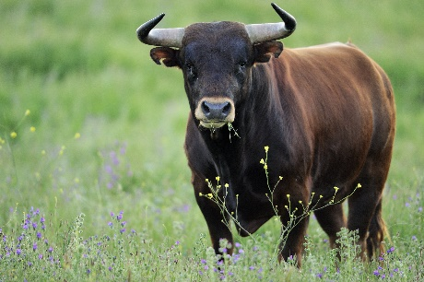 | STEER
BOAR  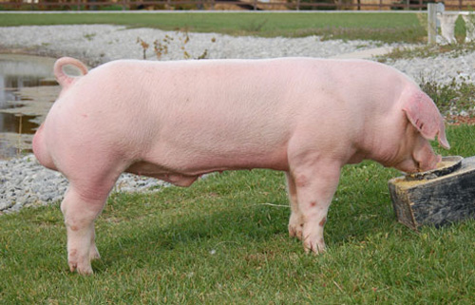 | BARROW  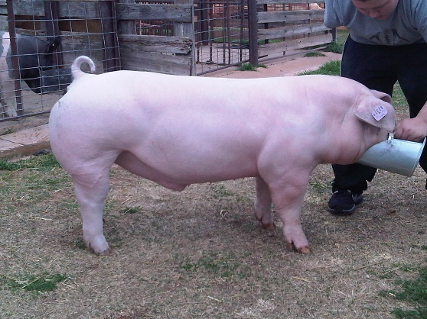
STALLION  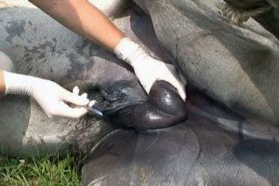 | GELDING  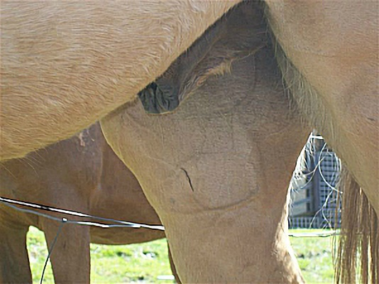
BUCK/BILLY GOAT  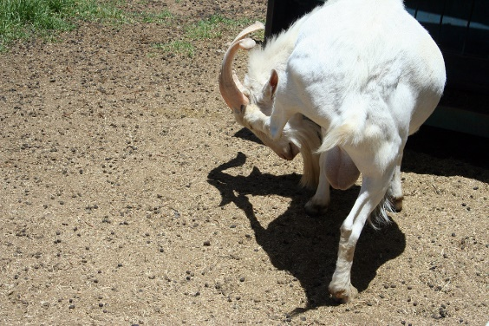 | WEDDER/WETHER/DINMONT
RAM/TUP  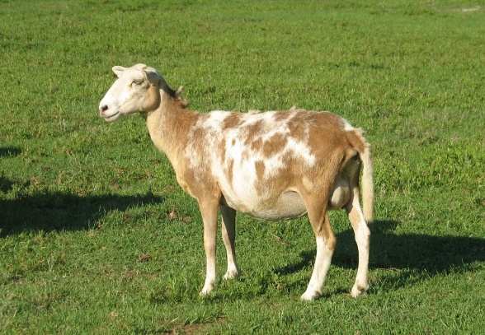 | WEDDER/WETHER/DINMONT

