**Restraint**

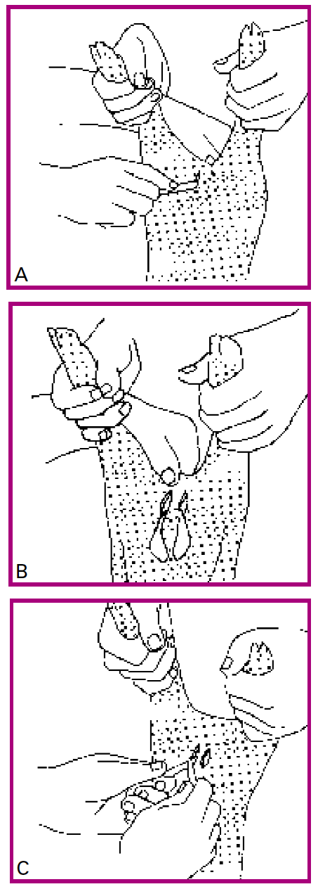Piglets:

1. Grab the piglet by the back legs
2. Hold the piglet in an upside down position
3. Push the testicles into the scrotum with your thumb and keep them there