Maximum volume @ site- 2-4 mls
18-20 gauage 3.5 inch spinal needle
Area desensitized- toe region of the sole.

Navicular Bursa Arthrocentesis
Landmarks
Space between the heel bulbs on just proximal to the coronary band.
Steps
- Perform aseptic protocol.
- Advance needle along a sagittal plane aiming for a point 1 cm below the coronary band, midway between the dorsal and palmar limits of the coronary band.
- Advance until the tip of the needle contacts bone.
- Fluid is seldom seen but needle is determined to be in the navicular bursa by low resistance to injection and ability to aspirate the injected contents through the syringe.

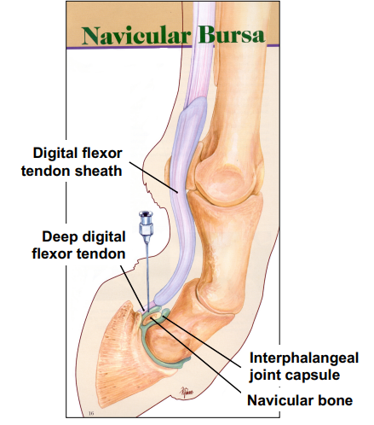

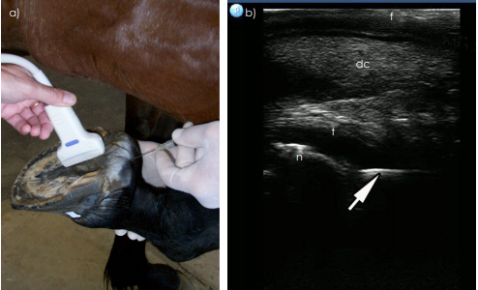
Centesis of the navicular bursa can be accurately determined ultrasonographically after needle placement using a 7.5 MHz linear probe placed on the frog in a sagittal orientation. (b) Using ultrasonography, proper placement of needle (arrow) is observed when the tip of the needle (arrow) contacts the flexor surface of the navicular bone (n). t = deep digital flexor tendon (which is partly hypoechoic); dc = digital cushion; f = frog.

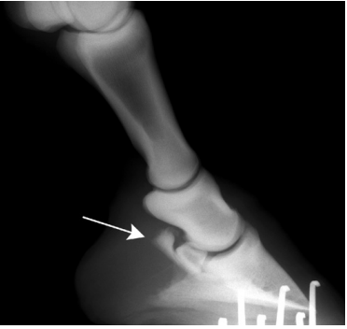
Another method of determining success of the procedure is to examine the foot radiographically (lateromedial view) immediately after injecting the bursa. Provided that 0.5– 1.0 ml of radiopaque contrast medium was added to the local anaesthetic solution. Radiographic identification of contrast medium within the bursa is evidence of a successful bursal injection.

