Metacarpophalangeal/ Metatarsophalangeal (MCP/MTP)/ Fetlock Joint Blocks
This joint is situated between the MCIII/MTIII and the P1 bones of the distal limb of the horse.
There are 3 approaches in accessing the Fetlock joint;
Dorsal Approach
Location: Palpate the depressions present on both sides of the common digital extensor tendon at the distal end of metacarpal 3.
Insert the 20-22G 1’ needle at an oblique angle, under the lateral edge of the common digital extensor tendon or slightly above the palpable joint space. Next, direct the needle medially and parallel to the frontal plane of the joint. Then, rotate the needle to obtain the synovial fluid from the joint capsule. Attach syringe and inject local anesthetic (8-12ml).
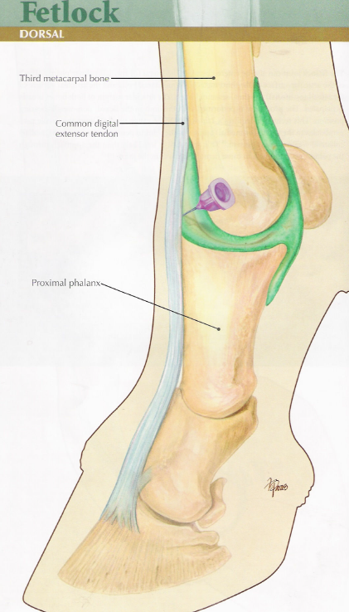

Proximal Palmar Pouch
Location: Identify and palpate distal to the “button” at the end of the splint bone, between the palmar aspect of the metacarpal 3 dorsally, the branch of the suspensory ligament palmarly and the apex of the proximal sesamoid bone distally.
Direct a 20-22G 1” needle in a horizontal manner lateral to medial until the synovial membrane is penetrated. Press in the contralateral pouch to assist with retrieval of the synovial fluid but this is prevented often from occurring. Attach syringe and inject local anaesthetic (8-12ml).6io
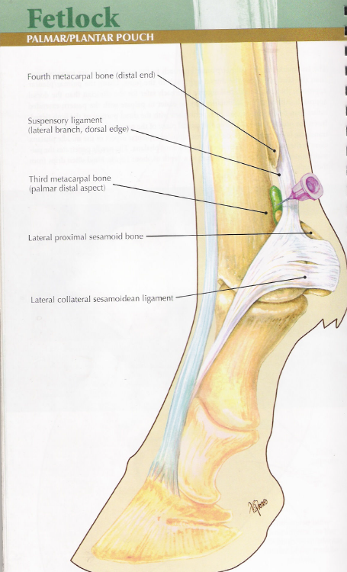

Lateral Collateral Sesamoidean Ligament (CSL)
Site: With the limb flexed the site is demarcated by the palmar pouch proximally, the lateral proximal sesamoid palmarly and the lateral condyle of metacarpal 3 dorsally.
Insert the 20-22G 1” needle through a shallow depression in the CSL approximately 1.5cm from the reference points. In more detail, the needle is directed perpendicular to the medial/lateral surface of the joint to penetrate medial/lateral collateral sesamoidean ligament. This technique results in minimal haemorrhage into the joint, minimal inflammation and consistent retrieval of synovial fluid. The joint can be distended or flexed.
