Equine Lameness
- DEFINITION
Equine lameness refers to abnormality or alteration in gait or stance. The underlying issue can be from the limbs, neck, shoulders, withers, back, loin or quarters.

Note: Lameness in one aspect of a limb may produce soreness in another aspect of the same limb. Likewise, lameness may also be observed in either the forelimb or hindlimb on the opposite side of the primary lame limb.

- CAUSES
- Pain- most common cause of lameness.
- Extended pressure placed on limbs during exertion. E.g. in racehorses where inflammation of joints, ligaments or tendons may occur as a result of racing long distances.

- Mechanical
- From previous trauma (indirect or direct to limbs).

- Neurological
- Ataxia
- Paresis

- THE LAMNENESS EXAMINATION

- Medical History:

- Signalment (breed disposition or discipline disposition, e.g. carpus arthritis in racehorses vs hindlimb suspensory lameness in dressing horses)

- Enquire about history of previous lameness.

- Enquire about if any trauma or underlying disease.

- Enquire about onset of lameness and progression since signs began.

- Enquire about treatment and response to treatment.

- Enquire about requirements of horse (whether racehorse or pet)

- Distance exam/ “hands off exam”:

- Observation of Body condition score, conformation, weight-bearing and non-weight bearing limbs, balance (stay apparatus) or any obvious lacerations or abnormalities.

- Physical Examination:

Always test the suspected lame limb first!

- Palpation of the muscles, ligaments, tendons, bones and joints. Observe for pain, obvious swelling or abnormalities.

- Hoof tester application- pressure applied to solar horn in order to assess for sensitivity.

- Joint flexion tests which involves testing degree of lameness prior to and after flexion of the joints. This provides further insight on the origin of pain.

- Neck and back should be examined.

Videos that have helped in understanding lameness
- https://www.youtube.com/watch?v=7Hv7TXPXJug

- Gait Assessment:

- To be considered:
- Whether the horse is definitely lame.
- Identification of the limb or limbs that are lame.
- The severity of lameness.
- Identification of specific characteristics of the lameness.
- Whether there is response to treatment or not.

- - Evaluate horse while trotting on a hard surface (ensure not safety hazard to horse). Trot horse in a straight line or circles. Horse can also be trotted in inclines.
-Identify limb and foot height when lifted off ground and foot placement.

- Forelimb Lameness

- The more commonly occurring lame limb.
- Identify head nod which is characteristic to forelimb lameness.
- Majority of forelimb lameness occurs below the proximal carpus.

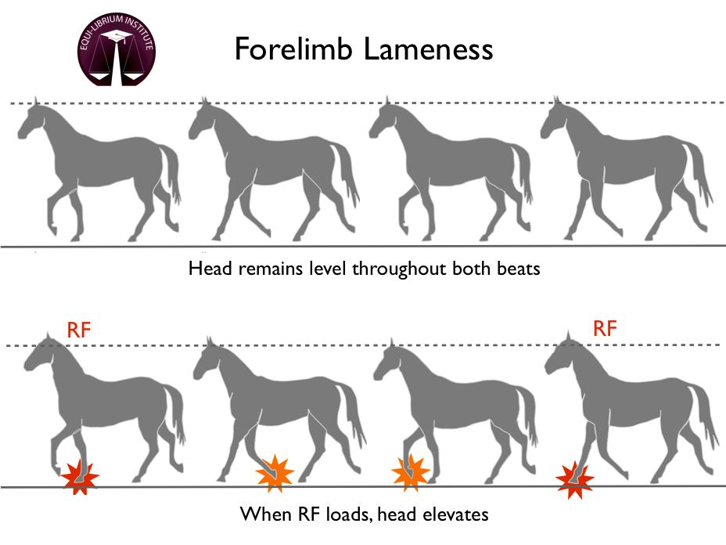

Videos that have helped understanding forelimb lameness and its identification:
- https://www.youtube.com/watch?v=0G-o1HIskgA

Hindlimb Lameness

- The characteristic marker for identifying hindlimb lameness is evaluation of the tubercoxae during trotting. The tubercoxae on the side of the lame limb with have an increased vertical displacement.
- Majority of hindlimb lameness occurs below the proximal hock.
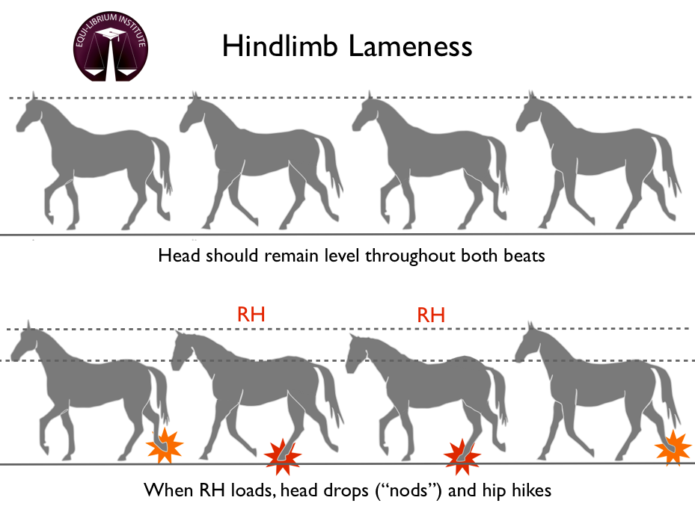
Videos that have helped understanding hindlimb lameness and its identification:
- https://www.youtube.com/watch?v=dJmhBzS_Zfk
- https://www.youtube.com/watch?v=dDUDL488zqQ

- Lameness is graded based on a scale from 1-5 with 0 being sound.

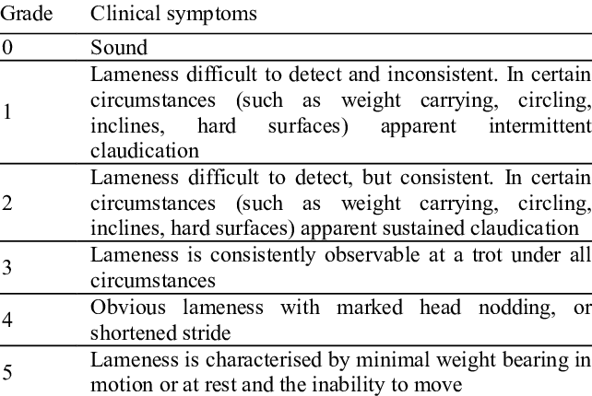

- Diagnostic Local Anaesthesia:

- Involves localizing source of pain by using nerve blocks from distal to proximal in the limb.

- Diagnosis:

- Radiography
- Ultrasonography
- Arthroscopy
- Computed tomography (CT)
- Magnetic resonance imaging (MRI)
- Synovial fluid analysis

References
- https://www.vetvoice.com.au/ec/horses/equine-lameness/#:~:text=A%20lame%20horse%20is%20defined,(e.g.%2C%20osteochondritis%20dissecans).

- https://aaep.org/horsehealth/understanding-lameness

- https://www.msdvetmanual.com/horse-owners/bone,-joint,-and-muscle-disorders-in-horses/lameness-in-horses

- https://www.msdvetmanual.com/musculoskeletal-system/lameness-in-horses/the-lameness-examination-in-horses

