Distal Interphalangeal Joint Block
Anatomy | - Coffin joint, (P2-P3)
Preparation of the site | - Site should be disinfected with a sterile antiseptic solution, such a chlorhexidine
Restraints | - Lip twitch  - Lead shank
Materials | - 1.5-inch, 20-gauge needle  - 10ml syringe  - Local anaesthetic of choice
Procedure | Dorsal Parallel:  - Easiest approach is accomplished using a dorsal parallel or inclined approach,  - A needle is placed into the dorsal pouch of the DIP joint on or near midline, just proximal to the coronary band. (Needle points into the limb or is parallel with the ground).  Dorsal Perpendicular:  - There is also the dorsal perpendicular approach where the needle is placed perpendicular to the bearing surface of the foot, near the midline, just proximal to the coronary band. (Needle faces downwards or towards the ground)  Lateral Approach:  - The needle is inserted near the palpable, proximal edge of the lateral cartilage of the foot, the needle should be angled medially to the weight bearing surface of the foot. This can be done with the limb either flexed or extended.
Structures desensitised | - Distal interphalangeal synovial membrane  - Distal deep digital flexor tendon  - Joint capsule  - Surrounding soft tissues  - Subchondral bone by diffusion  - Navicular apparatus  - Dorsal sole  (If more than 6ml of local anaesthetic agent was administered the palmar sole)
Considerations | - General depth of insertion should be 1 to 1.5 mm, but this would also depend on the size of the animal  - Synovial fluid can be seen in the hub of the needle if is correctly placed  - Volume to be administered: 4 – 6ml

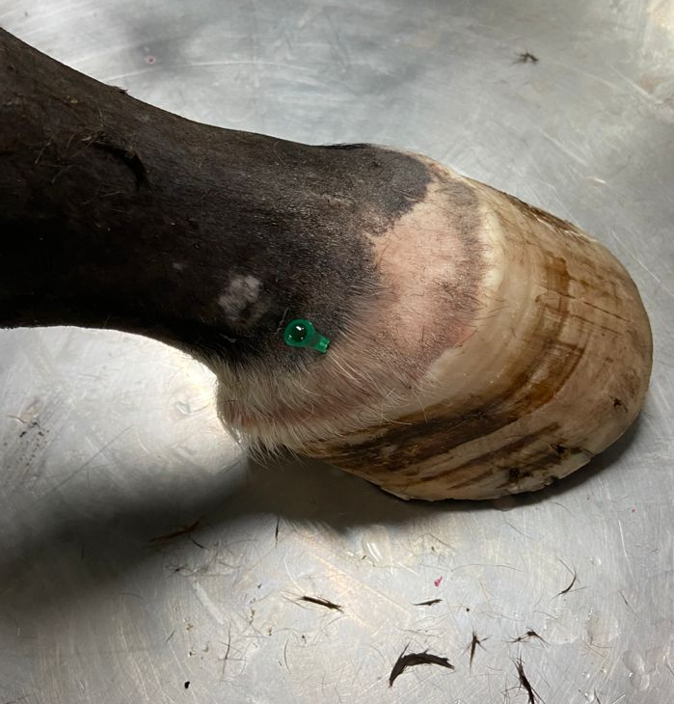
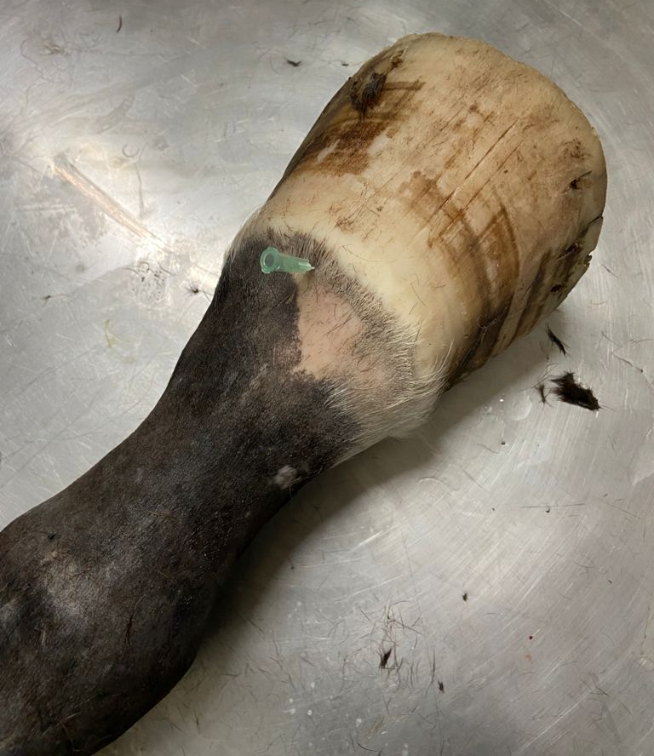
Dorsal Lateral approach to the Distal Interphalangeal Joint block
Dorsal Parallel approach to the Distal Interphalangeal Joint block

