Name of suture | Description | Procedure | Main points
Cruciate | 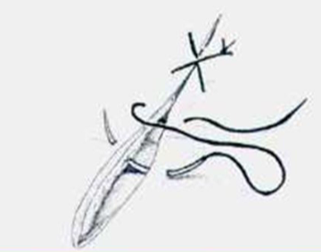  This is an interrupted suture pattern done synthetic non-absorbable nylon. | - Insert needle perpendicular to lesion into subcutaneous tissues.  - Place the nylon through the needle and pass it through the tissues and remove the needle.  - Next insert needle perpendicular to the wound on the opposing side and repeat step 2.  - Then, finish the suture pattern using a one handed knot tie.  - This is repeated until the entire wound is closed. | Tension relieving suture pattern;  abdominal muscle closure and amputations
Name of knots | Description | Procedure | Main points
One handed knot tie | 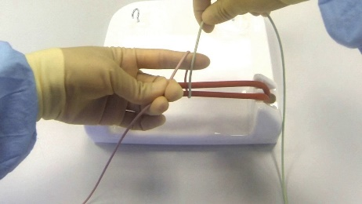  This is a hand tie done using a synthetic non-absorbable nylon. | - Take the tail end of the suture and bring it down to rest between the thumb and ring finger. Then take the working end and bring it down to rest on the middle and index finger.  - Next using the middle finger grab the tail end and pass it over and under the working end then pull down.  - Then come back up with the tail end between index and thumb and pull down the working end down between the middle and index finger. Then,using the middle finger grab the tail end and pass it over and under the working end then pull down.  - Repeat step 3. | It is faster than the two handed tie and can be done when one hand is occupied when holding an instrument. It is also used to tie deep cavities. It is stronger and more secure than a square knot.

