**RING BLOCK TECHNIQUE**

*Aseptic protocol involves alcohol or chlorohexidine solution for cleaning.

**TEAT CISTERN INFUSION TECHNIQUE**

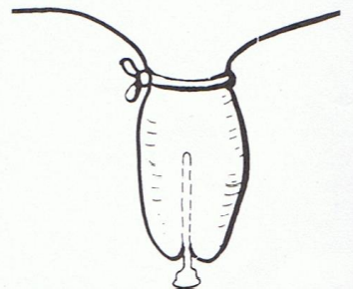

Sedate the cow as necessary and ensure the animal is adequately restrained, with tail tied out of the way.

NOTE: Do not place the tourniquet if a supernumerary teat is being removed.

**INVERTED ‘V’ BLOCK TECHNIQUE**

**VASCULAR (LOCAL) INFUSION TECHNQUE**

