**TEAT LACERATIONS**

Teat lacerations are classified by:

* Extent of trauma
* Localization
* Conformation
* Thickness (full or partial)

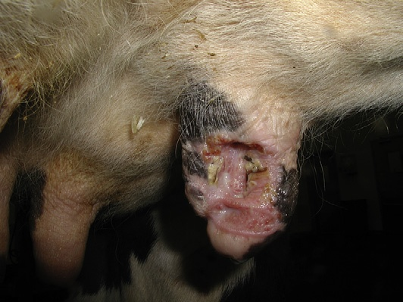 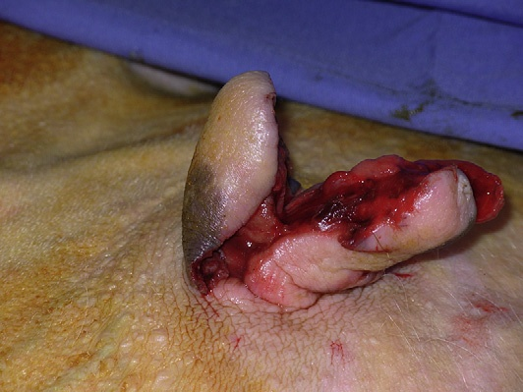

**Chronic Complex**

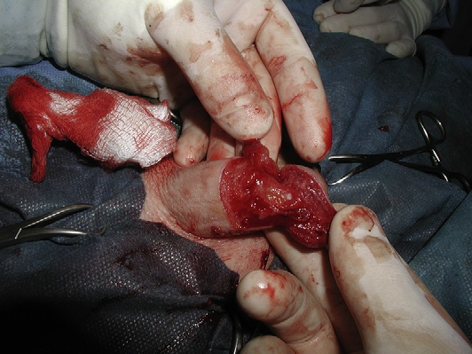 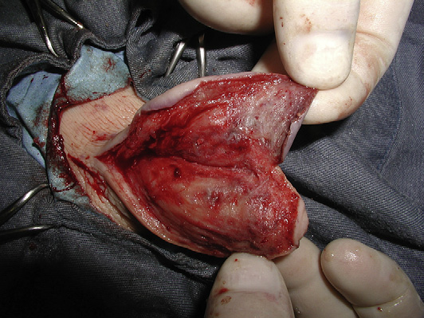

**Transverse Partial Thickness**

|  |  |  |
| --- | --- | --- |
| ***CLASSIFICATION*** | ***INFORMATION*** | ***CORRECTIVE APPROACH*** |
| Acute | <12 hours old |  |
| Chronic | >12 hours old | Debridement, thorough cleansing and suturing (not always) |
| Simple |  |  |
| Complex | Inverted “Y” or “U” | Primary Closure (even if older than 12 hours) with later Surgical Revision |
| Partial Thickness (Superficial) | Skin or Skin and stroma |  |
| Full Thickness (Deep) | Medical emergencies!  Mastitis should always be expected to develop  -Include vertical, horizontal, degloving injuries (teat flap normally develops) | If the lumen is penetrated, then multiple repairs are required |