MATERIALS | KEY POINTS
California Mastitis Test  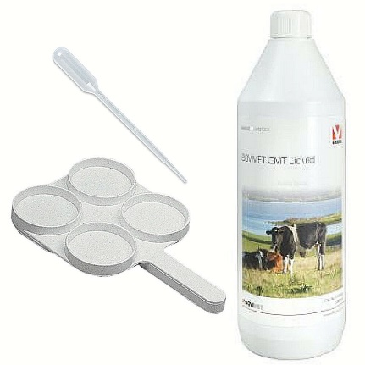 | - Used to detect subclinical mastitis  - Equal amounts of reagent should be added to equal amounts of milk  - Mixture swirled for 30 seconds to see if there is gelatinous formation
Doyen Intestinal Clamp  *See picture  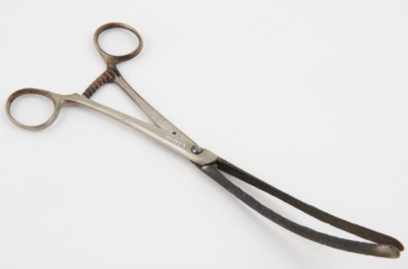 | - Not a typical teat surgical instrument  - Useful for stabilizing teat during surgery
Lichty Teat Knife/ Bistoury  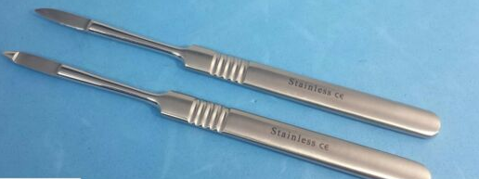  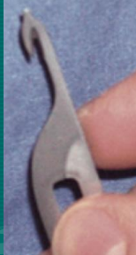 | - Slim stainless-steel blade attached to a handle  - Opens stenotic teats (increases teat diameter) via incision through scar tissues
Alligator forceps  *See picture  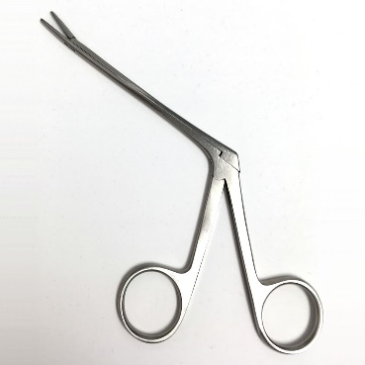 | - Not a listed teat instrument  - The small jaw at the top allows removal of lactoliths or floating growths within teat cistern.
Teat slitter  *See picture  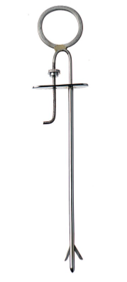 | - Knives protrude from the sides of the instrument.  - Used to open teat stricture and facilitate milk flow in hard milkers  - Cuts made in an “X” pattern
Self-Retaining Cannula  *See picture of both stainless steel and plastic  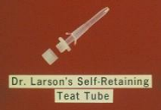 | - Inserted after teat surgery to keep the teat open for milking.  - Maintain canal patency while the teat heals.
Hug’s Tumour Remover  *See picture  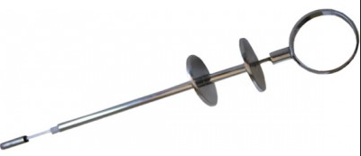  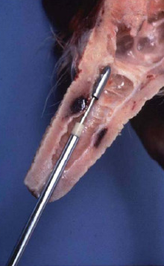 | - Facilitates mass removal in the teat cistern
Cornell teat Curette  *See picture  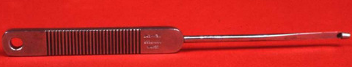 | - Sharp edge affixed at the bottom of the loop.  - Allows gathering of tissues, removal of obstructions and biopsies of tumours
Spiral Teat Curette  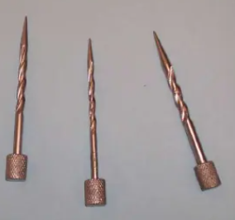 | - Enlarges the teat canal  - Slowly screw in and pull hard to open canal
Teat Dilator  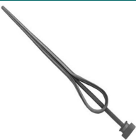 | - Gradually widening instrument placed into teat canal  - Allows milk flow.
Udder Infusion Cannula  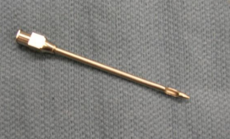 | - Blunted needle like tube inserted into teat canal  - Facilitates administration of medication into teat canal; draining of mastitic quarter; keeps the sphincter open; flushing abscess; peritoneal tap.
Theloscope  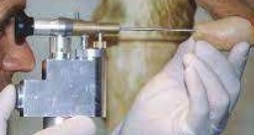 | - Optic device used for visualization of distant objects.  - Not a typical teat and udder surgical equipment.  - Used for removal of teat peas, lactoliths and remove stricture of teat.
STANDARD SURGICAL EQUIPMENT USED DURING SURGERY

Scalpel Handle and Blade  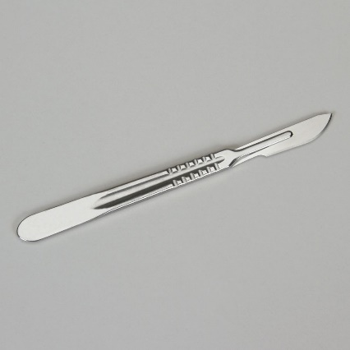 | - Essential for cutting into tissue.  - Blades and handles are of differing sizes and required based on surgeon’s preference and surgery performed.
Mayo Scissors  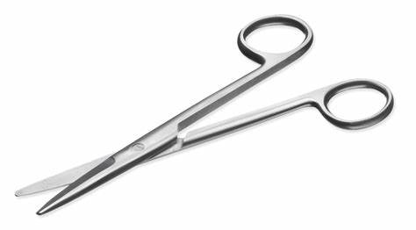 | - Used for cutting fascia  - Blunt and sharp dissection.
Metzenbaum scissors  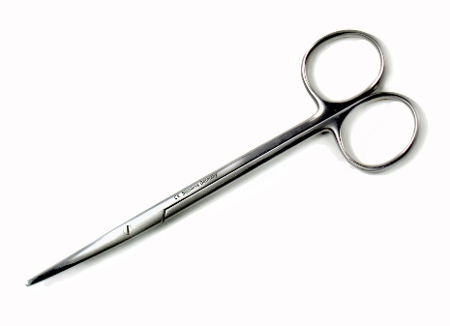 | - Used for very cutting delicate tissues and structures.
Mayo Hegar Needle Holder  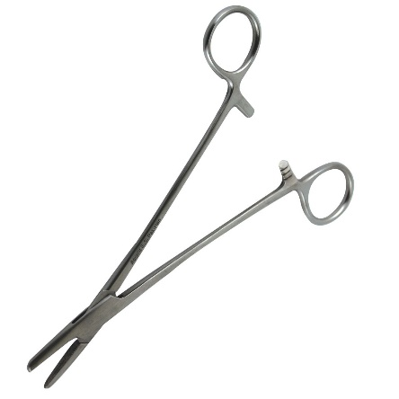 | - Standard surgical equipment.  - Allows surgeon to hold the suturing needle for wound apposition and closure during surgical procedures.
Adson-Brown Tissue forceps  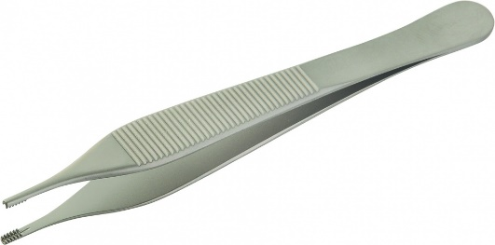 | - Traumatic forceps that allows surgeon to hold and manipulate the tissue.  - Teeth at the tip causes trauma to the tissue.
DeBakey Atraumatic Forceps  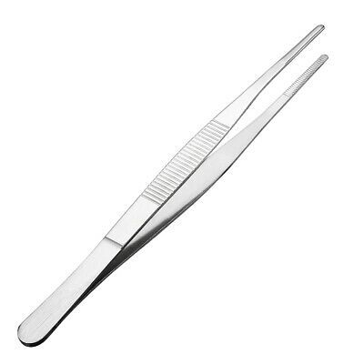 | - Same purpose  - Does not have teeth and eliminates trauma to tissue when grasping.

